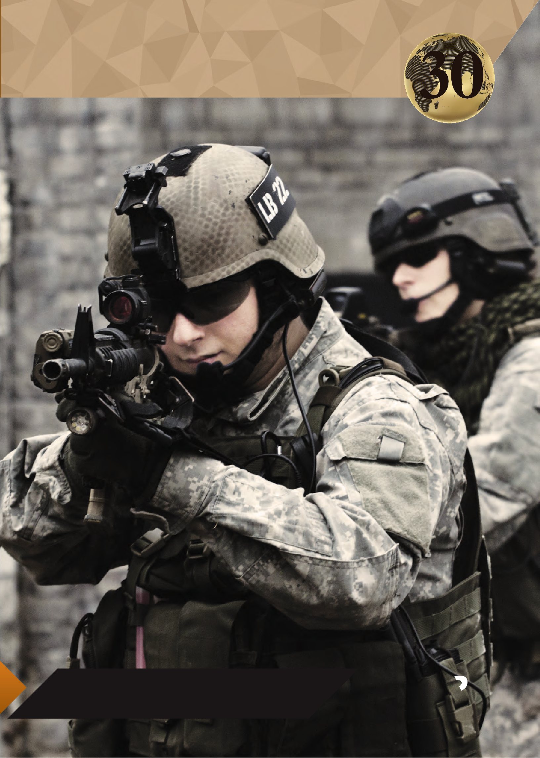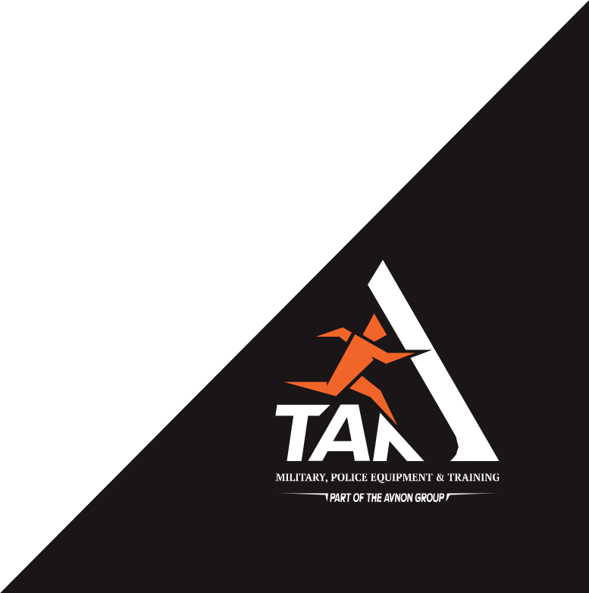GROUND FORCES

World Leader in Supplying Ground Equipment and Training
forces

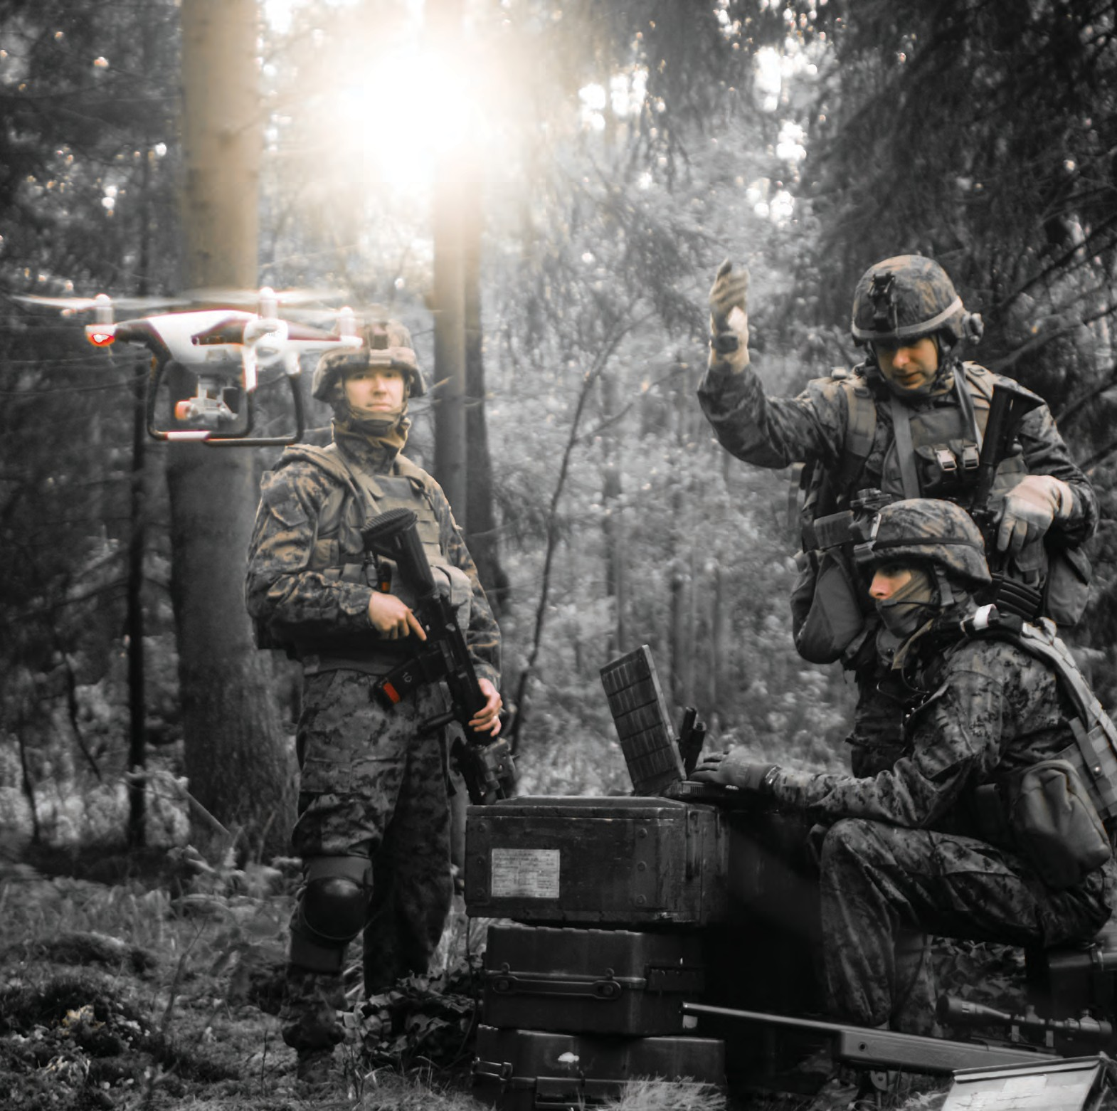COMPANY PROFILE

Scan The Code

GLOBAL FOOTPRINT
Founded in 1990, TAR IDEAL CONCEPTS established itself as a leading solutions provider, representing international HLS & Defense companies to the Israeli MOD, Law Enforcement Units and Prison Facilities.
In 1995, TAR expanded activities to the international market, adopting the civilian ONE STOP SHOP concept. As an integrator of products and technologies, Tar's experts take care of planning and execution, including post-delivery, ongoing training and management support to ensure projects' success.
NATIONAL-SCALE SOLUTIONS
In 2013, the Avnon Group was established, leveraging on the different technologies within the group, TAR provides more technology-based projects and solutions to a broader client base. Understanding that governments are looking for holistic solutions, TAR has made a transition from an integrator of 3rd party products to delivering national-scale integrated technology solutions to meet their threats and operational requirements.
As a client orientated company, we address the specific threats, time frames and budgetary constraints of our clients'. Our flexibility enables us to build customised solutions for each project.
WORKING TO SECURE YOUR FUTURE
TAR's ONE STOP SHOP concept encompasses all the many elements of a project; from operational knowledge and technologies, to advanced equipment and training. This enables Special Forces, First Responders and decision makers to establish operationalprotocols, training techniques, and combatcapabilities, using the latest technologies to address threats ranging from terrorism, international crime, natural and man-made disaster and intrusions to our critical information infrastructures.

2 MILITARY AND POLICE EQUIPMENT WWW.TARIDEAL.COM 3

TRANSPORTATION
Scan The Code

VEHICLES

TAR offers a wide range of transportation platforms for military, police, air, land and sea, customized to meet customer requirements.
TAR offers: Transportation Vehicles APC
Helicopters Logistic Trucks ATV
Combat Jeeps Trailers

HELICOPTER/ TA04160

AVLB /TA04190

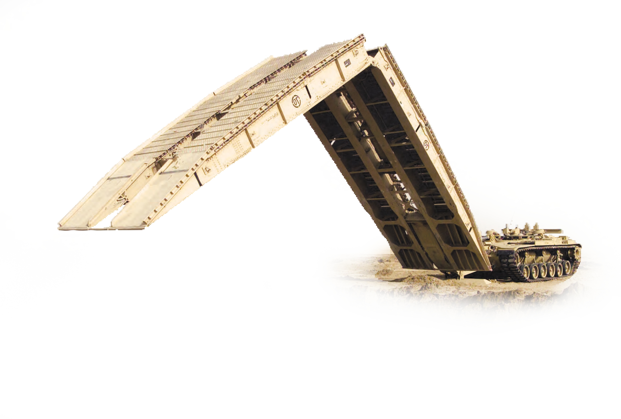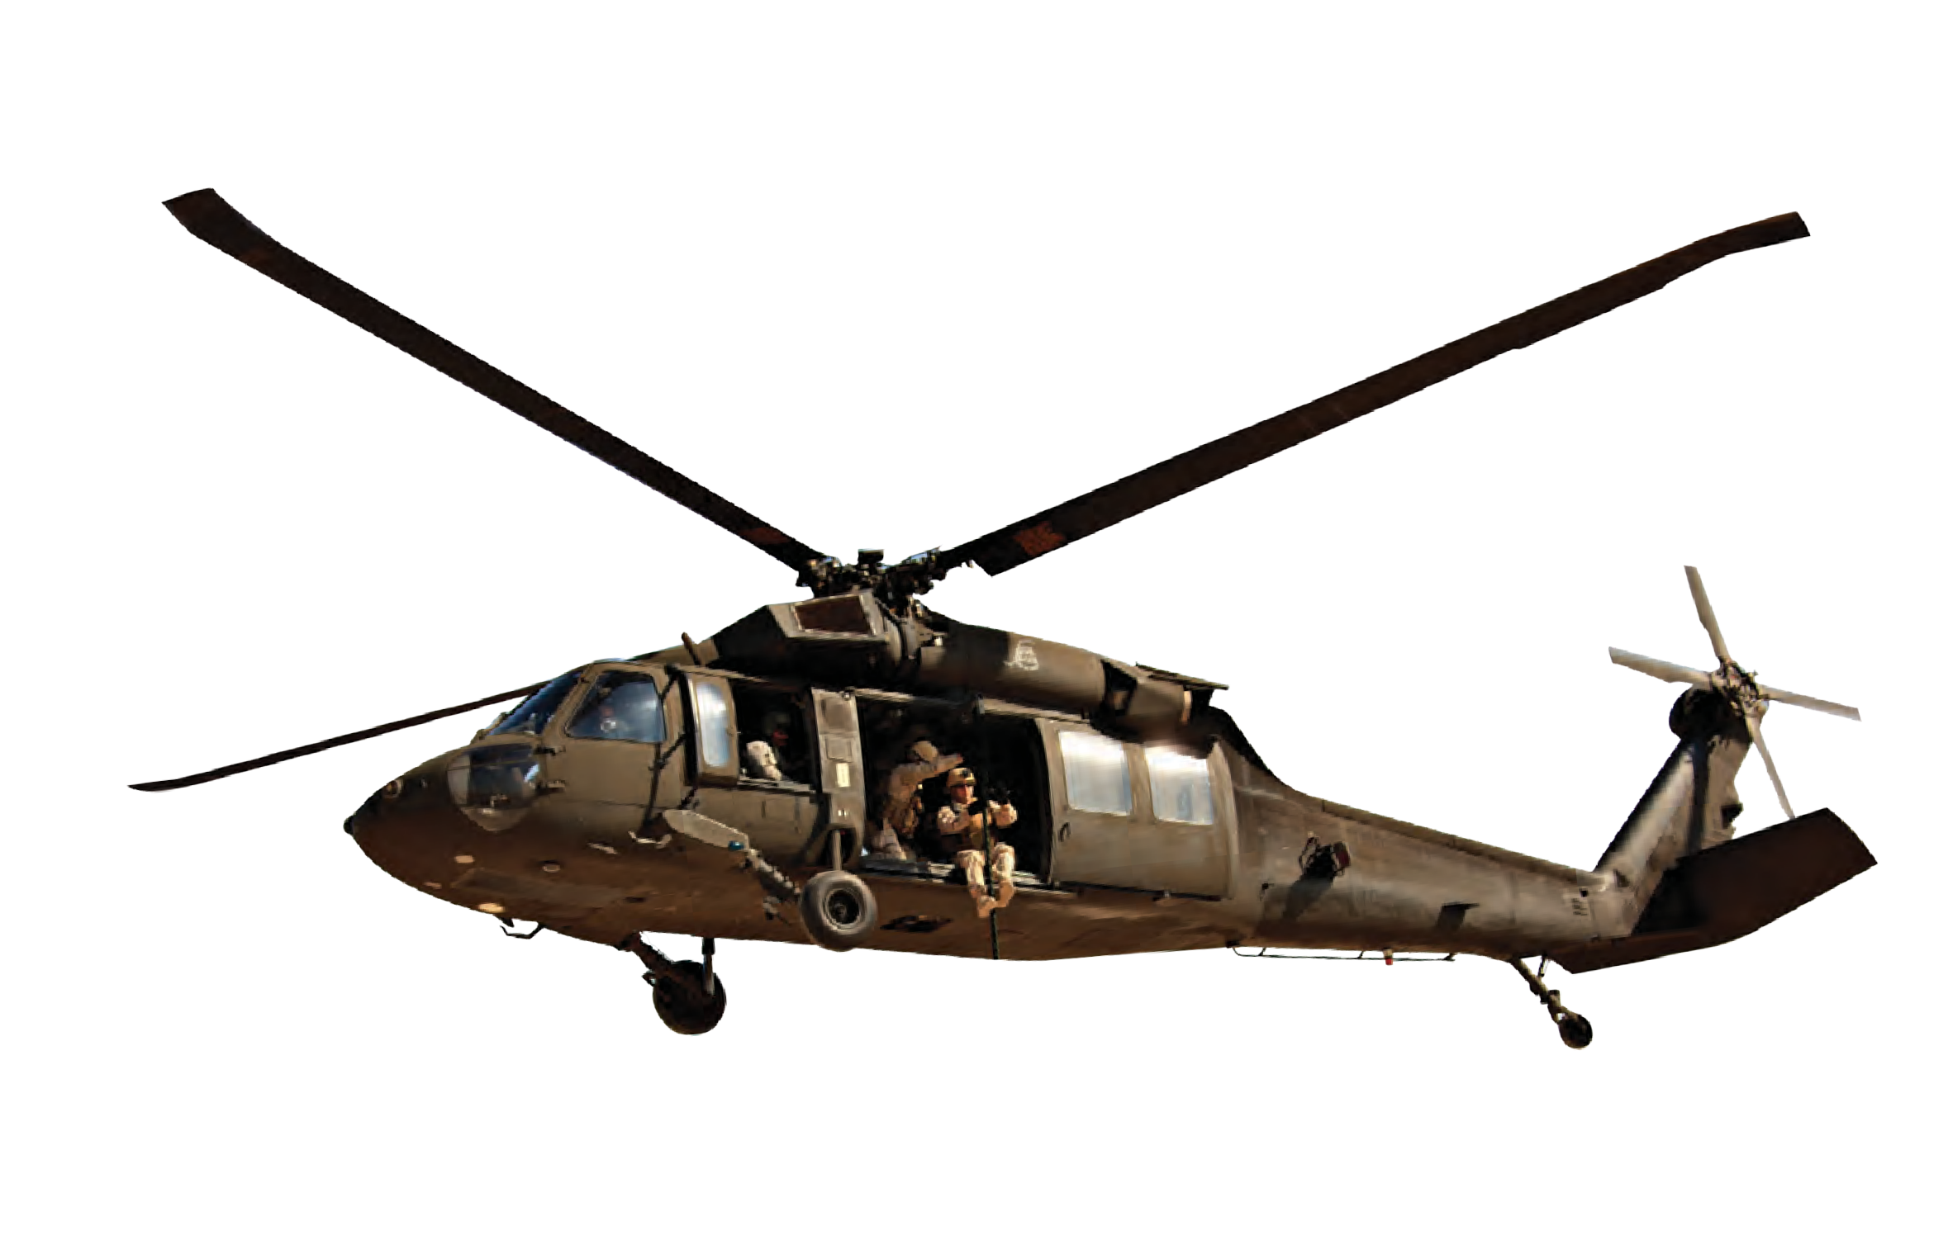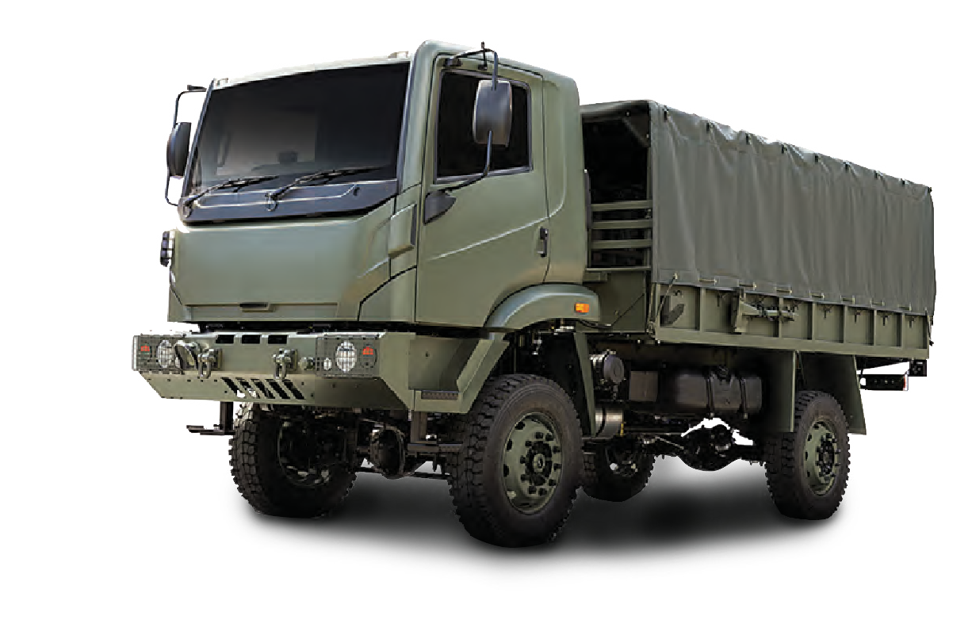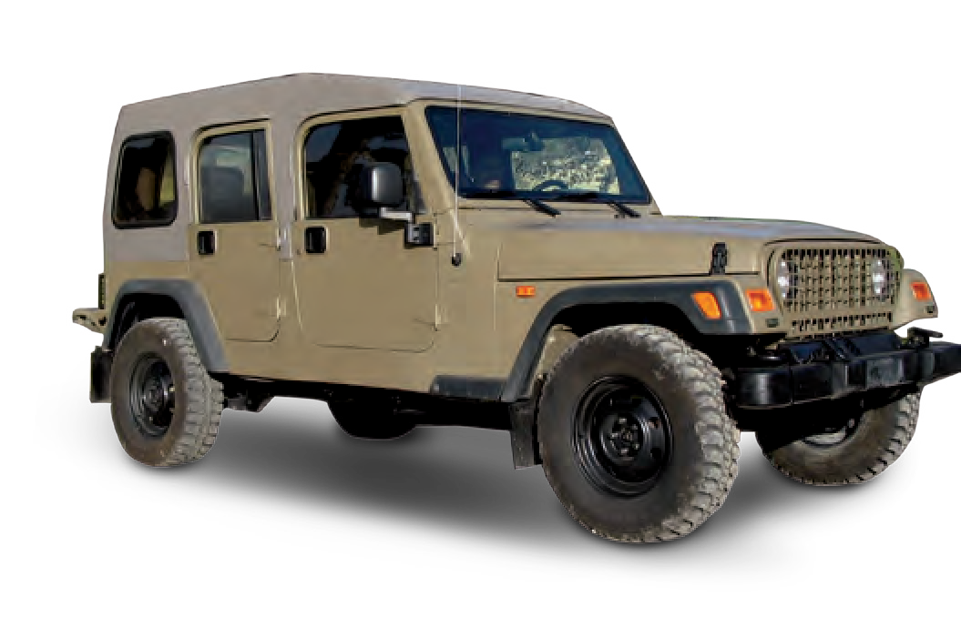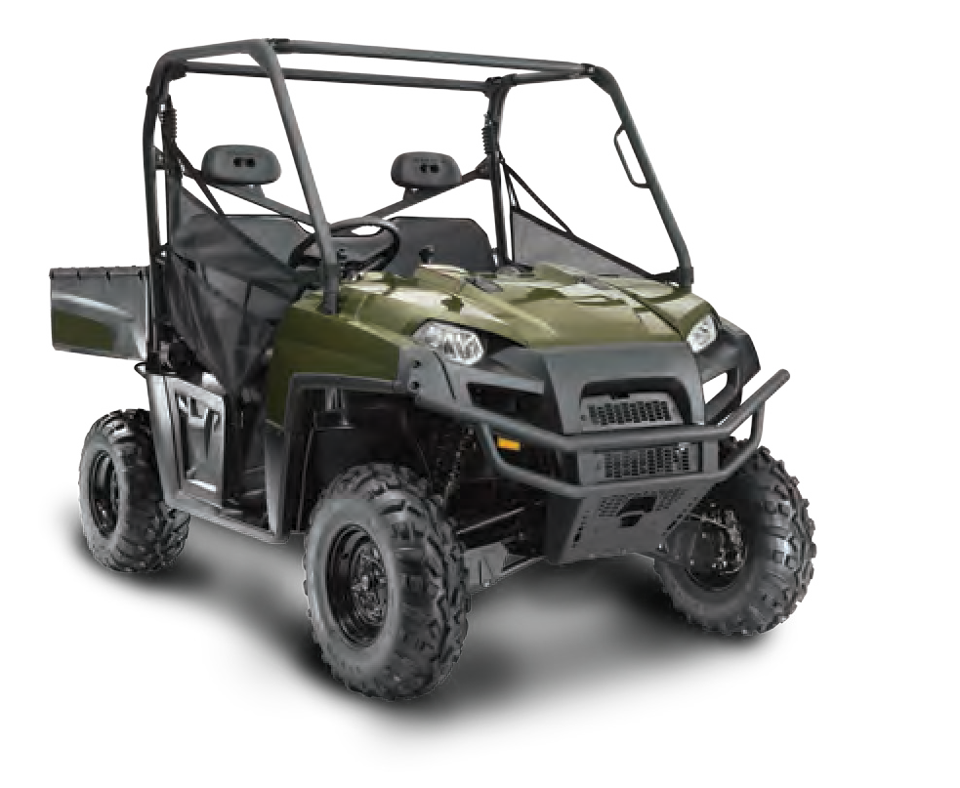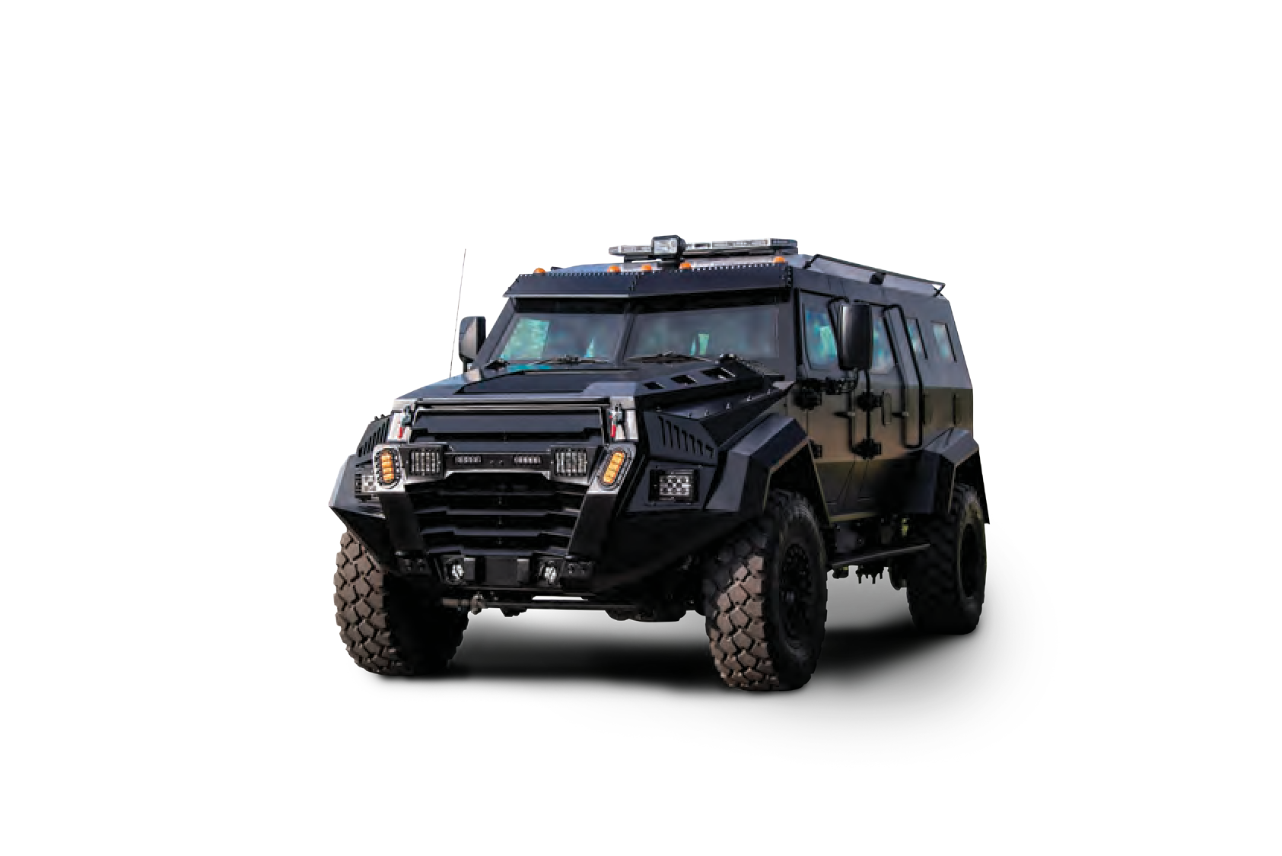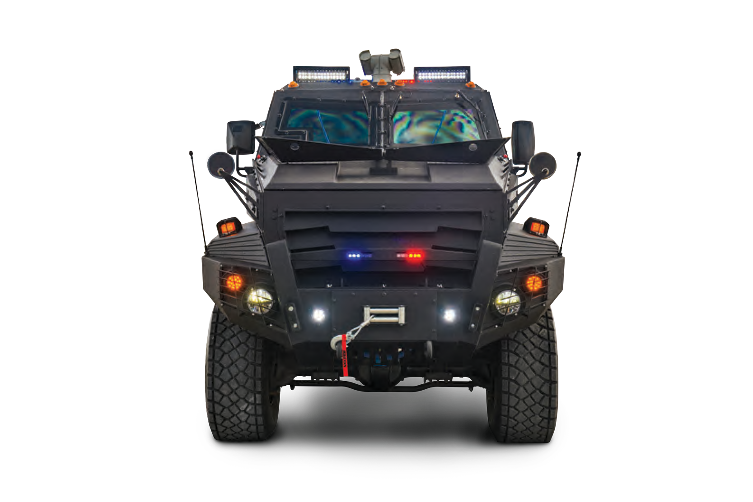

LOGISTIC TRUCK/ TA04155 TRANSPORTATION VEHICLES/ TA04156 APC/ TA04157 ARMY ATV/ TA04158 COMBAT JEEP/ TA04159

4 MILITARY AND POLICE EQUIPMENT WWW.TARIDEAL.COM 5

UAV
Scan The Code

ADVANCED LIGHT-WEIGHT UAV SYSTEM G2

TA04305
A fully autonomous, Light-weight UAV. Provides real-time day and night video stream via the Ground Control Station. Ideal for fast deployment & turnaround time. High payload stability.

MID RANGE UAV

TA03202
The UAV is an electrically propelled platform that provides real-time visual intelligence with a 50km communication range. The payload has a continuous optical zoom, high resolution day camera, IR cooled 3-5um night sensor with continuous optical zoom, and Laser pointer. The UAV’s typical missions are target acquisition, border surveillance, force protection, frigate defense and the protection of critical Infrastructures.
Features:
Endurance: 6-10 hours.
Wingspan: 4.4 meters. Payload: 3.5kg.
Ceiling: 15,000 ft. MTOW- up to 30kg.
Fully autonomous mission including take-off and landing.
Low acoustic, heat, radar signature.

ADVANCED HIGH PERFORMANCE UAV SYSTEM

TA04306

Equipped with a gimbaled, stabilized high performance EO & IR payload that is interchangeable with other sensors that are up to 3kg.

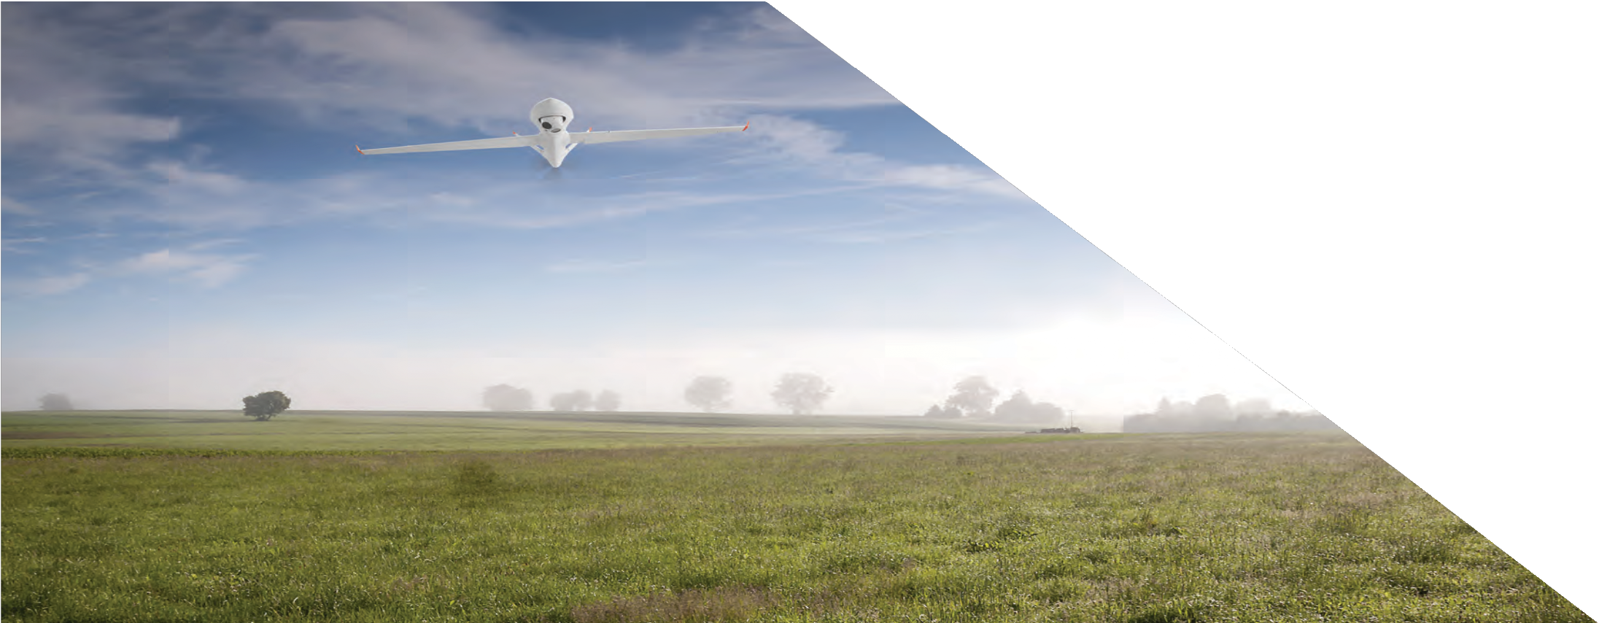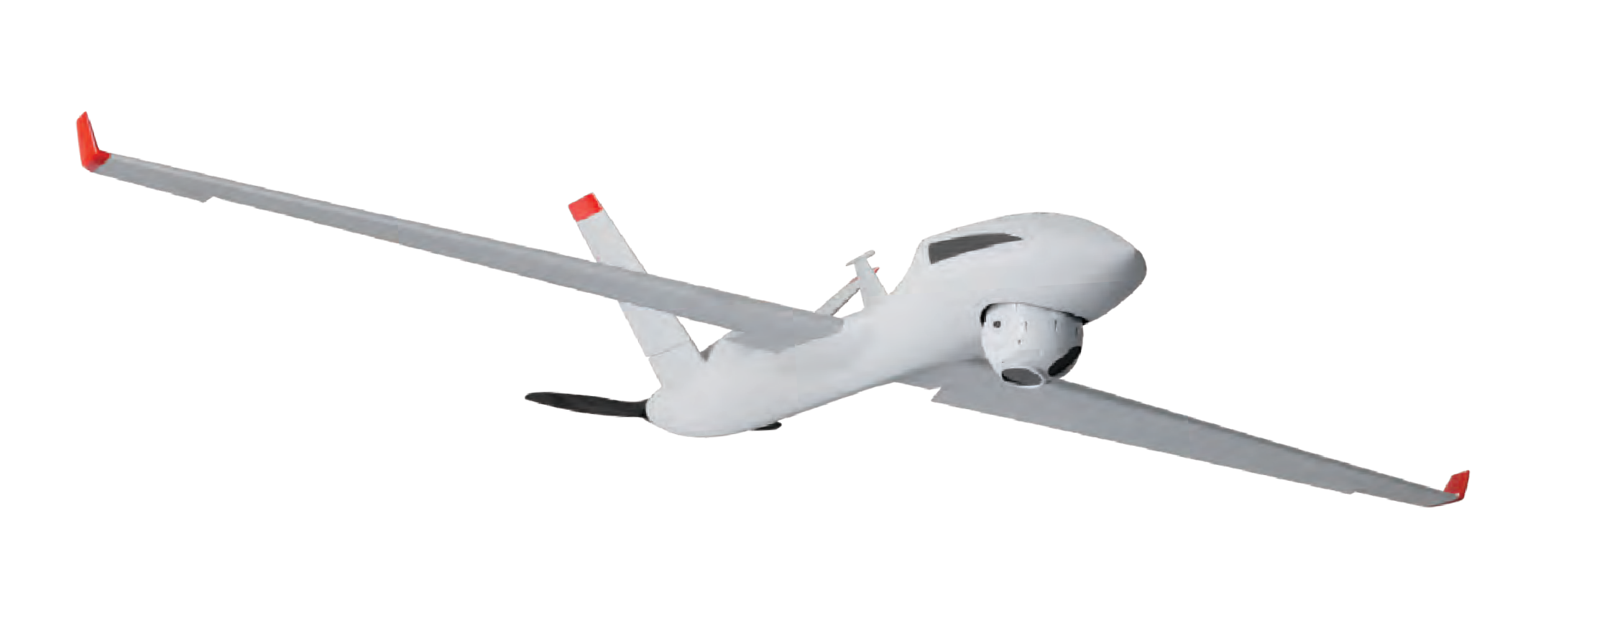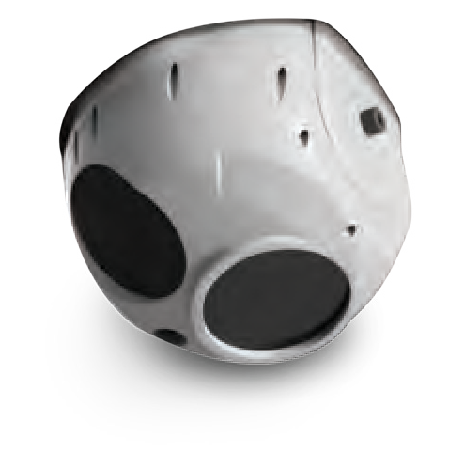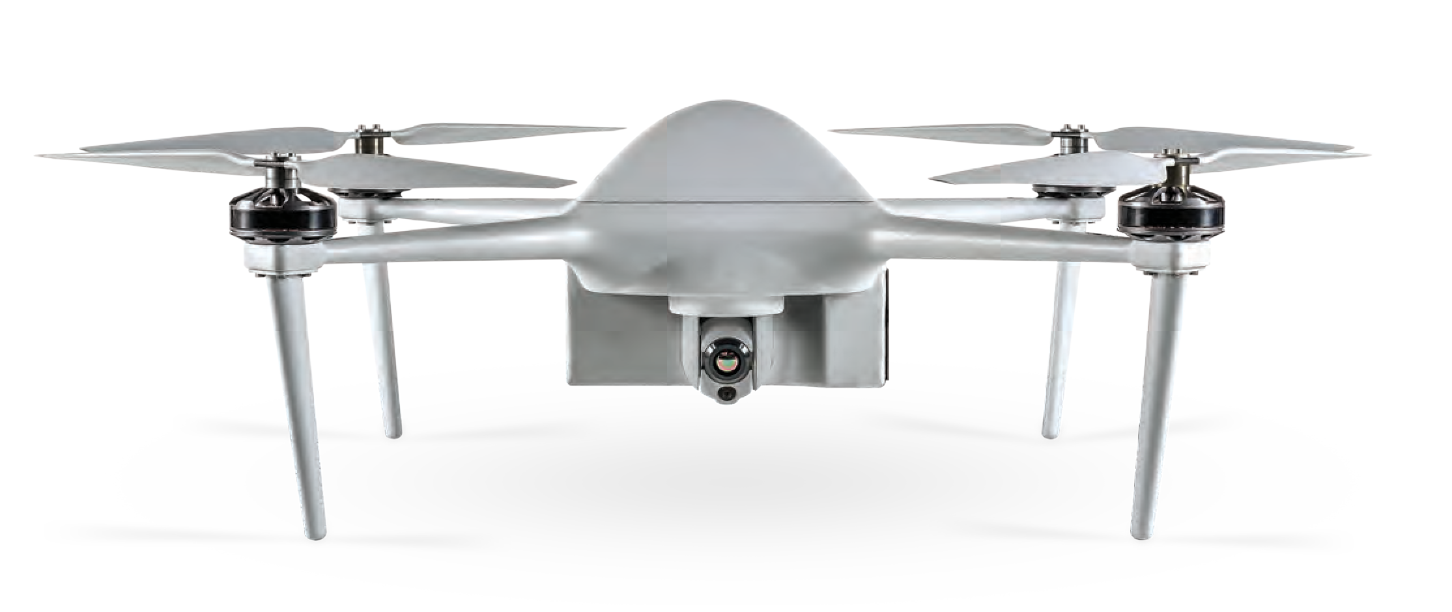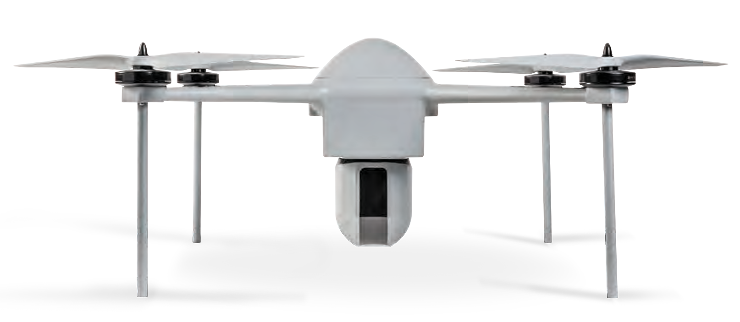

6 MILITARY AND POLICE EQUIPMENT WWW.TARIDEAL.COM 7

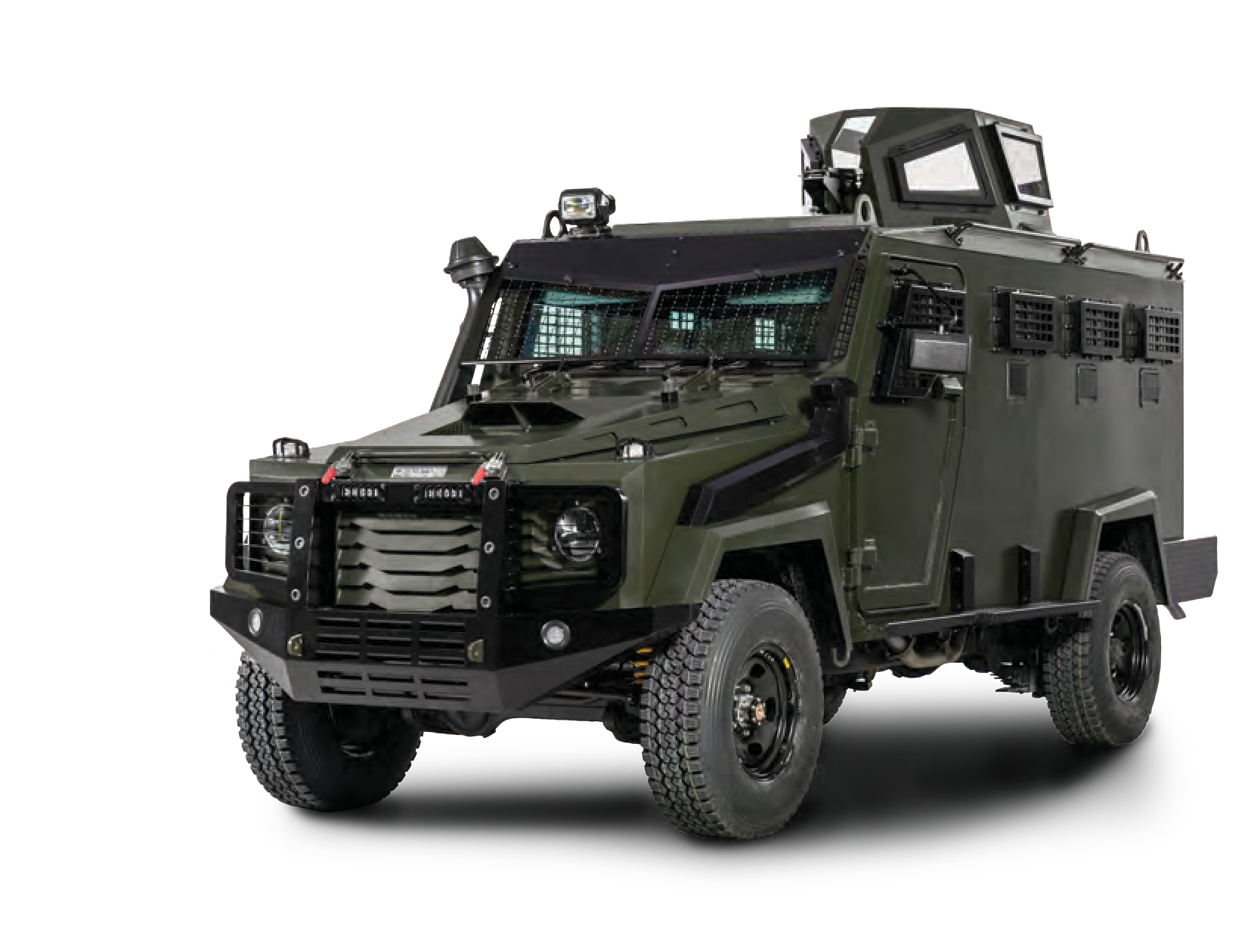
COMMAND & CONTROL ARMOURED VEHICLE

TA02011
Mission ready management vehicle, modified to meet the constraints of mobile dissemination of orders and alerts.

Optional Systems:
12 Passengers
Electronic nightvision system Escape hatch
360° gun-port coverage Advanced door lock mechanism Heavy-duty electronic winch Multi-layer ballistic glass, no spall
Removable wire mesh glass protection External view cameras providing 360° F.O.V. Siren/PA system
Emergency lights package

OBSERVATION VEHICLE

TA02006
Designed for long range security patrols, to secure and control large areas. Defends mobile targets, with perpetual adaptation of reconnaissance patterns.
Enhances the ability of early threat recognition
effectively improving perimeter control.

SURVEILLANCE VEHICLES

TA04304
Designed and equipped to gather and analyze audio-visual intelligence from multiple sources, in real-time.

COMMAND & CONTROL TENT

TA02118
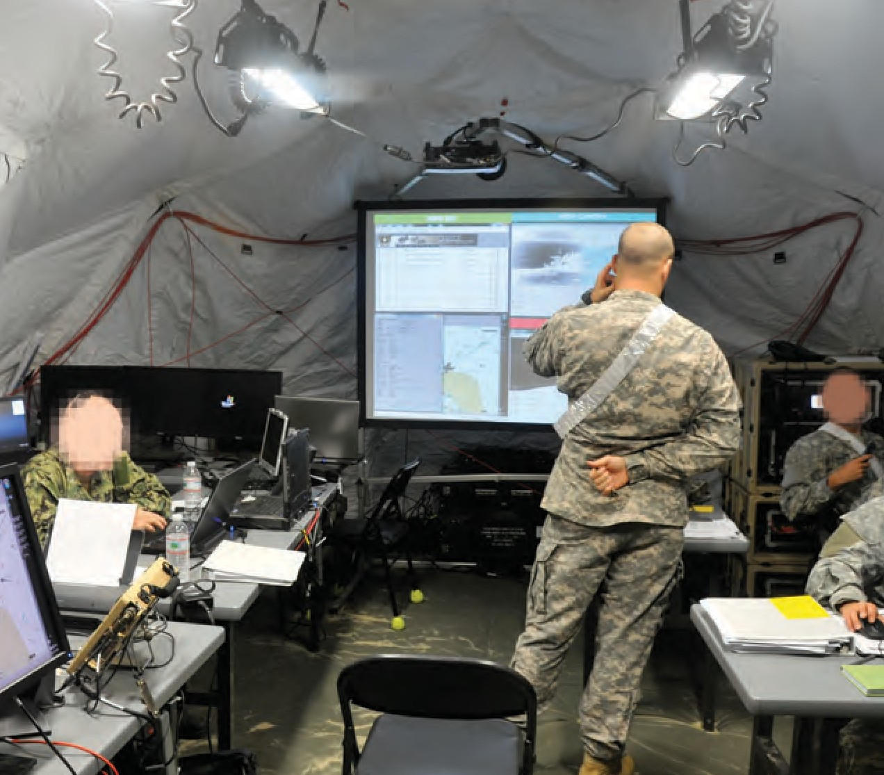
Enables the joint force commander to set up a temporary, self-contained, self powered, computer network-enabled headquarters.

SURVEILLANCE AEROSTAT

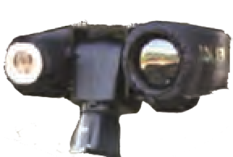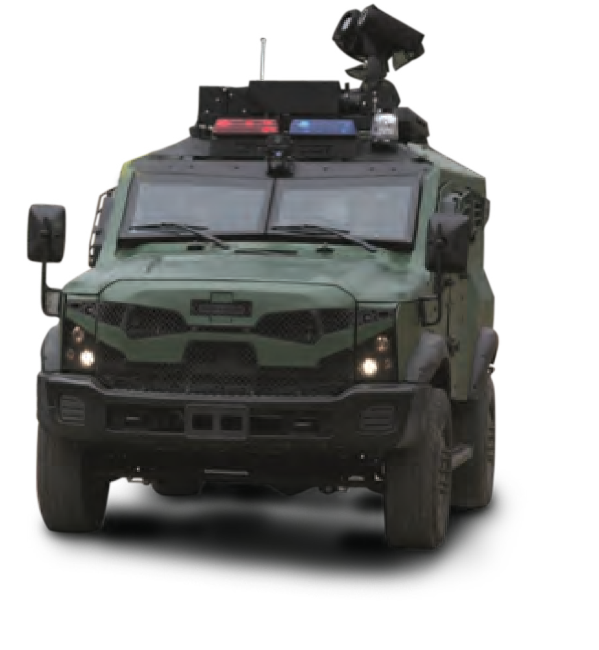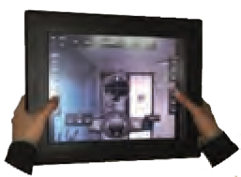TA02005
Balloon observation system with Day/Night vision cameras with self-stabilization and real-time video transmission:
Unmanned Aerial Surveillance Target Acquisition
Border & Coastal Surveillance Intelligence
Search & Rescue Battle Proven

FAST DEPLOYMENT OBSERVATION WIRELESS SYSTEM

TA02007
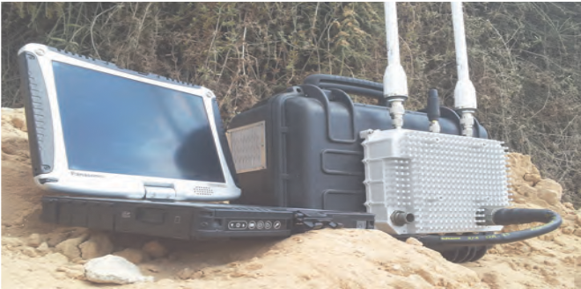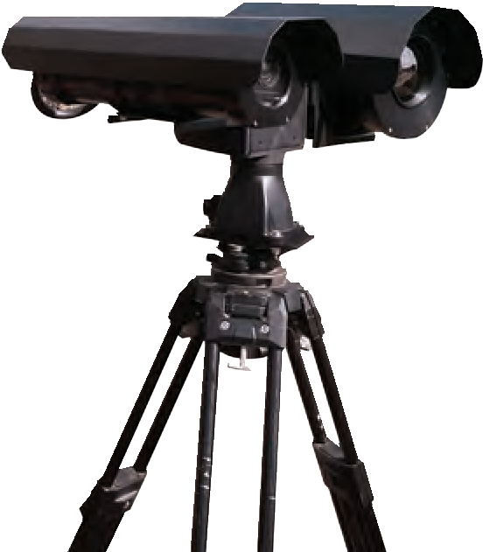Ideal for observational operations in remote enemy territories and rural areas where a car or balloon cannot be deployed.

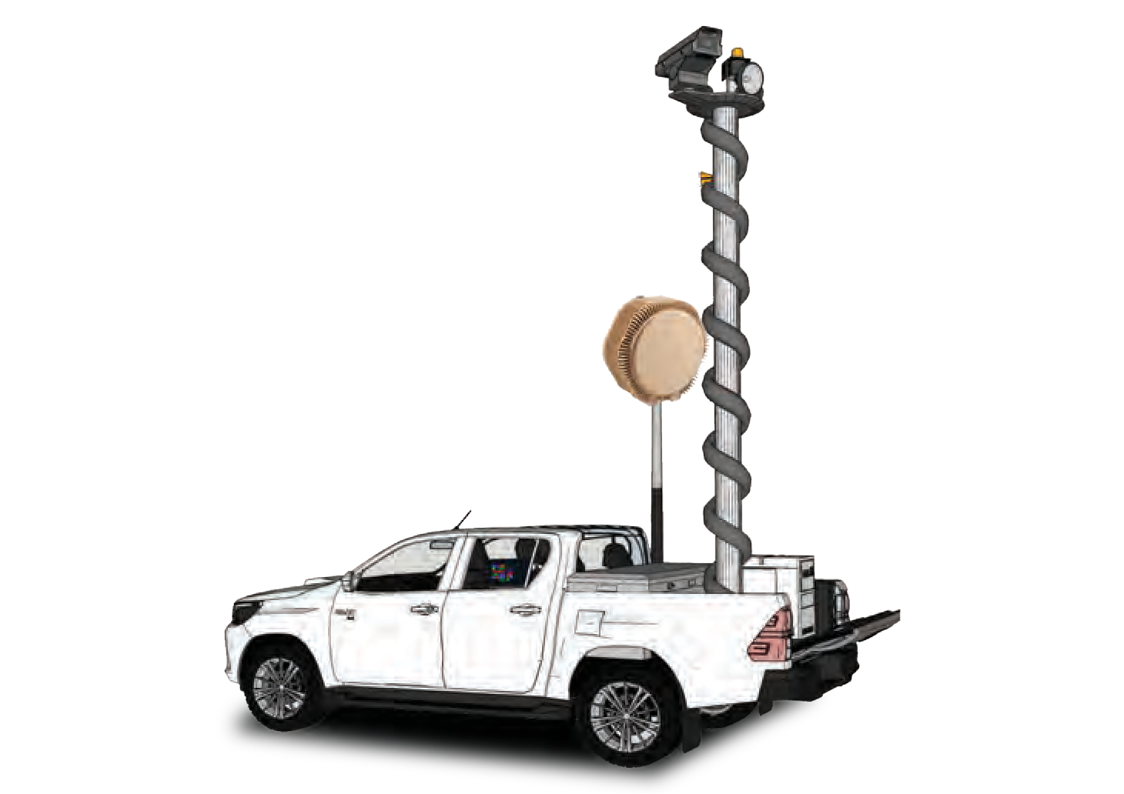
8
MILITARY AND POLICE EQUIPMENT
WWW.TARIDEAL.COM
9
COMMAND & CONTROL
OBSERVATION
Scan The Code
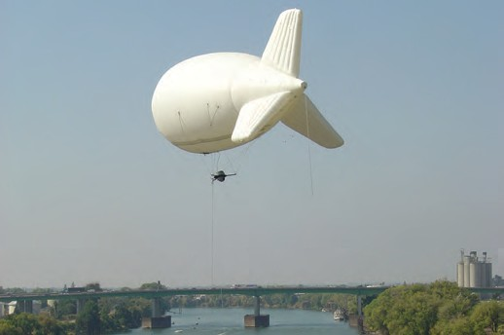

SQUAD TENT
MODULAR DIVISION TENT
BUNK BED FIELD TABLE

TA04135
Accommodates 12 soldiers. Easy to assemble and waterproof.
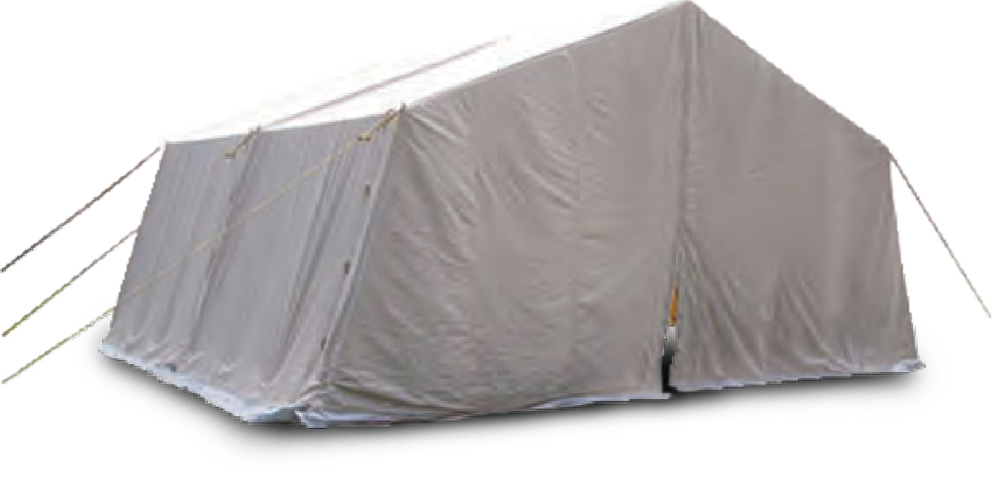

RIDGE TENT
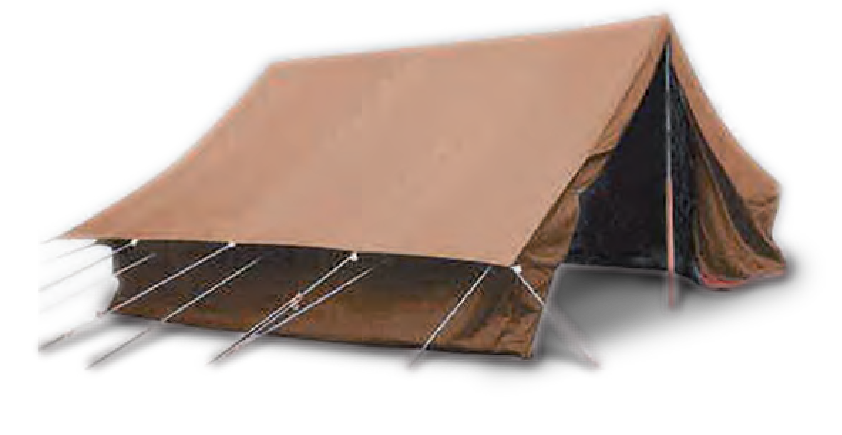TA04137
Accommodates up to 4 soldiers.
Easy to assemble and waterproof.
SHOWER PLATFORM

TA04142
TA04136
Multi-purpose tent used as a storage, hospital, command tent etc. Ideal for use in extreme weather conditions.
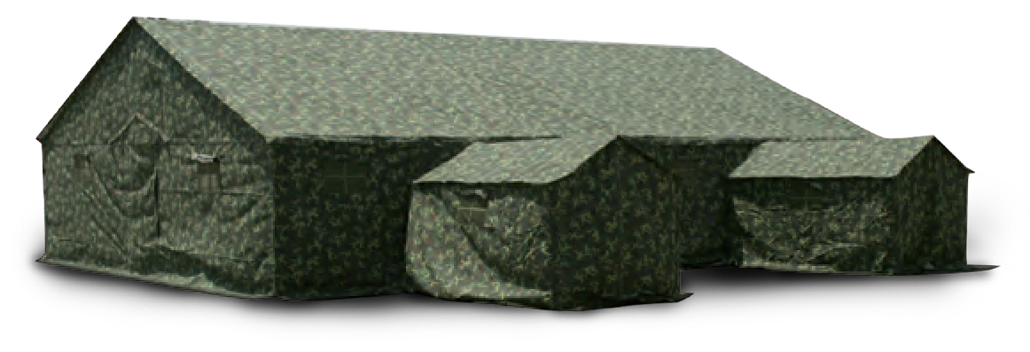

NYLON TOILET TENT

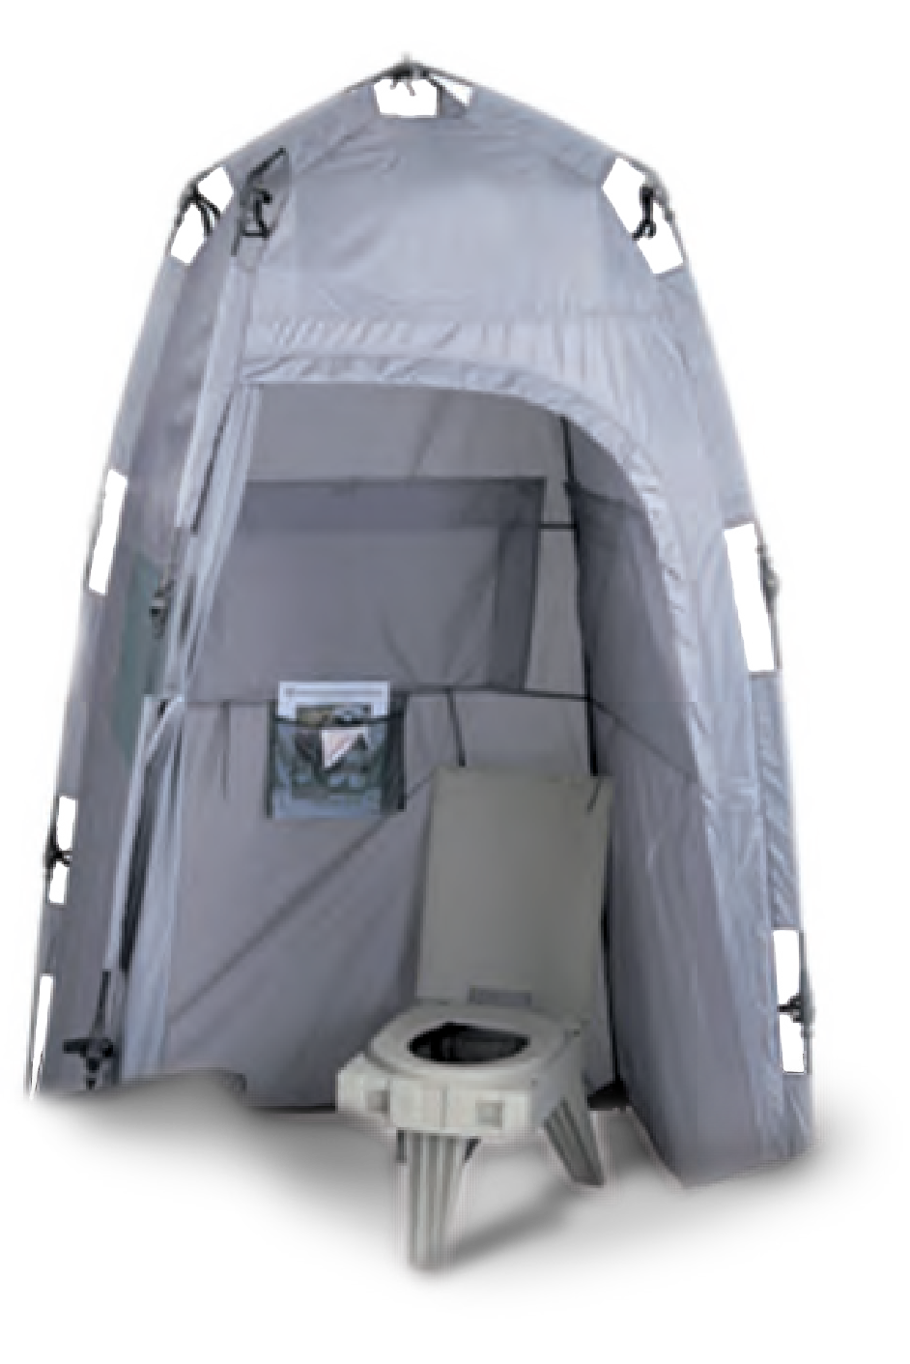
TA04147
TA04143
Designed to be assembled within seconds single handedly.

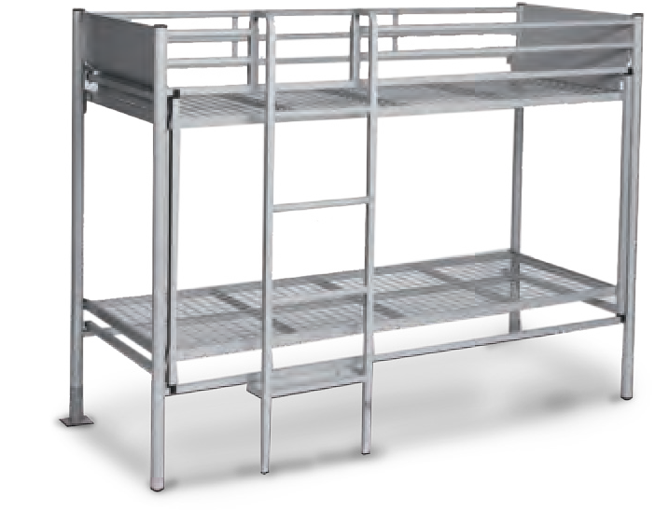

WATER TANK TRAILER

TA04145
Capacity: 200L, 300L, 500L.

TA04149
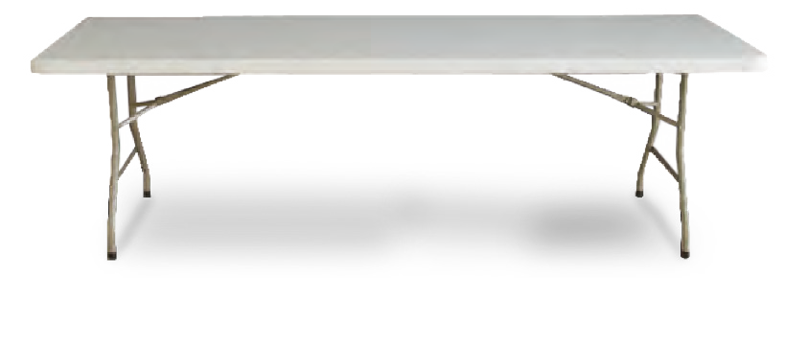

SINK SYSTEM
TA04151
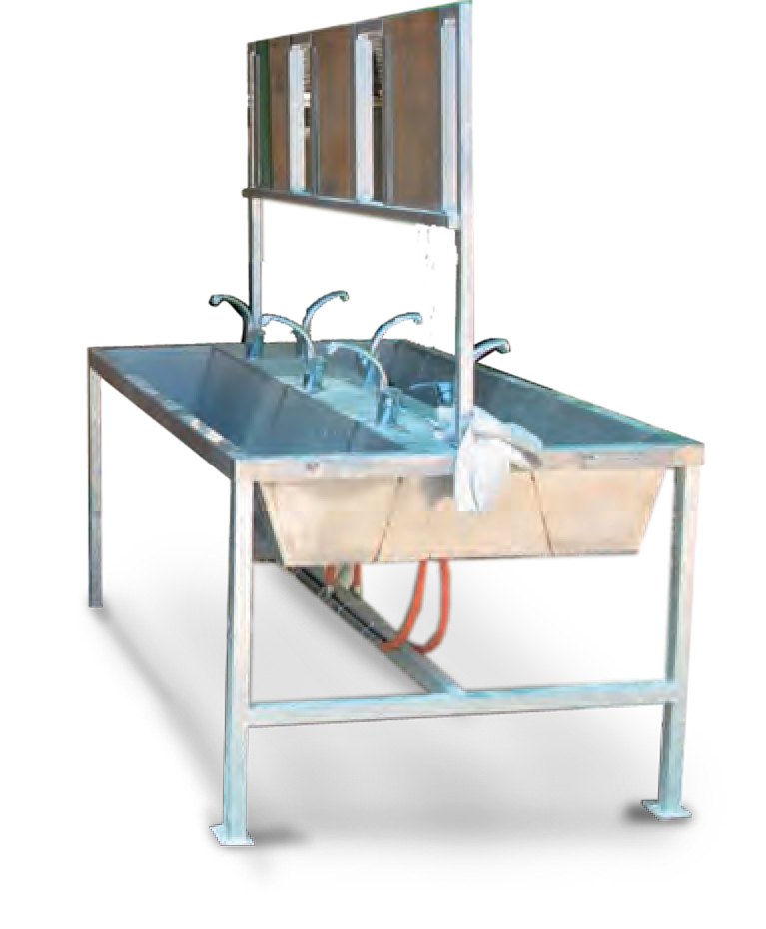
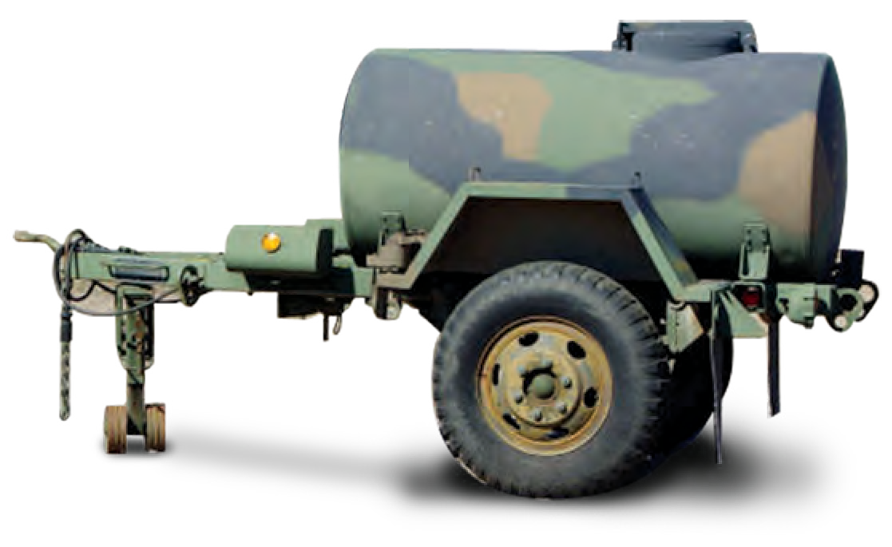Available in different sizes & models.

COOKING TRAILER

LOGISTIC TRAILER

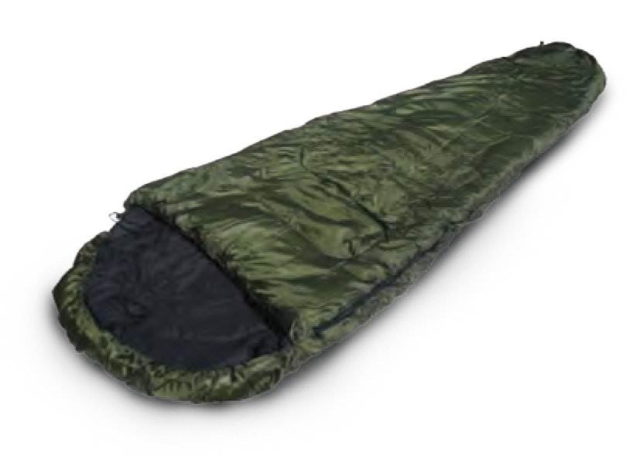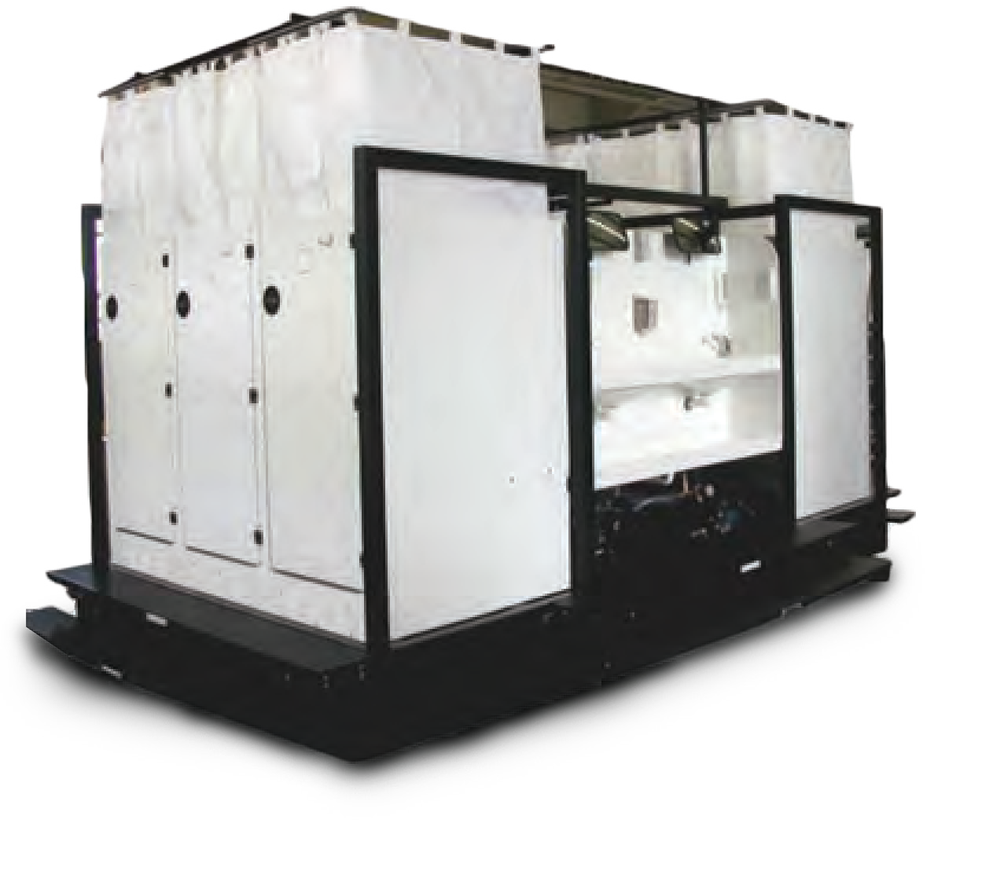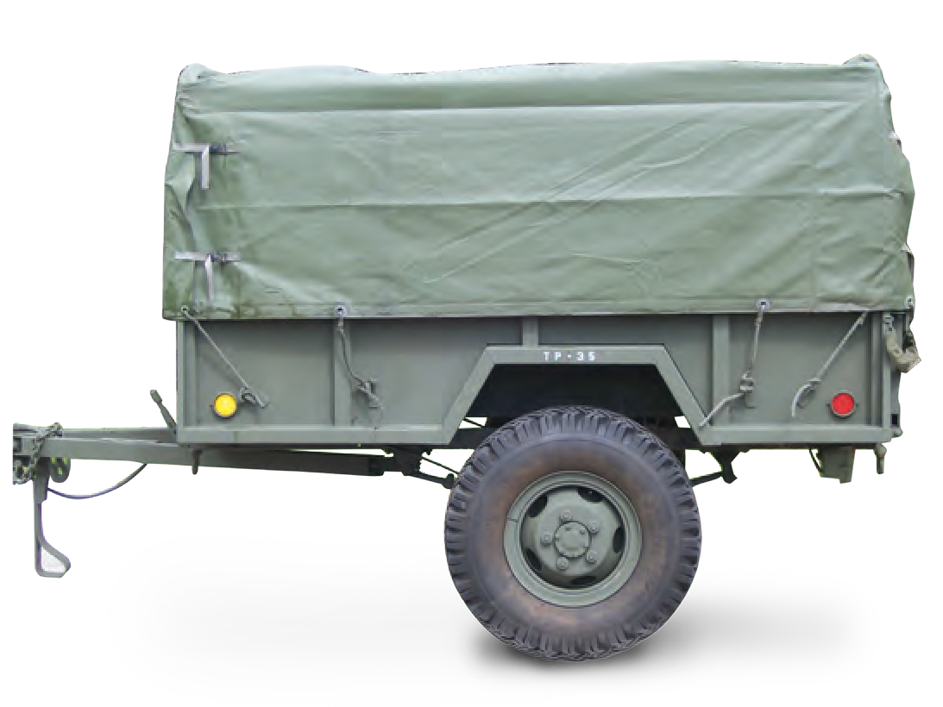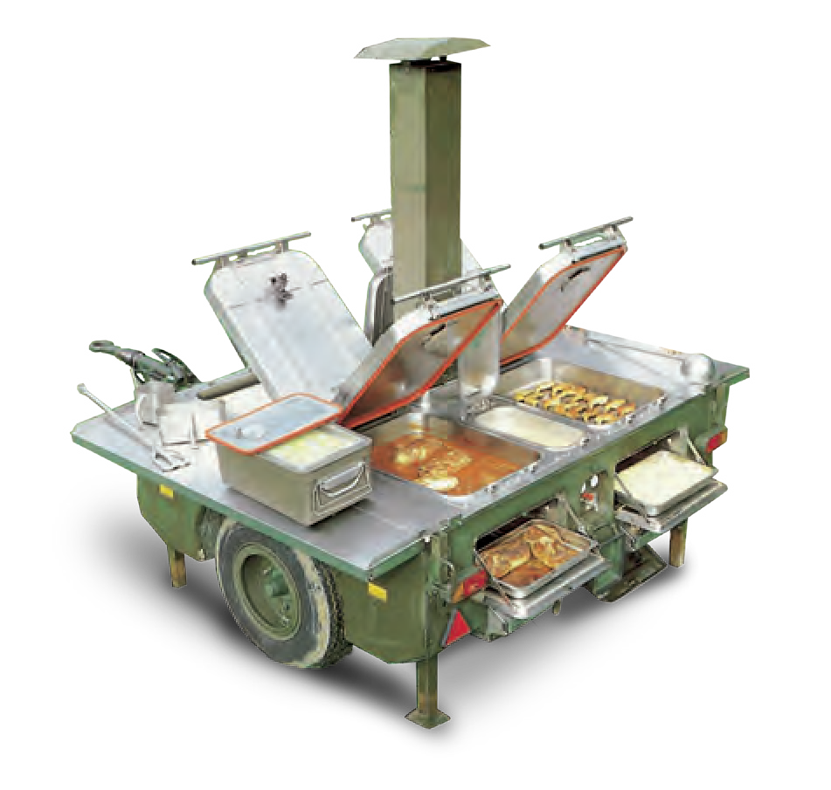
This mobile shower platform is used as a modular
sanitary system in the field. Mounted on a platform
for easy transport.
EXTREME WEATHER
SLEEPING BAG
TA04140
Light-weight, small pack size, waterproof outer nylon with hood.
TA04150
TA04138
10
MILITARY AND POLICE EQUIPMENT
WWW.TARIDEAL.COM
11
CAMP EQUIPMENT
LOGISTICS
Scan The Code

MULTI-COLOR LED FLASHLIGHT

TA03150
Waterproof up to 20 meters.
Works at temperature from 50-60 degrees Celsius.
TLG

TA03167
Designed to be used with (or without) night vision devices to engage enemy targets at night.
The TLG is a dual beam, weapon mounted. IR and
red aiming laser activated by two integral On/Off
TL6 PRO

TA01078
TL6 PRO is a mountable, shatterproof, and waterproof tactical LED flashlight that will light your way.

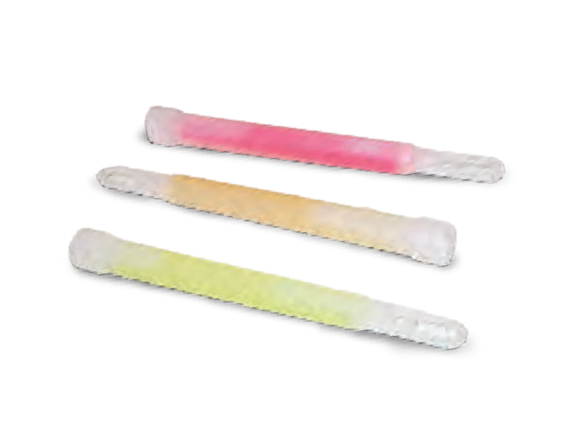
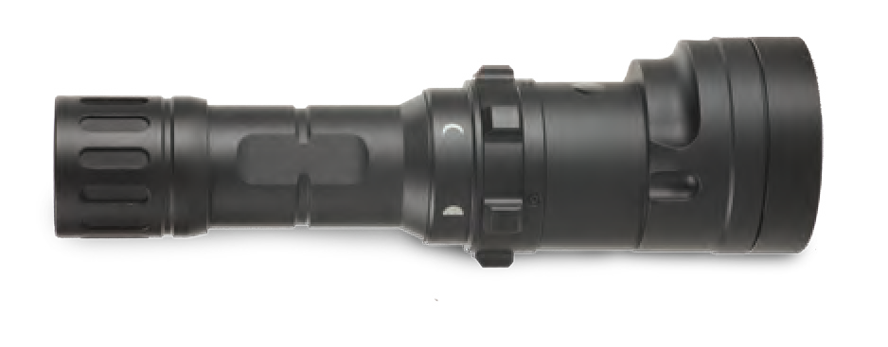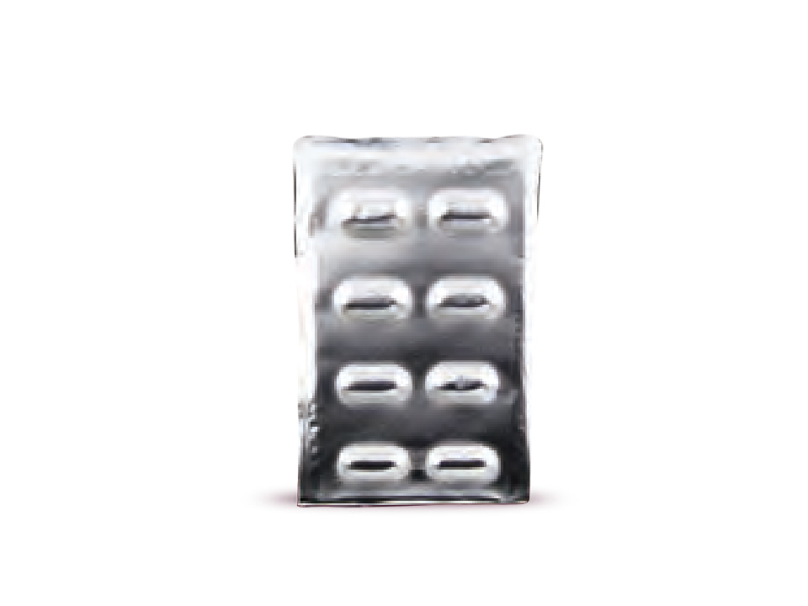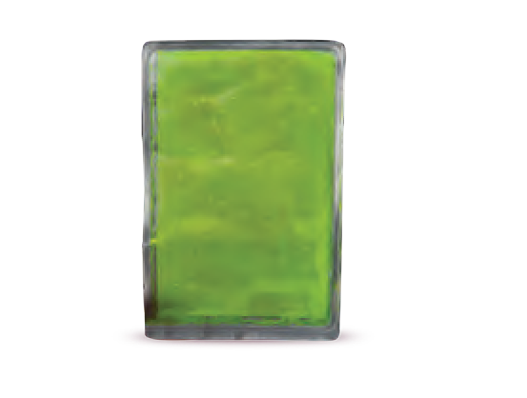 STICK LIGHTS

PERSONAL FLASH LIGHT
GLOWPAD
TA04195

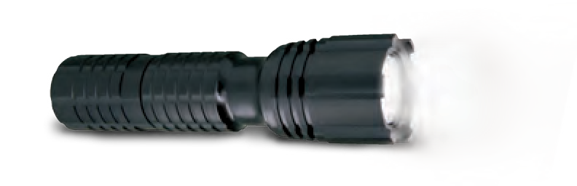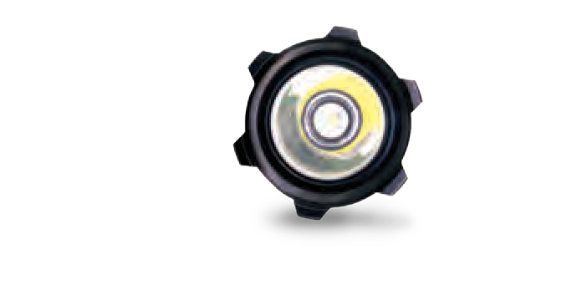TA04161
TA04124
PORTABLE 360 LIGHTING AREA

TA01081
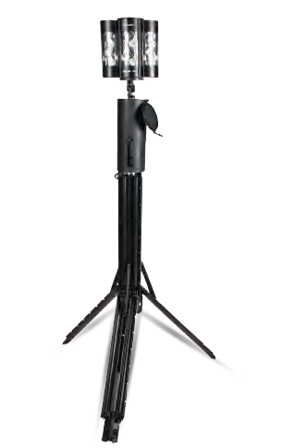
Portable, lightweight, and rechargeable LED used to provide a powerful 360° scene light.

ILLUMINATION TRAILER WITH GENERATOR

TA04162
Provides high illumination output for large areas. The trailer has a powerful diesel engine enabling long periods of operation.

TA04132
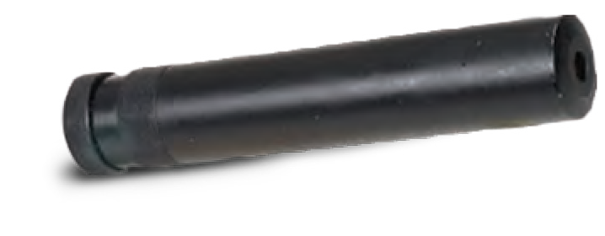

RAIL SYSTEM

TA02132
Allows user to customize the gun with equipment
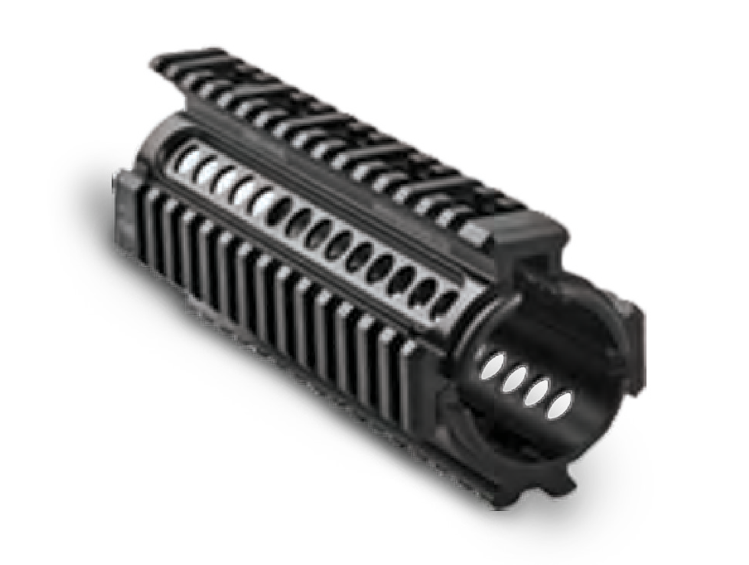
for a specific missions.

TA02095

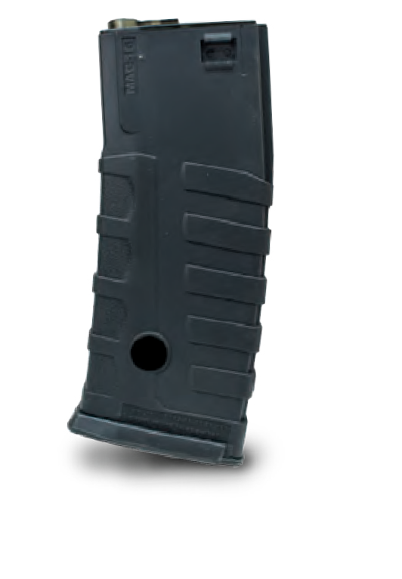
WEAPON GRIP

TA02133
M-16 Grip AK-47 Grip

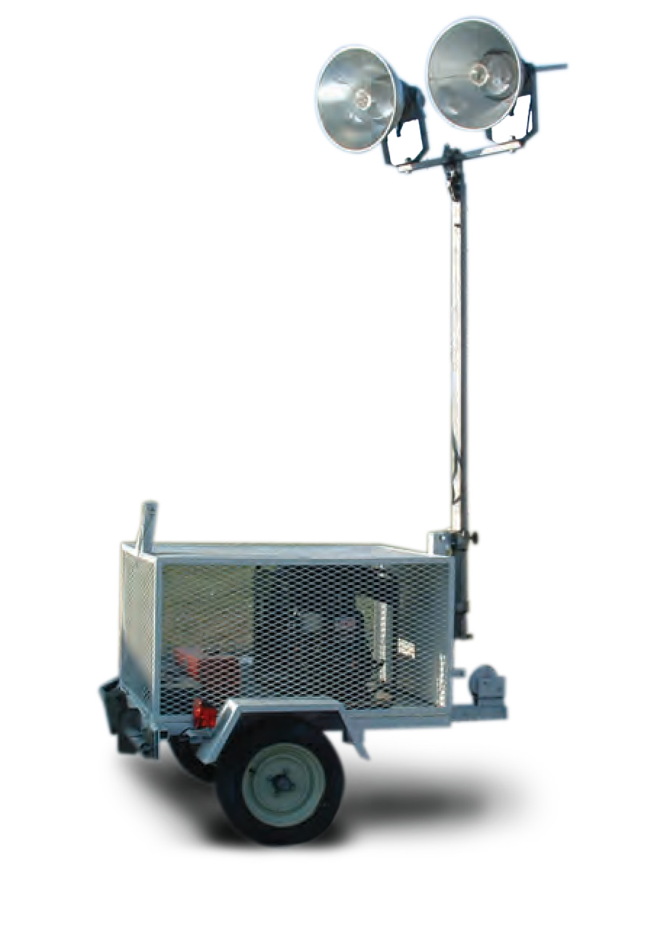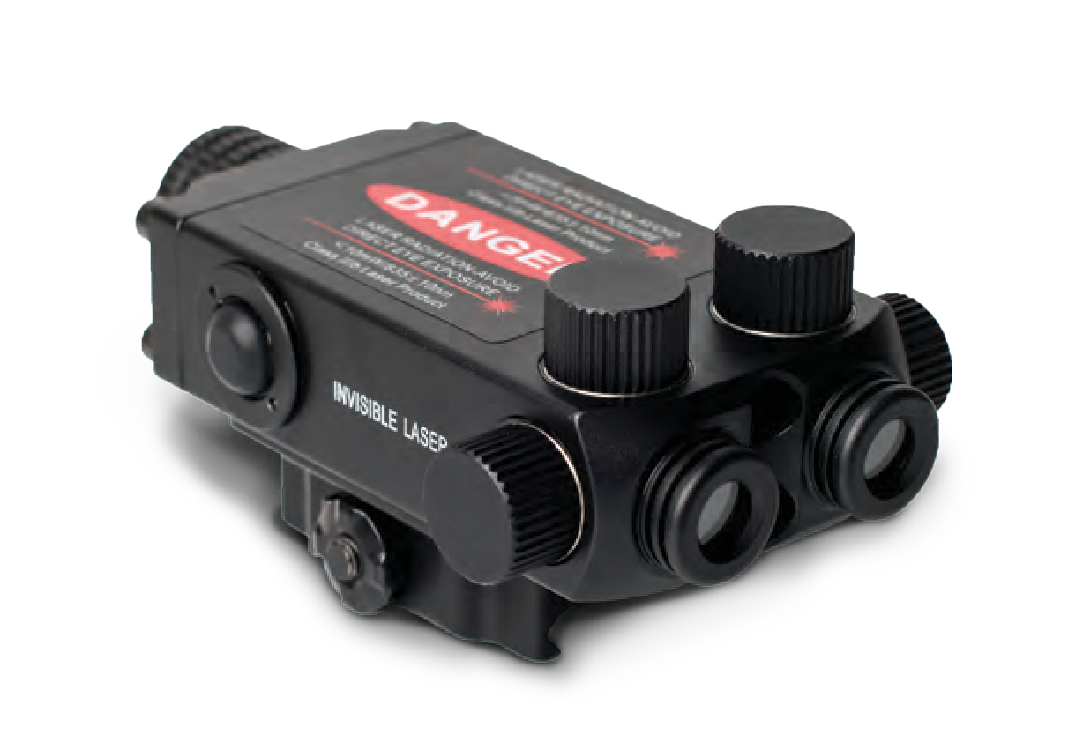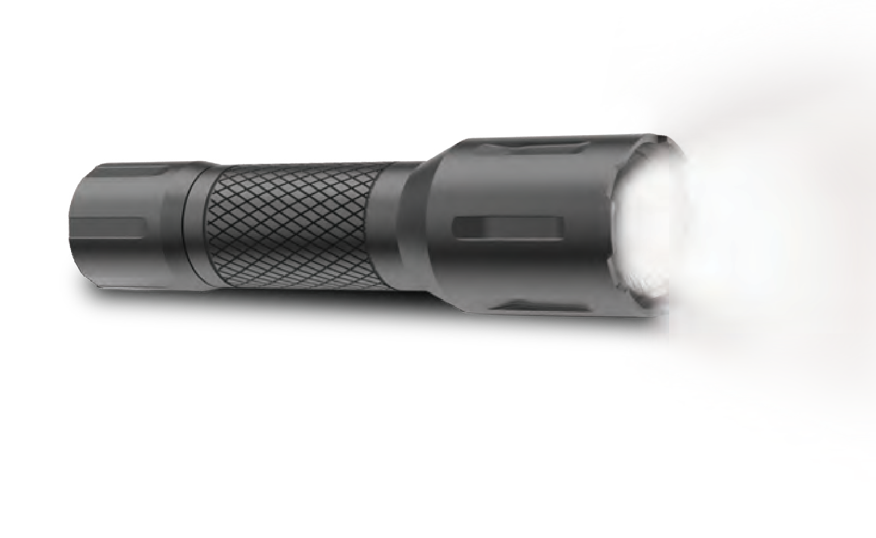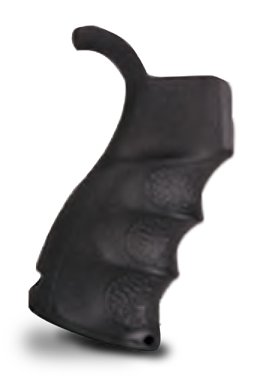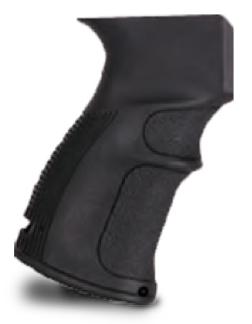
ILLUMINATION
WEAPON ACCESSORIES
Scan The Code
switches or by a remote pressure switch.
Meets MILSPEC standards,
SILENCER
POLYMER MAGAZINE

12 MILITARY AND POLICE EQUIPMENT WWW.TARIDEAL.COM 13

9mm PISTOL
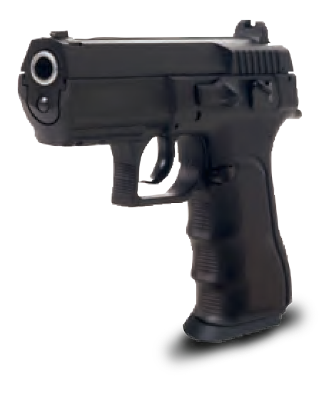
TA03126

M-16

TA04002
Assault rifle. Different stock & barrel length
options, for Infantry, SWAT & Special Forces.

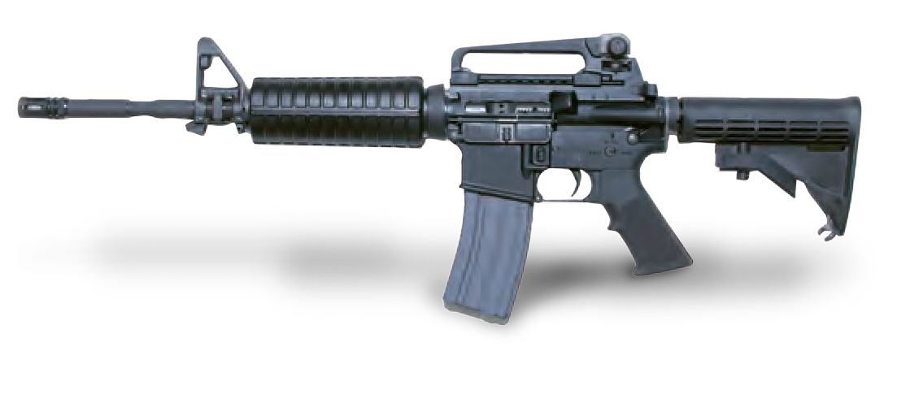

CQB RIFLE

TA03133
This lightweight weapon, approx. 2.7kg, has a telescopic stock to enhance compatibility and comfort. Reaching the extended length of 63.5cm, this weapon is used for short range anti-terror battle and urban settings.
M-203

TA04003
Complete range of 40mm high explosive and special purpose ammunition.

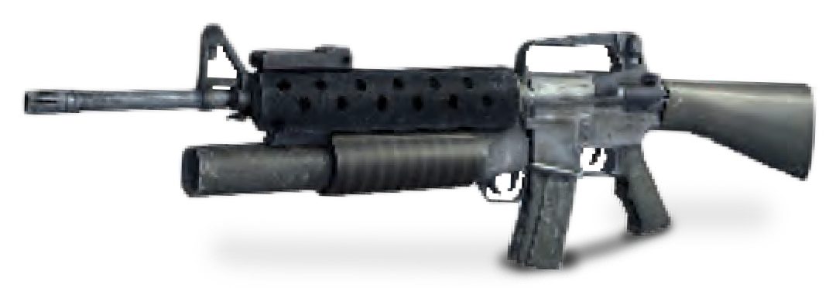

UPGRADED AK-47

TA03198
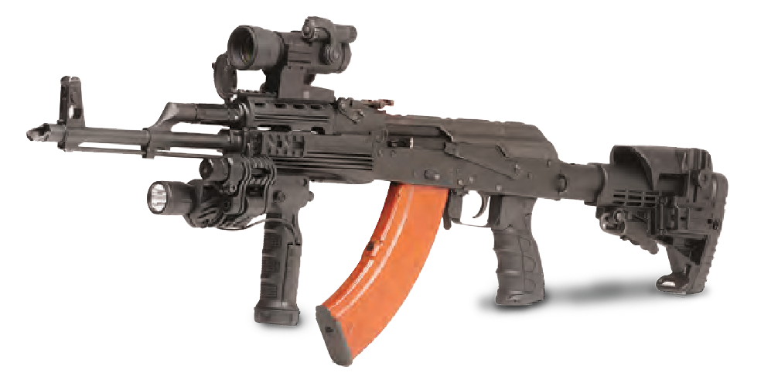This upgraded weapon weighs approx. 5.21 kg and an effective range of up to 400meters. The Upgraded AK-47 has a telescopic stock and has a rate of fire of up to 600 rounds per minute.
MAG

TA04206
The MAG is a multi-purpose 7.62mm machine gun with a range of up to 1,200m. The MAG has been proven as an effective and useful weapon.

7.62 MACHINE GUN

TA04008
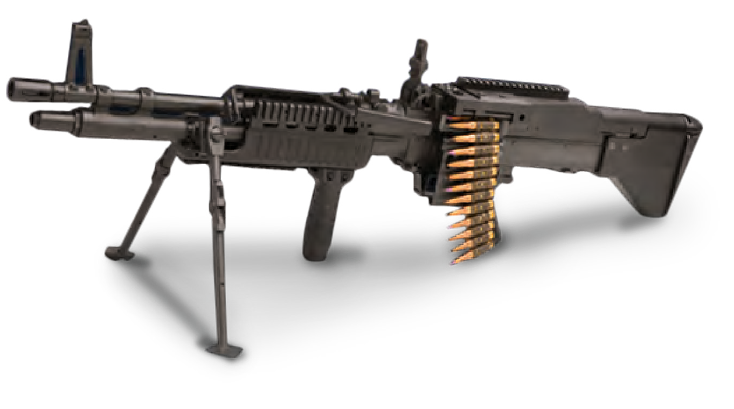7.62mm machine gun. Reliable and user friendly. Light and compact design provides increased mobility and allows for accurate offhand (shouldered), direct fire support.

MORTAR

TA04018
Available: 52mm, 60mm, 81mm, 120mm.

ROCKET LAUNCHER

TA04007
Light Anti-Tank Weapon (one-shot launcher).

MACHINE GUN 0.5

TA04006
Can be fitted to all types of armored vehicles,
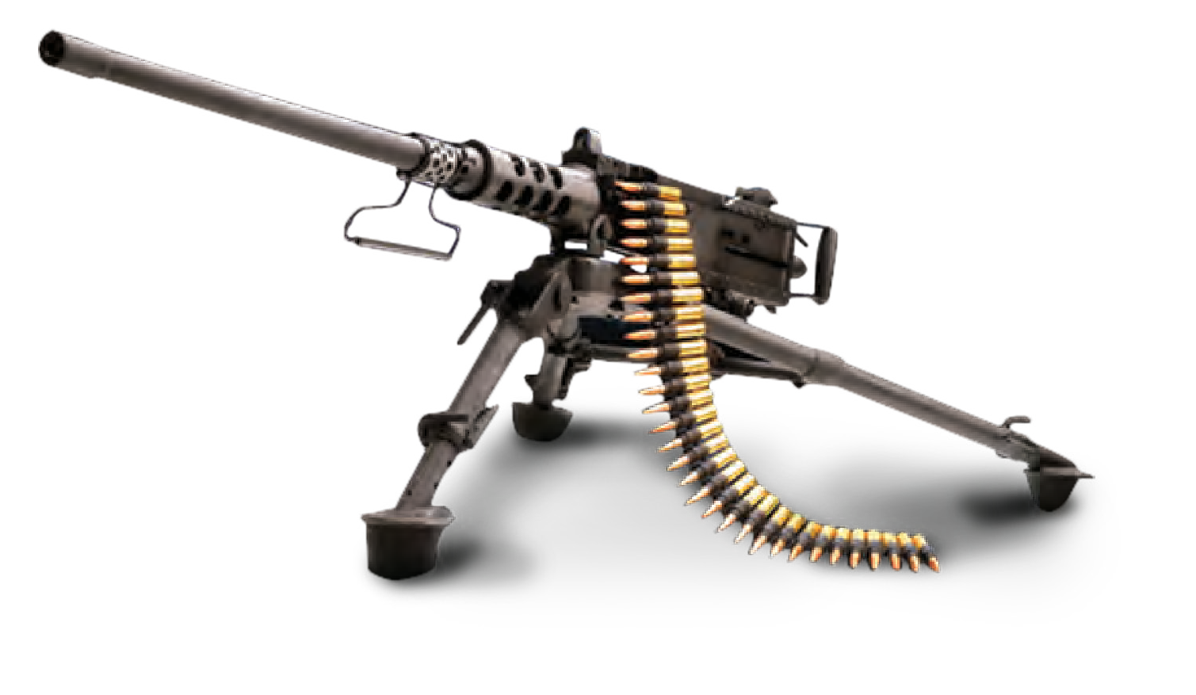patrol boats, helicopters, and aircrafts.

40mm GRENADE BELT-FED LAUNCHER

TA04005
40x53mm ammunition. Effective range up to 1,500m. Can fire from a tripod mounted position or from a vehicle mount.

R.P.G.

TA04009
The RPG is a portable, unguided, shoulder-launched, anti-tank rocket-propelled grenade launcher.

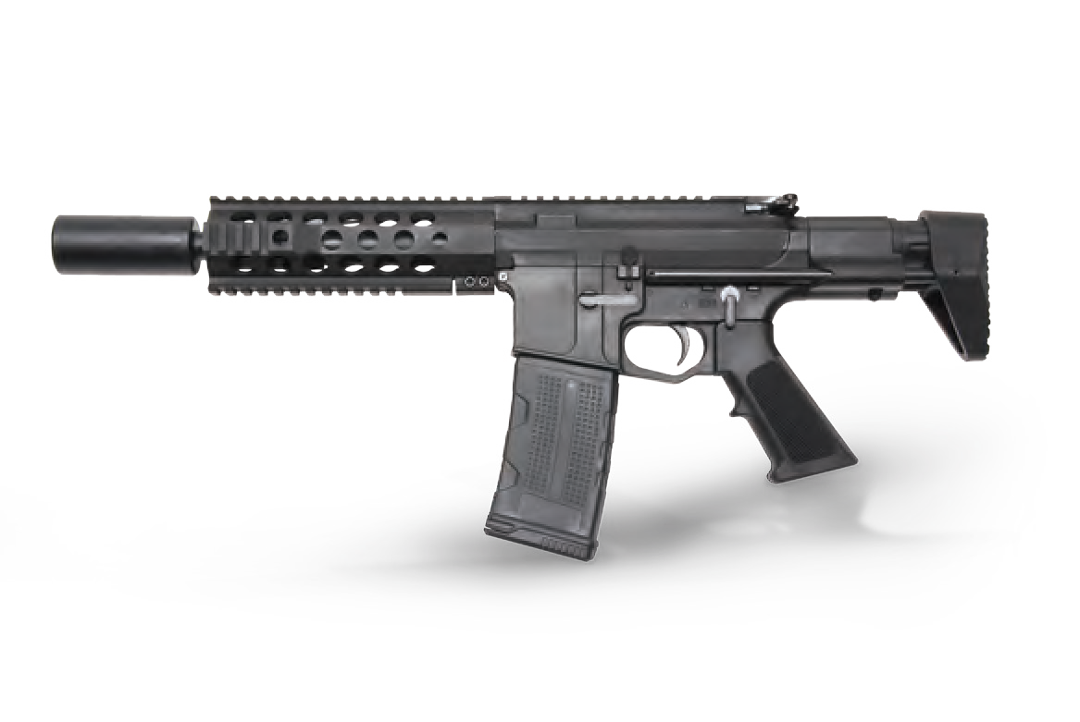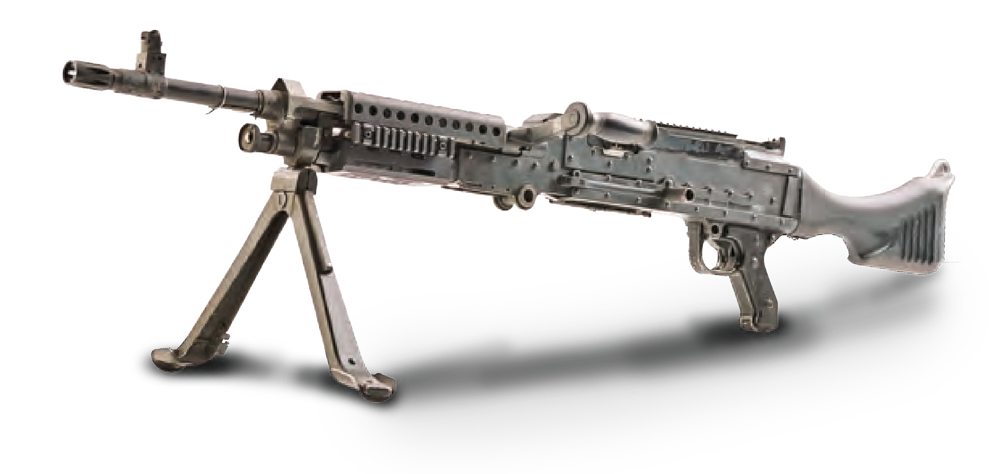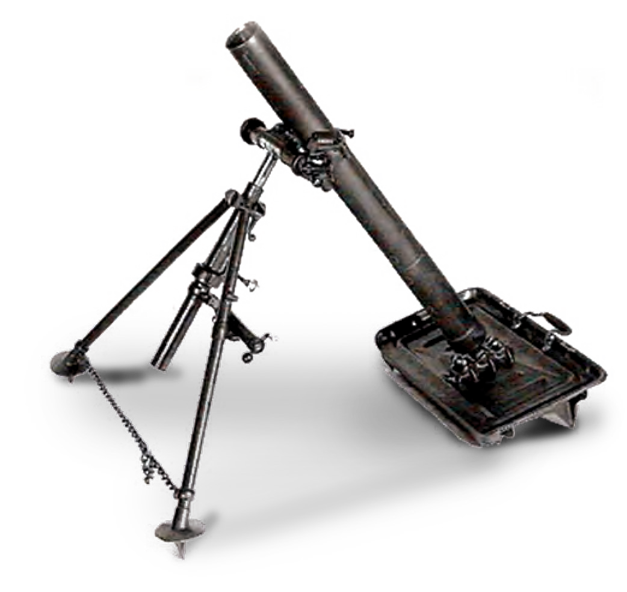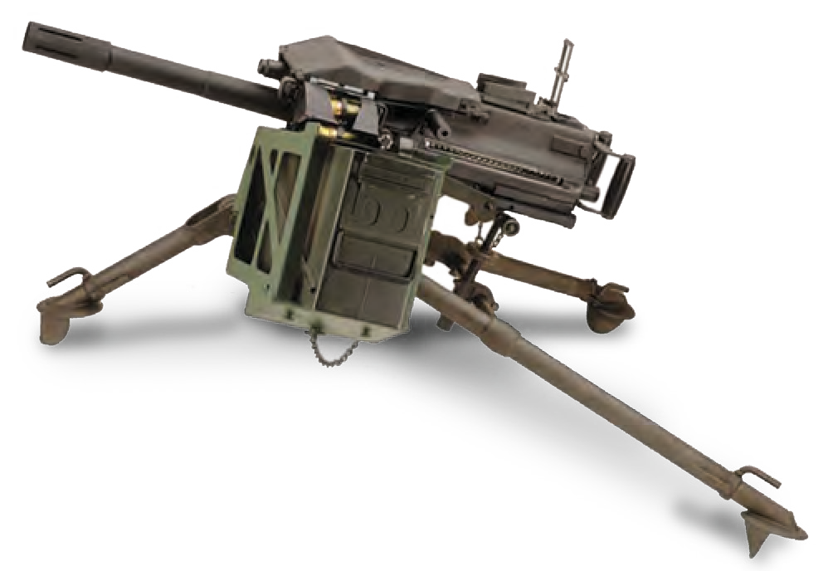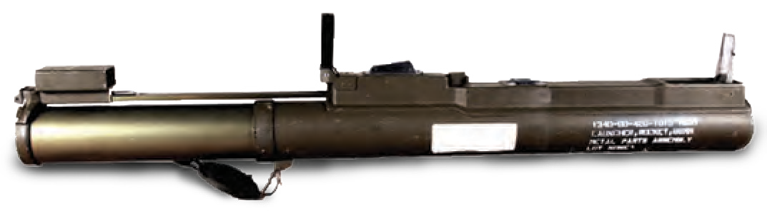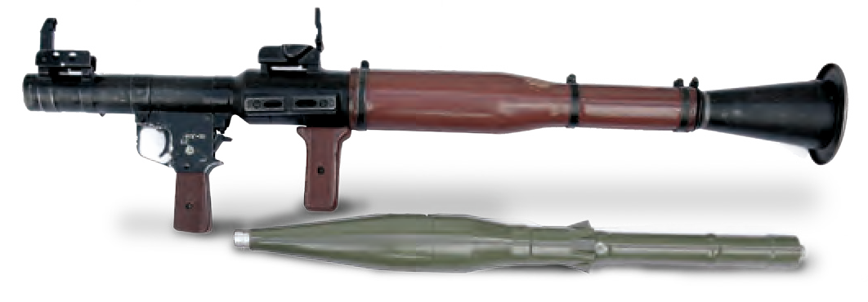
WEAPONS
Scan The Code

14 MILITARY AND POLICE EQUIPMENT WWW.TARIDEAL.COM 15

9mm

TA04015
7.62mm
TA04012

40mm GRENADE - HV/LV
TA04020

FRAGMENTATION HAND GRENADE

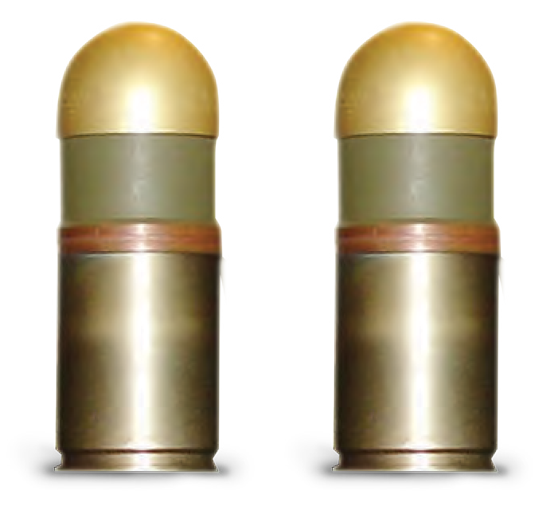
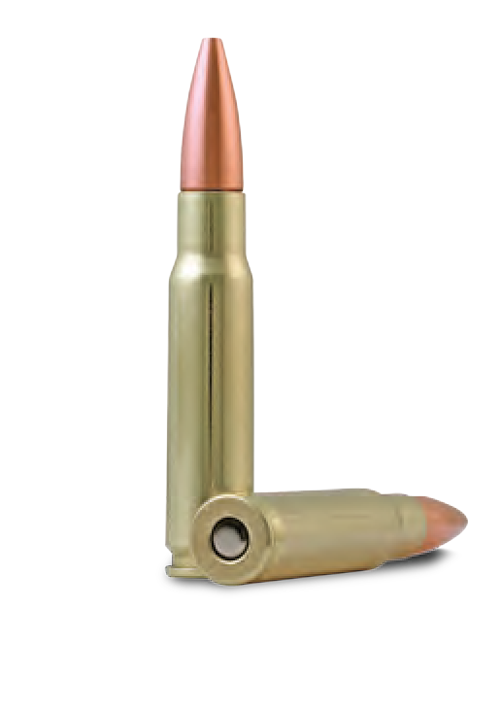
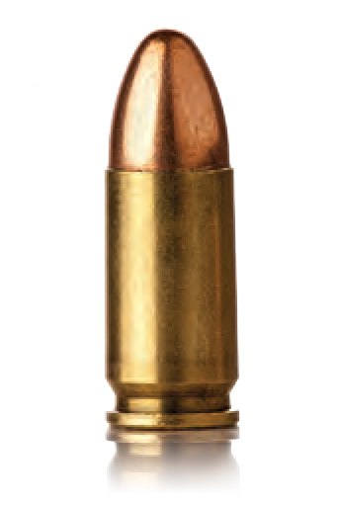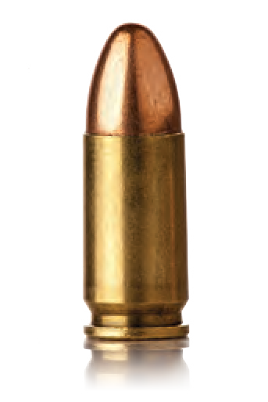7.62X54, 7.62X51, 7.62X39 40 X 46, 40 X 53

SUBSONIC AMMO

TA04021
Effective range: 5-12m.

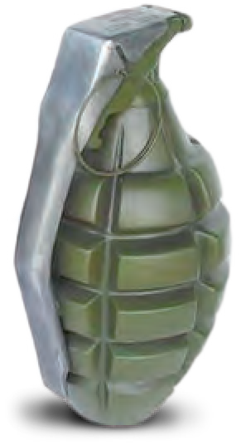

5.56mm

TA04011
Types: Ball, Tracer, Blank, Dummy, Non-Bullet, M193 / SS109

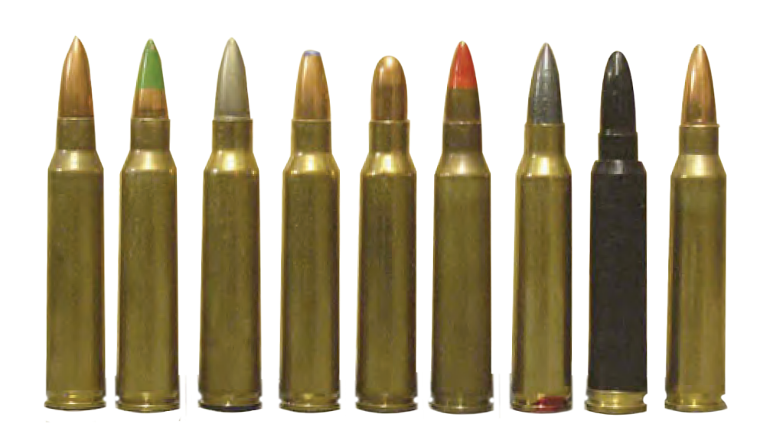

LINKED AMMO

TA04001

TA02093

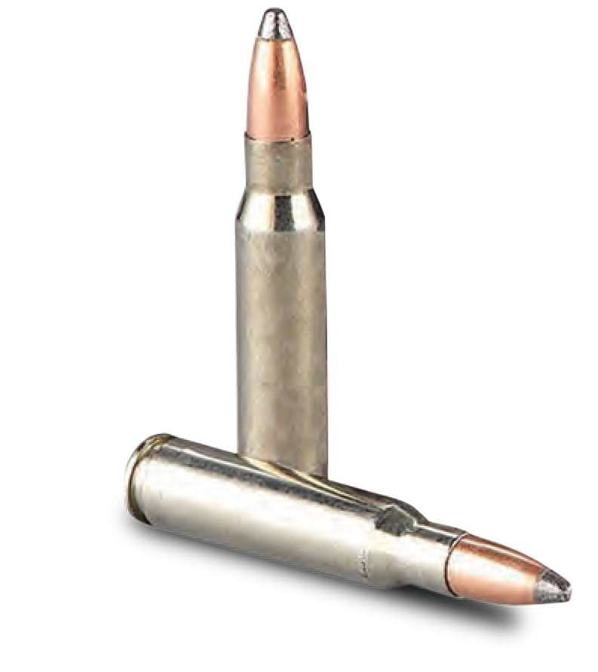
SNIPING AMMO
TA02025

FLASH & BANG

TA03188
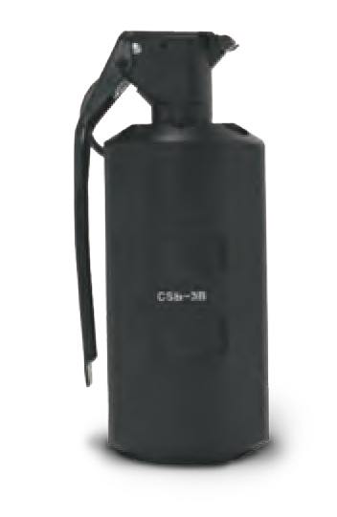
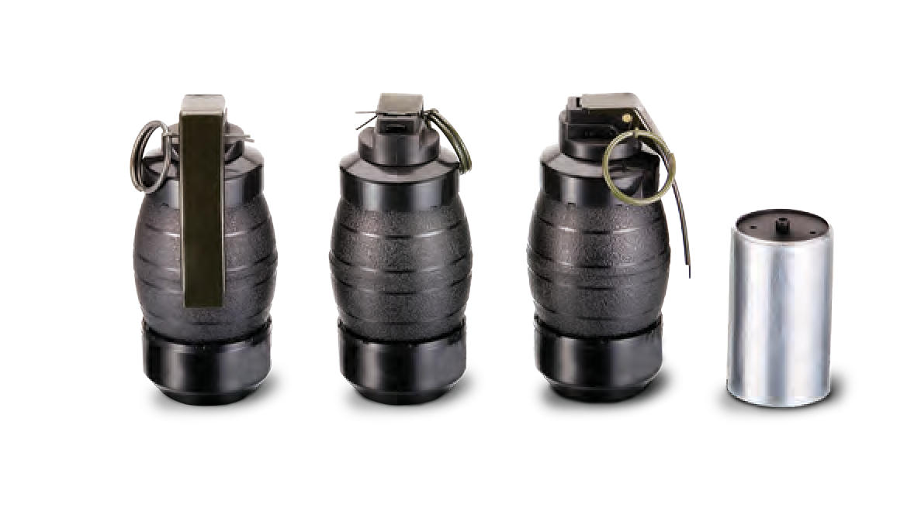
Designed to create a distracting and disorienting effect in combat field situations or during tactical entry.

ILLUMINATION ROCKET
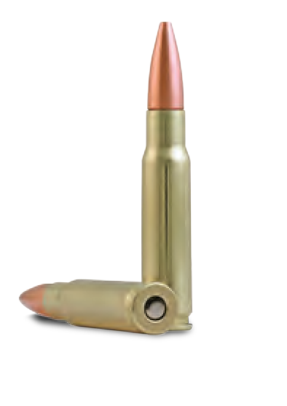
TA04123

CS GRENADE

TA03190
Tactical CS Gas Grenade. Useful especially for Anti-Riot and Law Enforcement.

MORTAR BOMB
TA04122

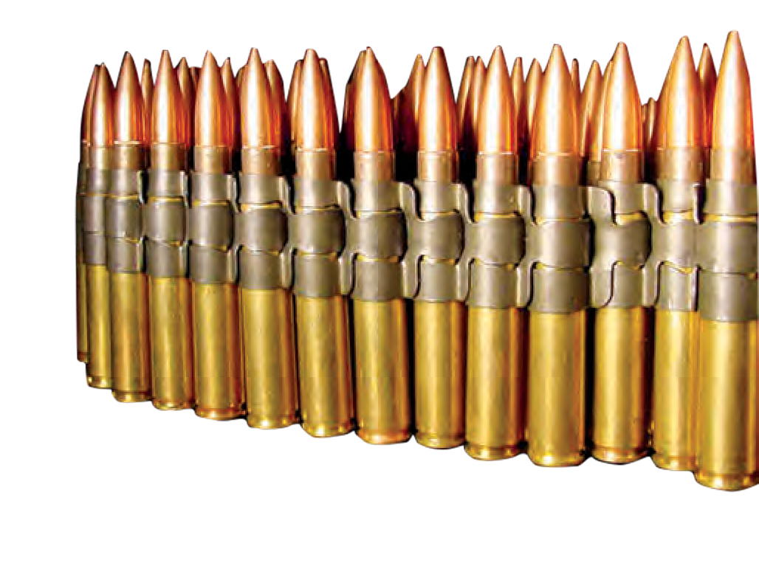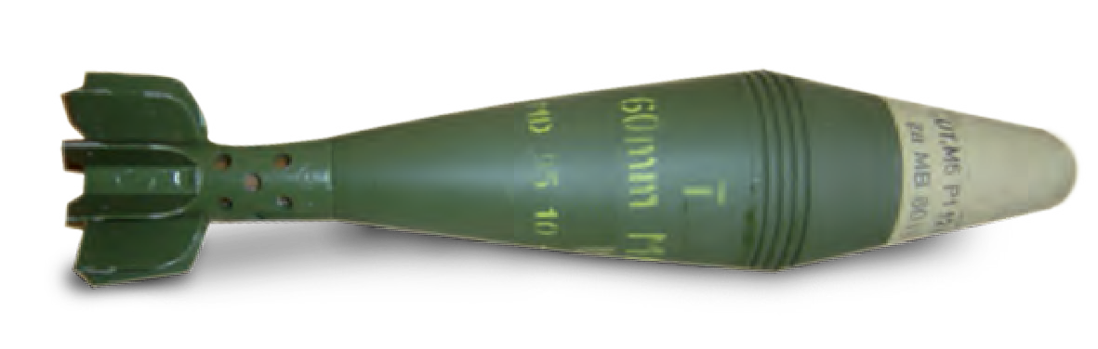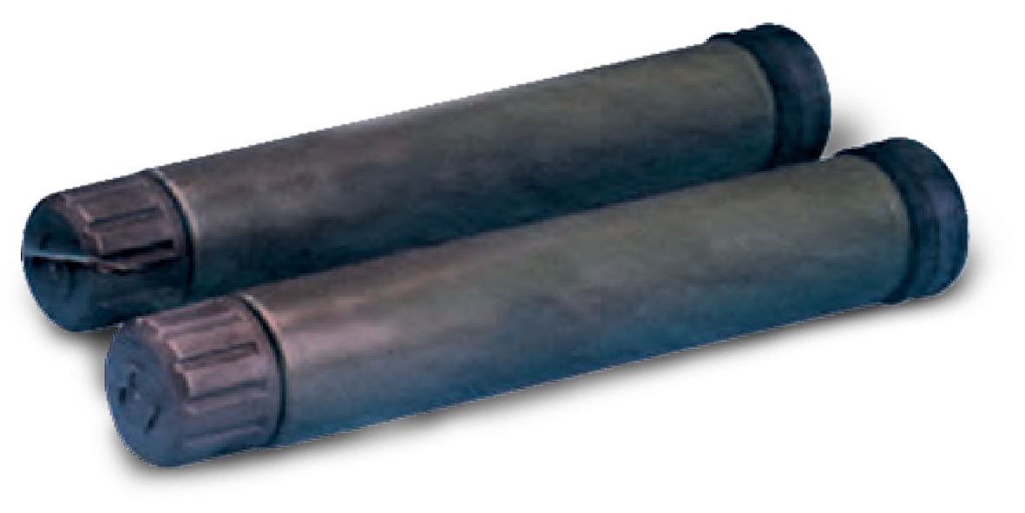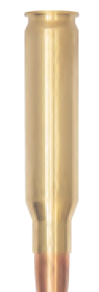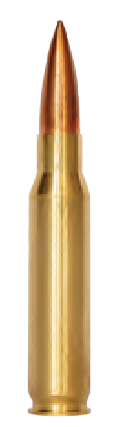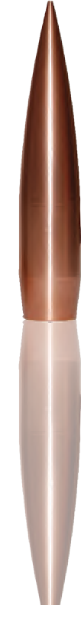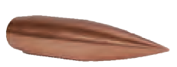
Long range ammunition.
Manual illumination rocket: Range:
300, 600 ,1000 meters.
HE / NT / Illumination. Available:
52, 60, 81 and 120mm.
0.308
0.5
16
MILITARY AND POLICE EQUIPMENT
WWW.TARIDEAL.COM
17
AMMUNITION
Scan The Code

0.338

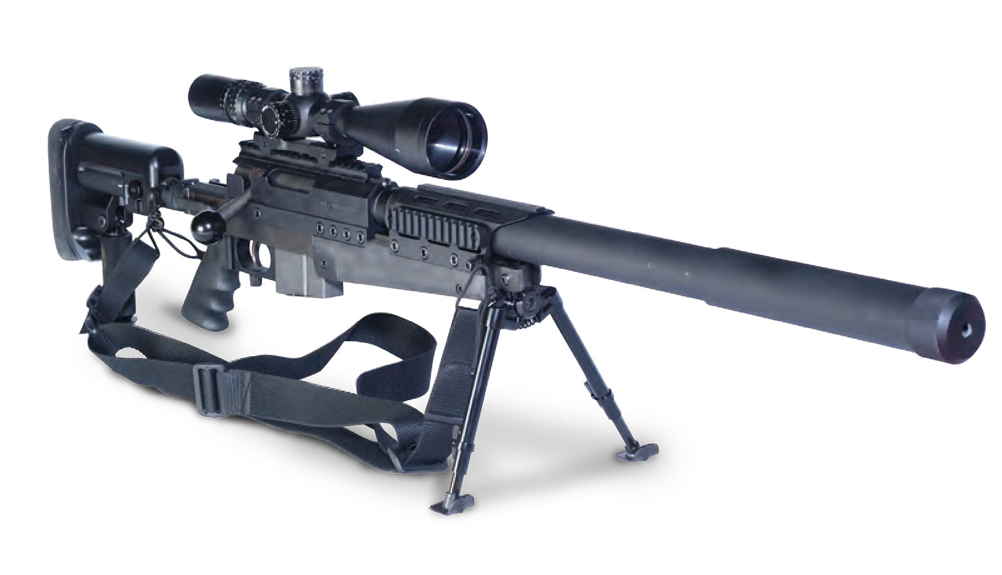 .308 SNIPER RIFLE

TA04163
Caliber: 7.62 x 51mm NATO.

SNIPER MANAGEMENT SYSTEM

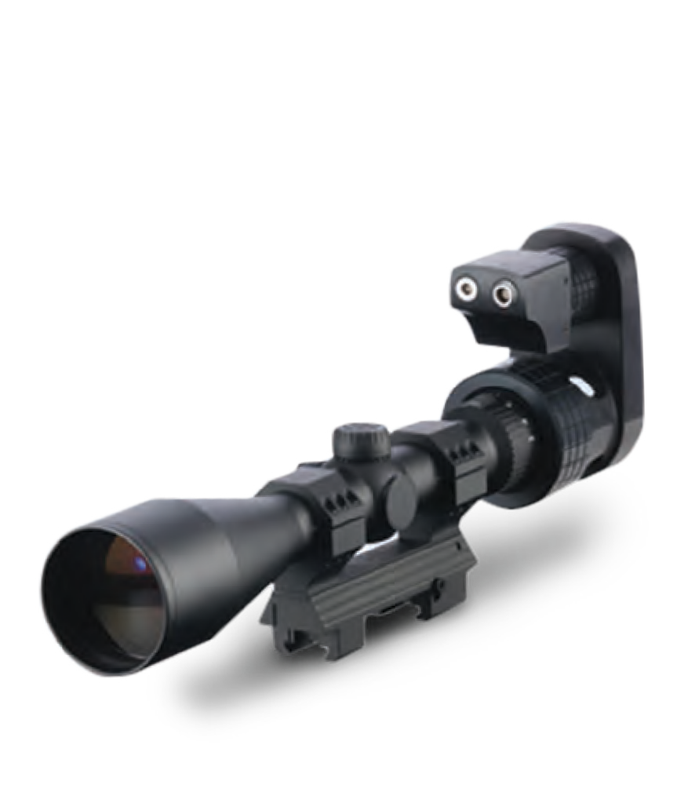
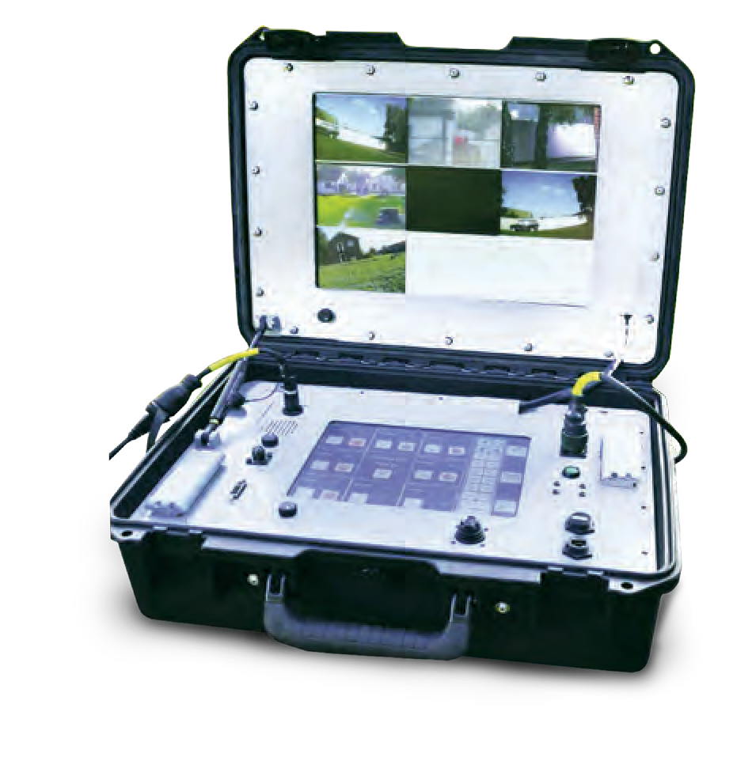TA02034

POCKET WIND METER
A real-time integrated video, audio and data communications system which allows remote decisions to be made.

.338 SNIPER RIFLE

TA02021
A long-range high-precision rifle. Intended for the trained marksman, this weapon is designed to shoot targets at up to 1200m and beyond.
Caliber: 0.338

7.62 SEMI AUTOMATIC RIFLE

TA02023
The 7.62 mm delivers long range precision, rapid fire, and enables execution for long range missions. High capacity, quick change magazines enable ammo selection optimization in both the suppressed and unsuppressed firing models.

LASER RANGE FINDER

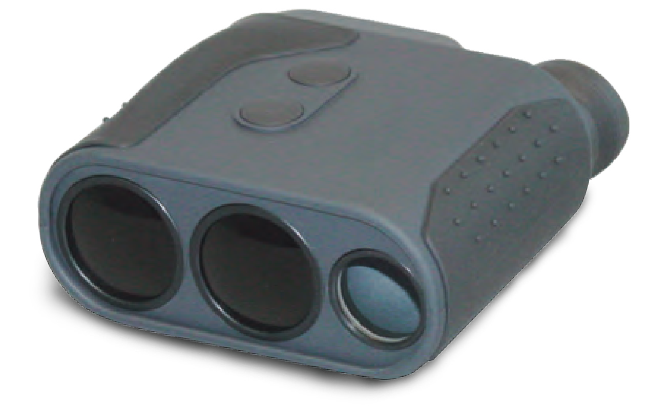TA04028
Provides instant distance and speed
measurements.

TA04025
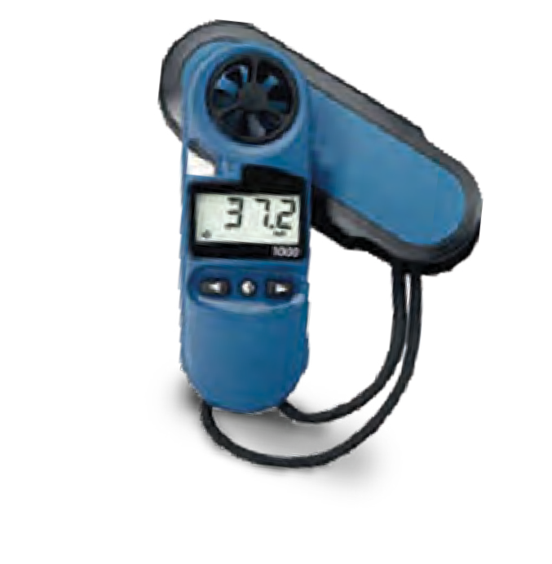
Water resistant and buoyant. Wide range of wind speeds and low startup speed.

OPTIC DETECTOR (LONG RANGE)
TA02035

SPOTTING TRIPOD KIT

TA02033
Tactical tripod with LRF, IR and visible pointer and scope.

SNIPER RIFLE 14.5X114
TA04165

LONG-RANGE SNIPER RIFLE

TA02022
Tactical Rifle – 50 caliber.
Detects passive optical and electro-optical devices such as binoculars, night vision devices, weapon sites, etc.
LRF

SPOTTING SCOPE

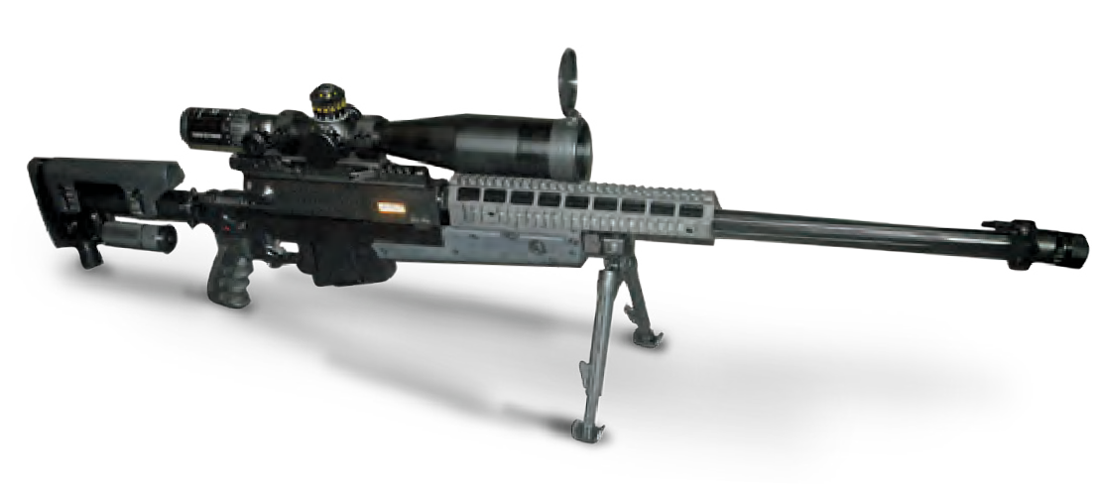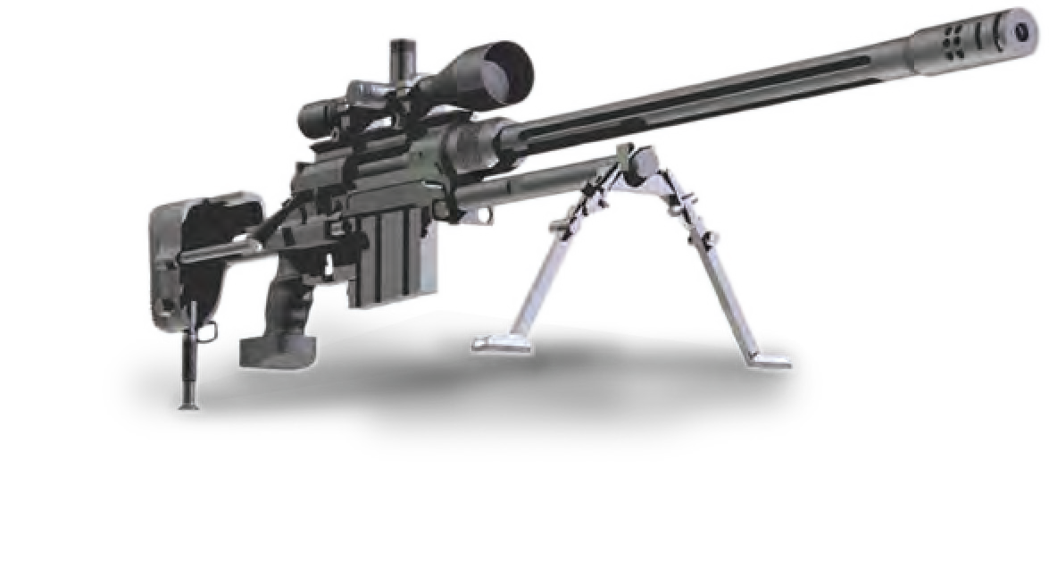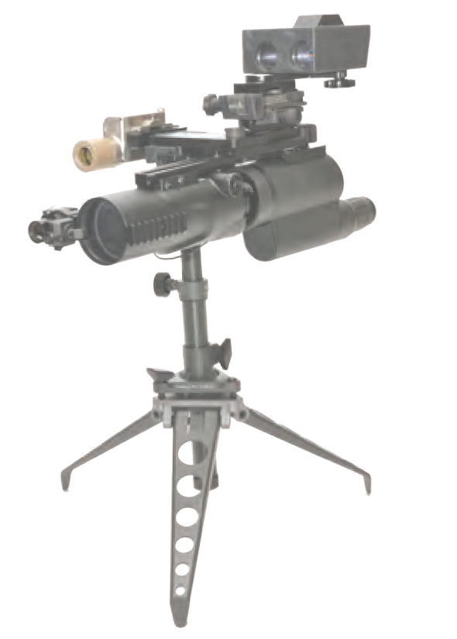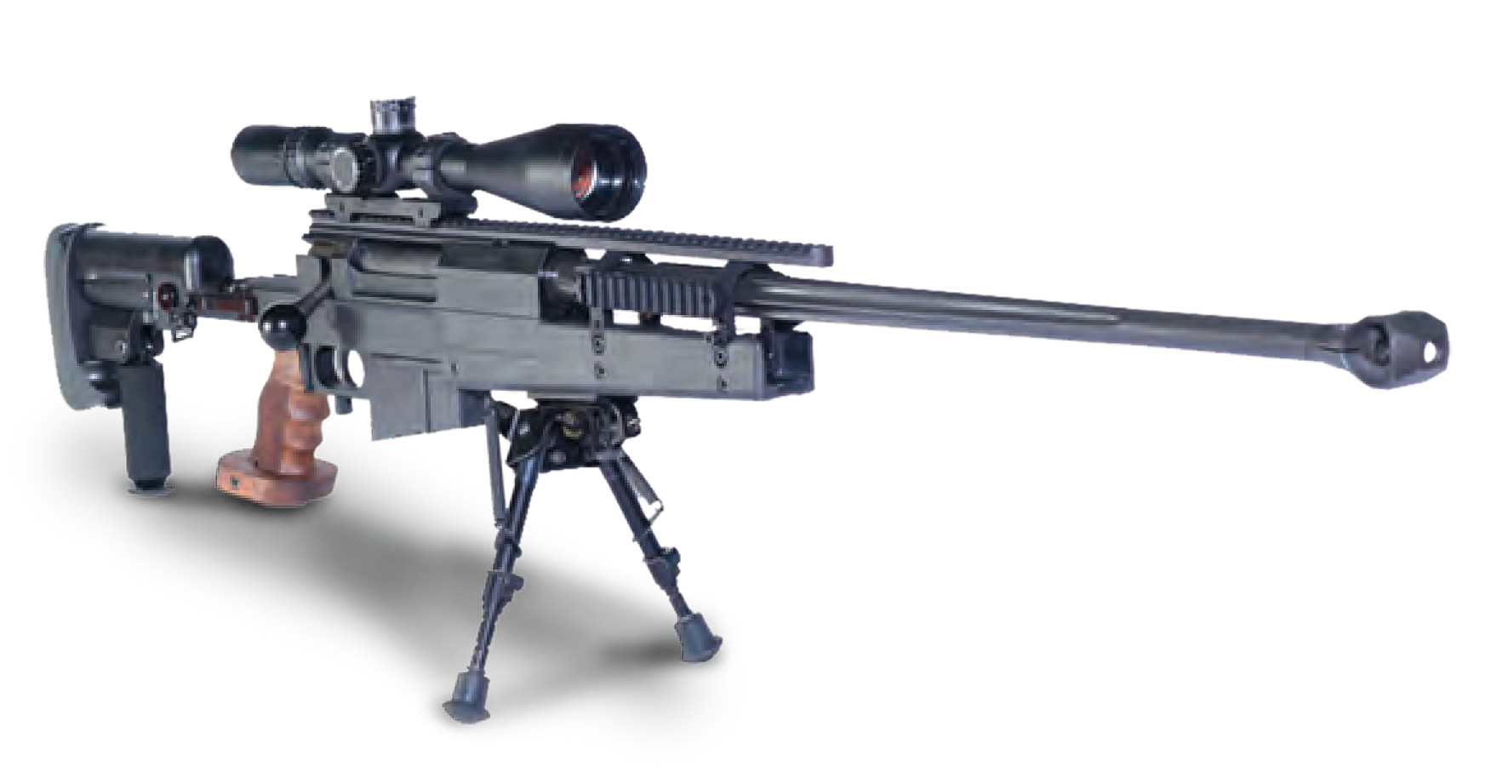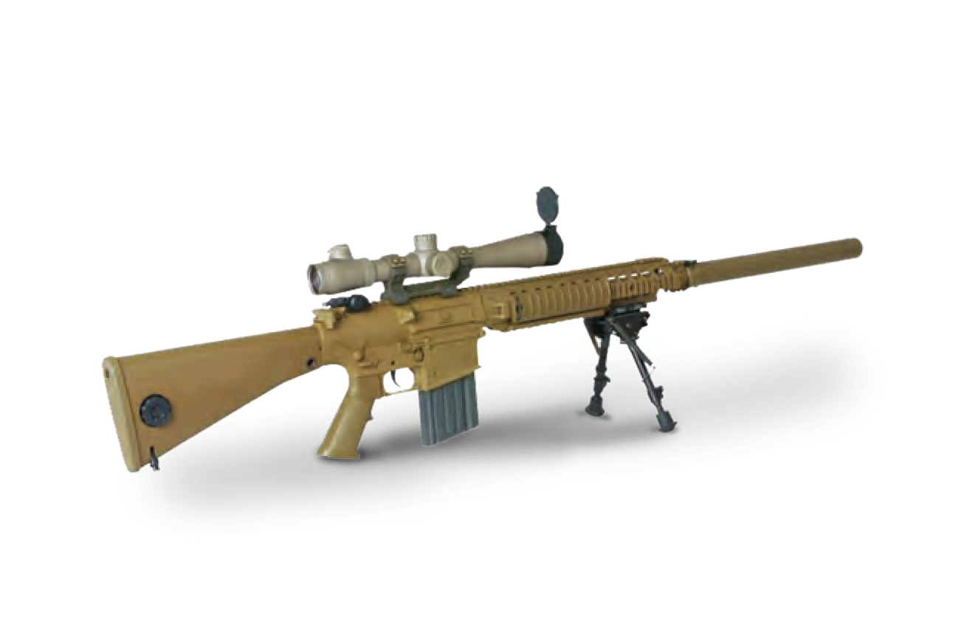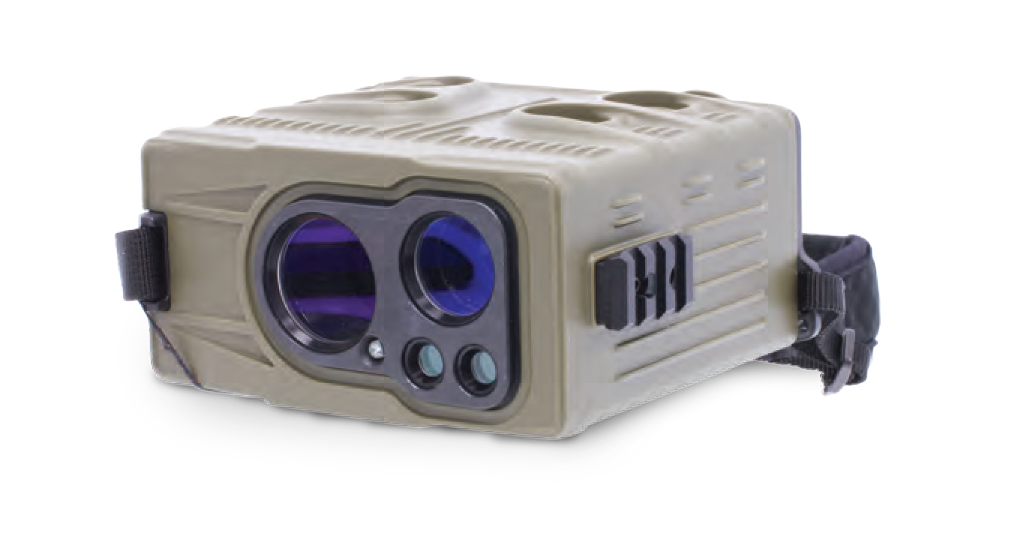
SNIPING
SNIPING ACCESSORIES
Scan The Code

18 MILITARY AND POLICE EQUIPMENT WWW.TARIDEAL.COM 19

CAMOUFLAGE

Scan The Code

CAMOUFLAGE KIT

TA04030
Camouflage is used for concealment and disguise, to minimize the detection or identification of troops, weapons, equipment and installations, includes taking advantage of the immediate environment as well as using natural and artificial materials.

The kit includes:
Hammer: 1
Secateurs: 2
Insulating tape: 5
S.P. pipe: 5
S.O.F. brush: 2 Hard brush: 2 Strings: 5
Camouflage net
(2m x 4m): 1
Canvas (2m x 4m): 1 Glue spray: 5
Soil bag: 5
Shovel: 2
Wire: 10 Aluminum rods:10

Develop & design unique solutions for:
Combat Personnel Vehicle
Sensors & Cameras

GHILLIE SUIT
TA04168

NIGHT TIME GILLIE SUIT

TA02119
Worn at night the camouflage suit makes the wearer invisible to the naked eye. Fire redundant. Optional thermal protection.

SNIPING CAMOUFLAGE KIT

TA04166
A perfect solution for blending in with the surroundings to breakup the distinctive human shape.

CONCEALED CAMERA
TA04169

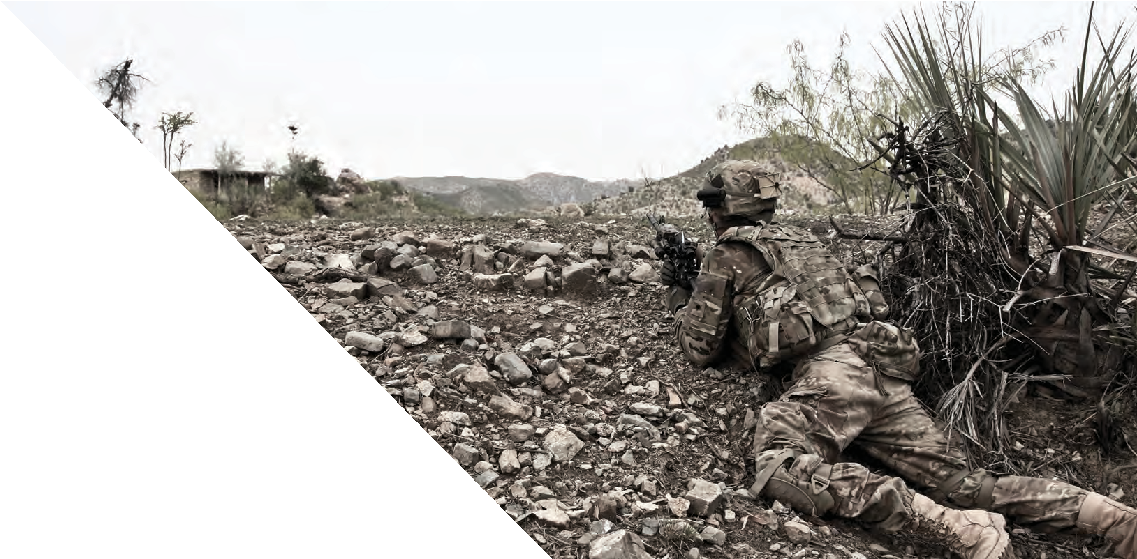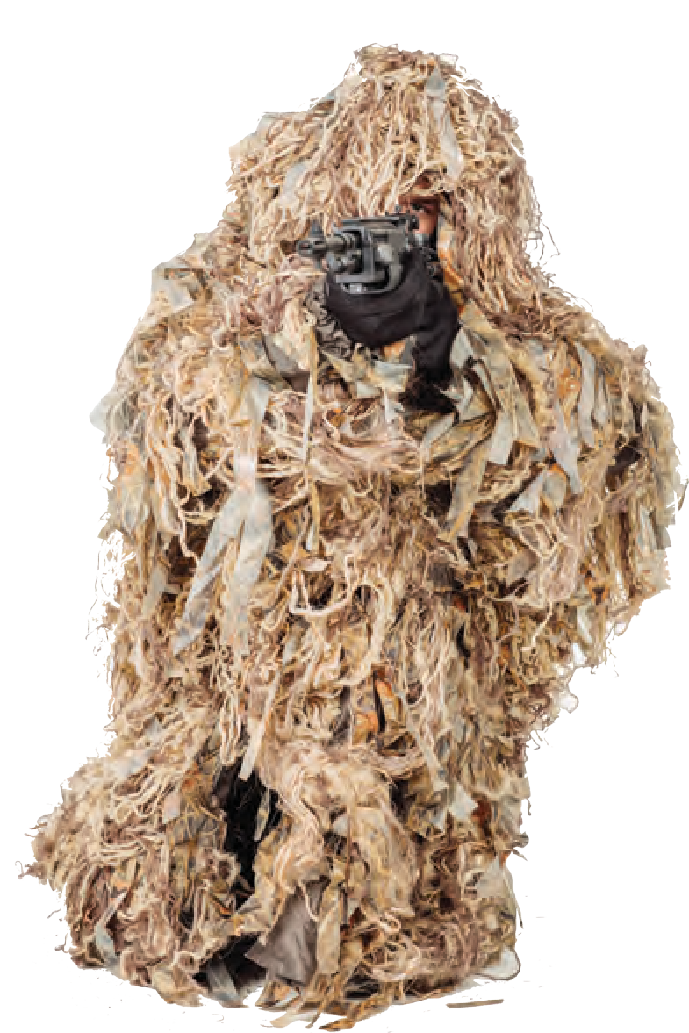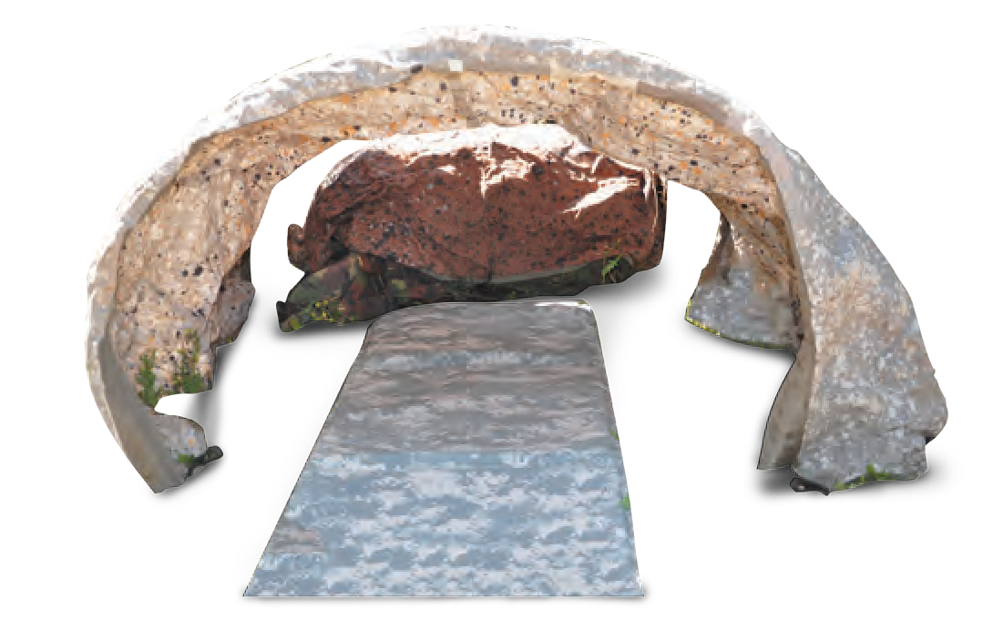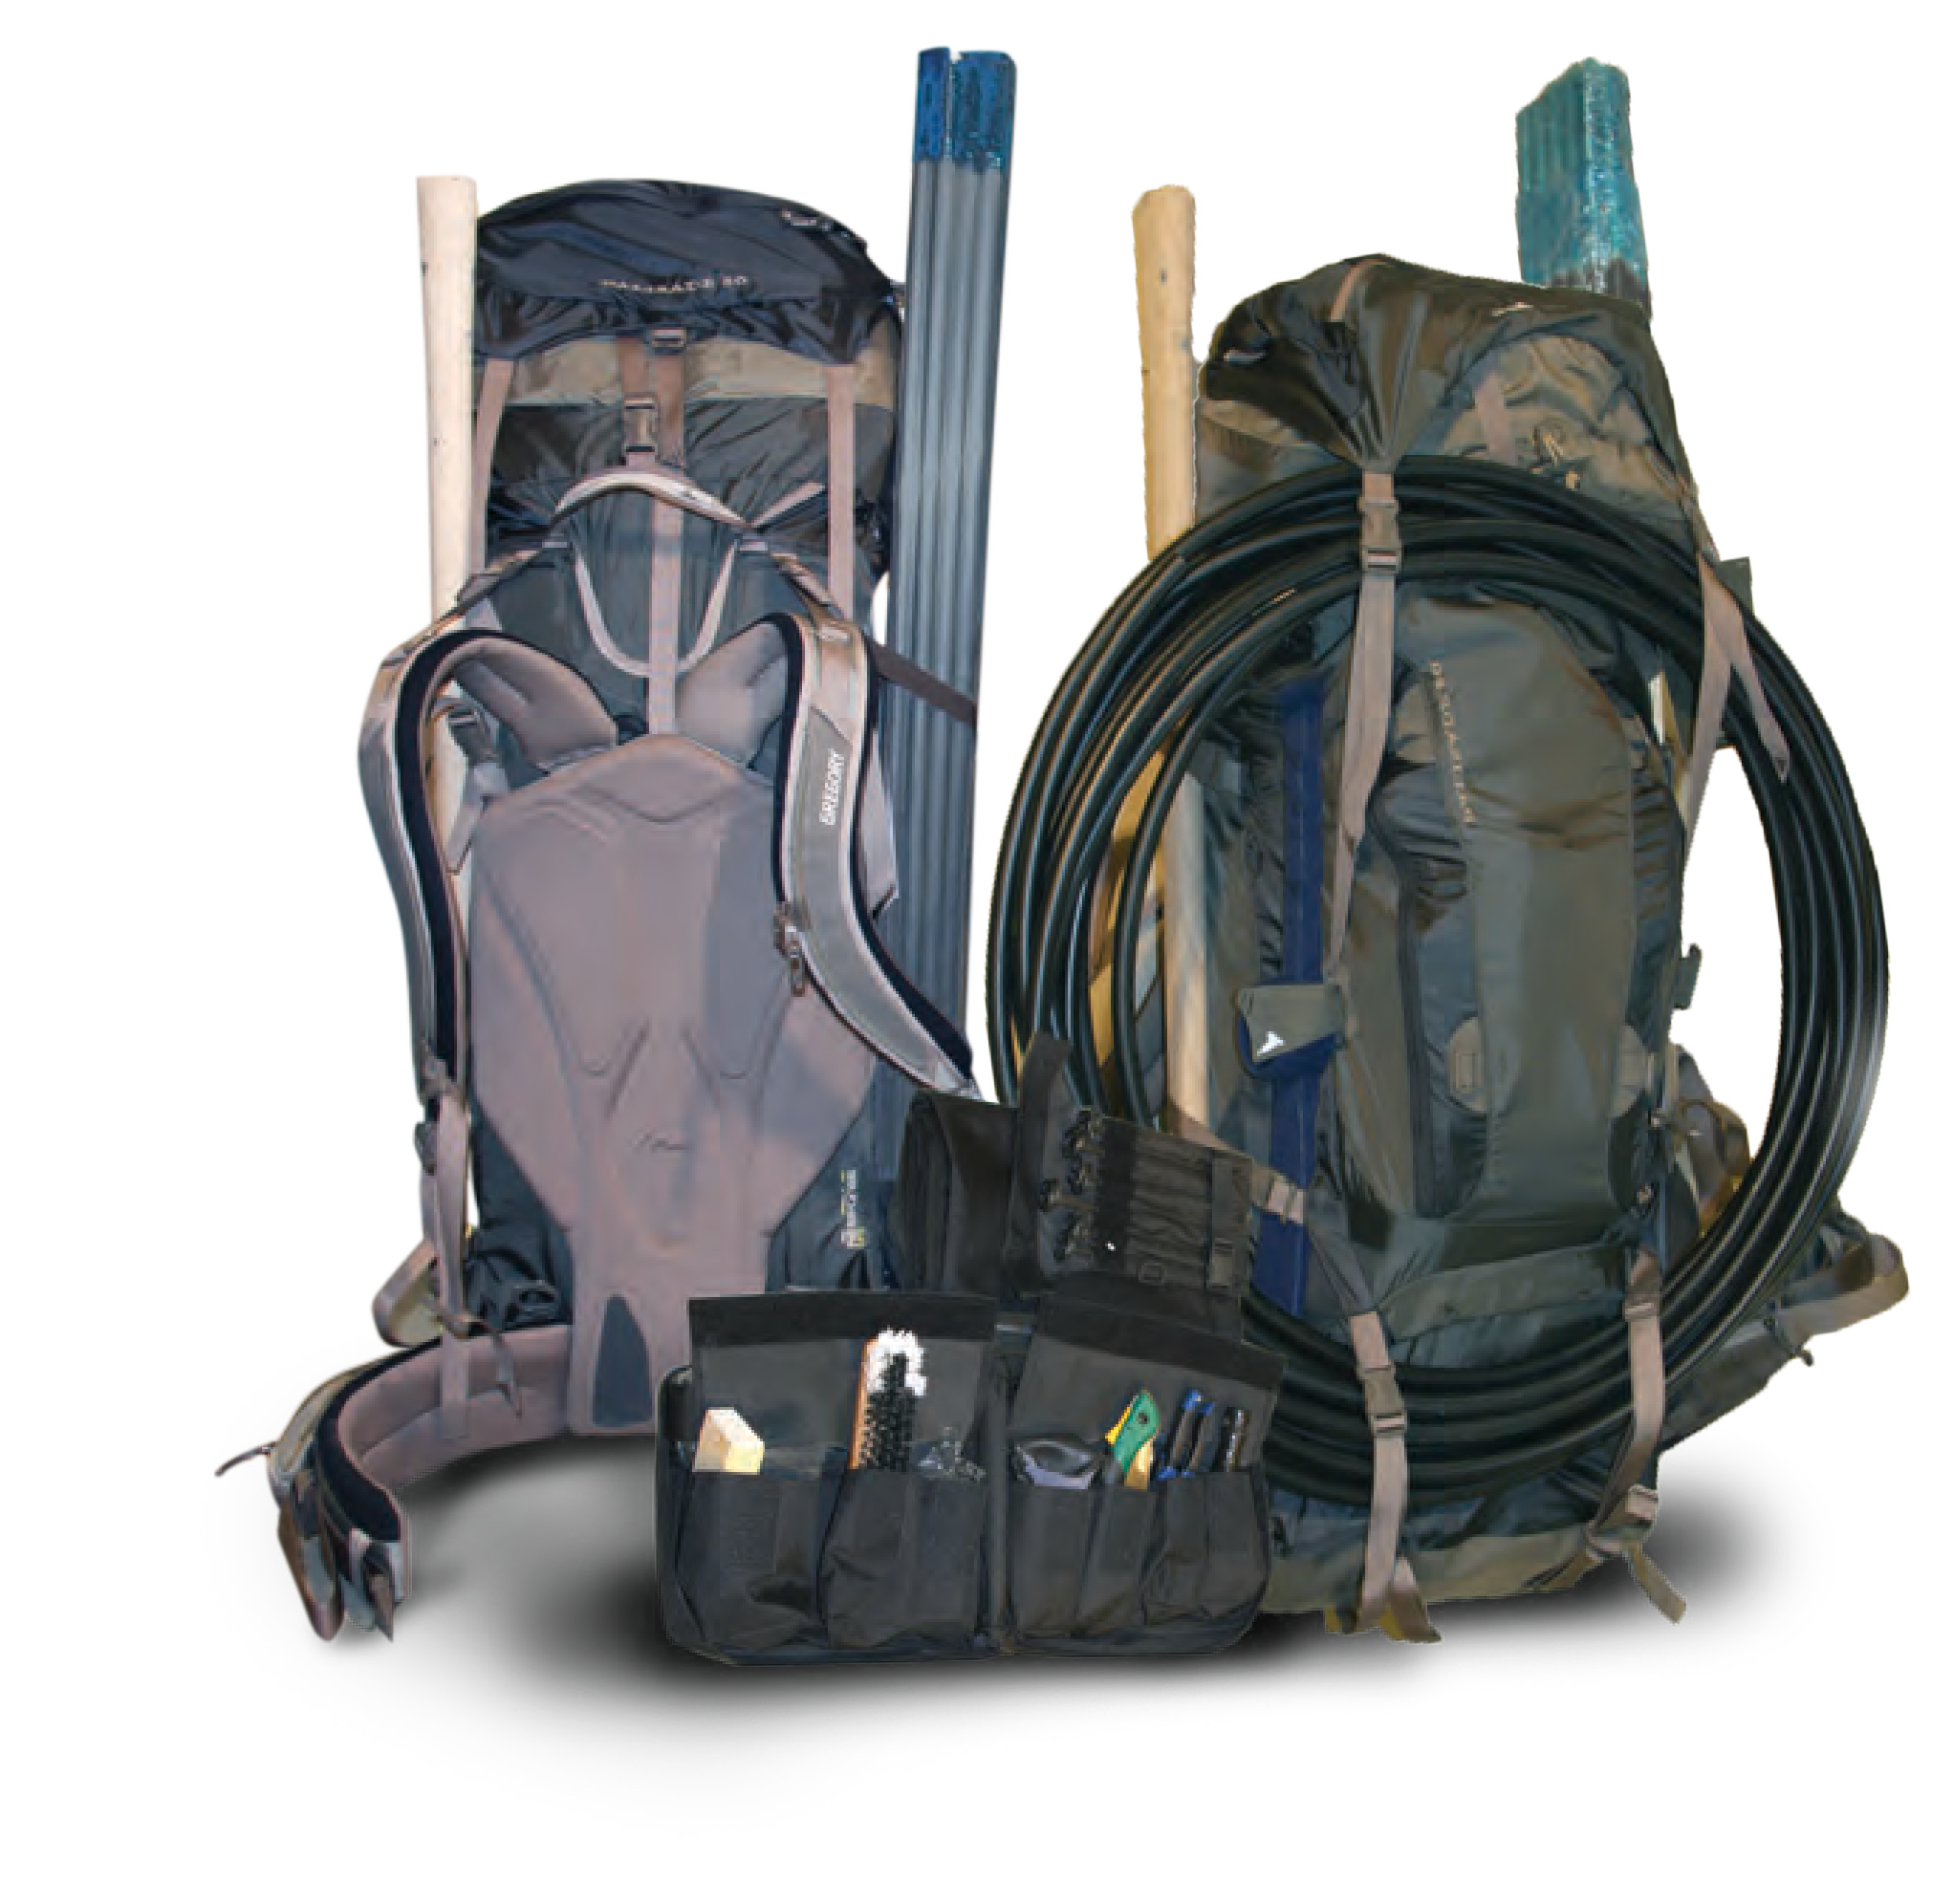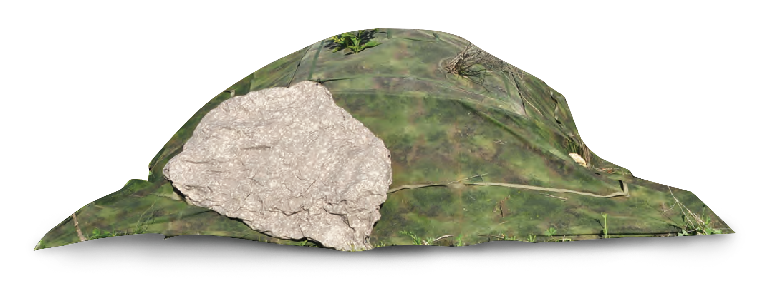
20
MILITARY AND POLICE EQUIPMENT
WWW.TARIDEAL.COM
21

PARACHUTE RESERVE PARACHUTE CANOPY
TA04042 TA04043

ALTIMETER
TA04170

ALTITRACK ALTIMETER

TA04301

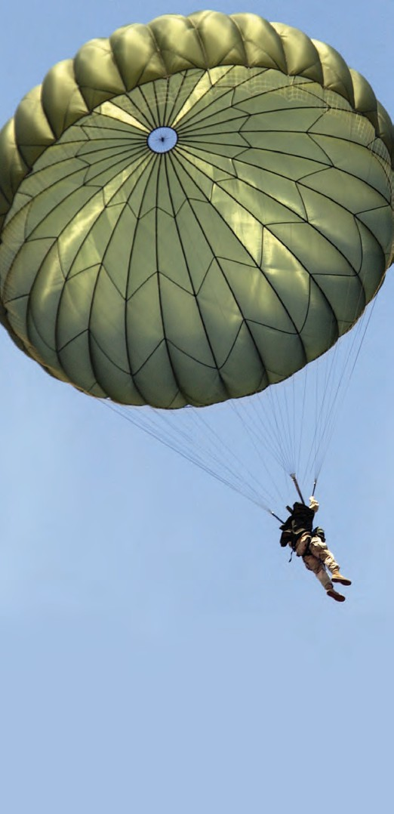
The parachute is steerable with anti-inversion netting. Minimum air passes through the material enabling a slower than normal descent and softer landing. Used during higher field elevations or descending with heavy payloads.
Reserve emergency parachute for maximum load. Can be folded in deployment bag.

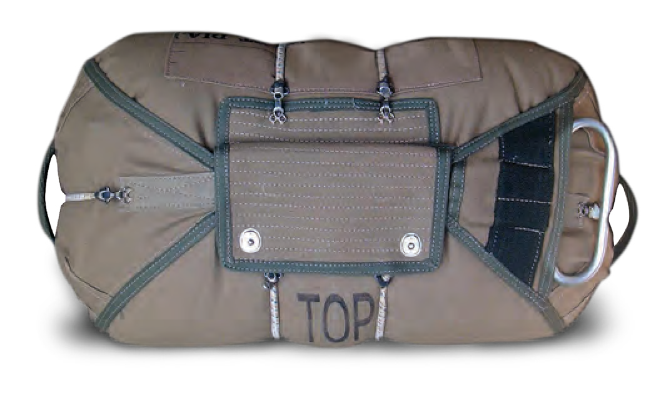

CARGO PARACHUTE

TA04044
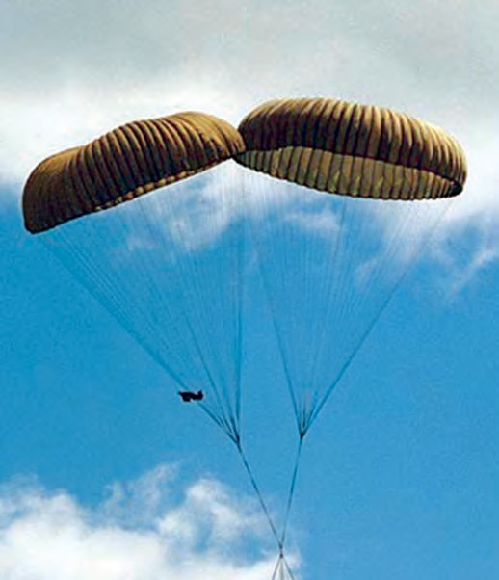
Parachute delivery of non-fragile equipment using a high-velocity air delivery method.

CYPRES

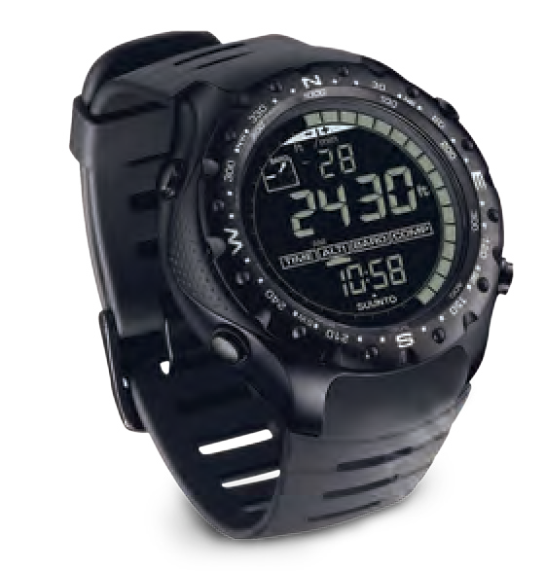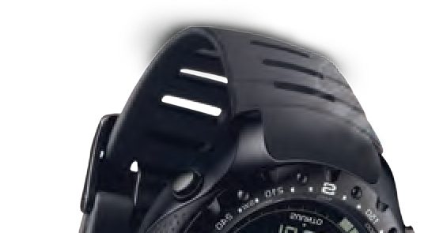TA04171
Can be operated manually or automatically.
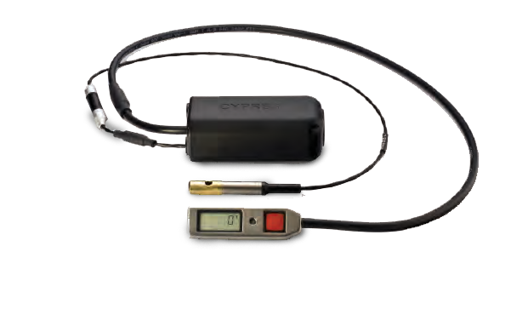

SUPREME HEADSET

TA04172
Designed to be connected to a push-to-talk system and a communication radio. Waterproof microphone and loudspeakers.
Withstands extreme variables in both heat or cold conditions

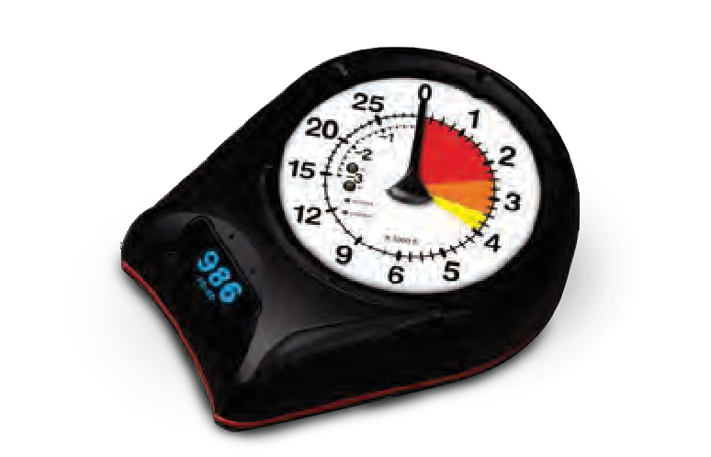
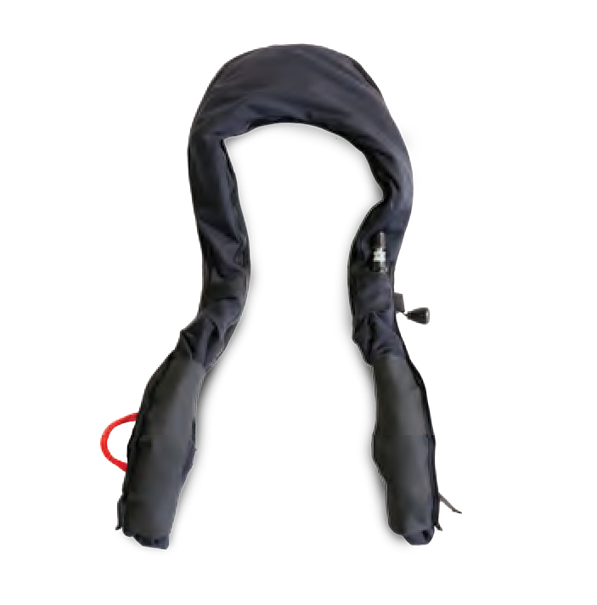
INFLATABLE FLOATATION SYSTEM

TA04303
Provides the appropriate amount of lift necessary to bring to the surface and float in a face-up orientation.

SKYDIVING HELMET

TA04302
Provides unbeatable comfort and field of vision. High polycarbonate visor provides protection against hits while maintaining an undistorted view. No pressure points.

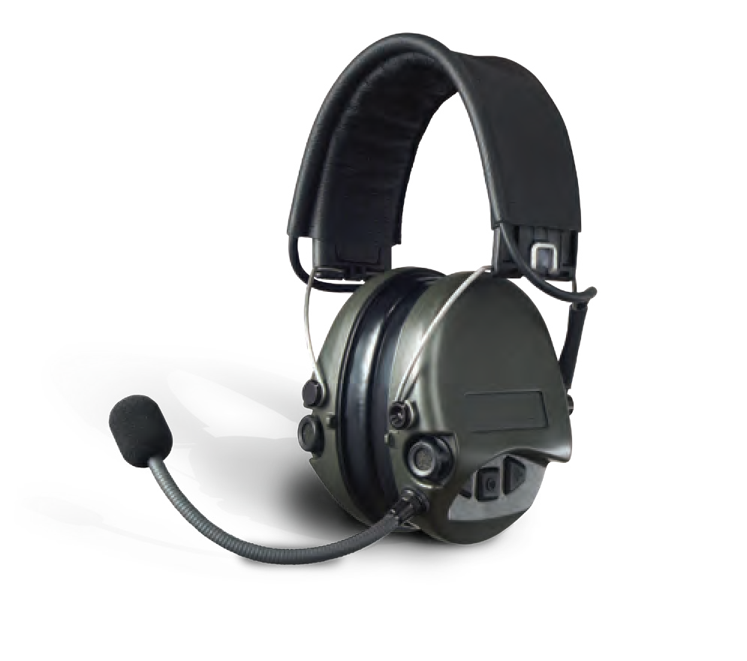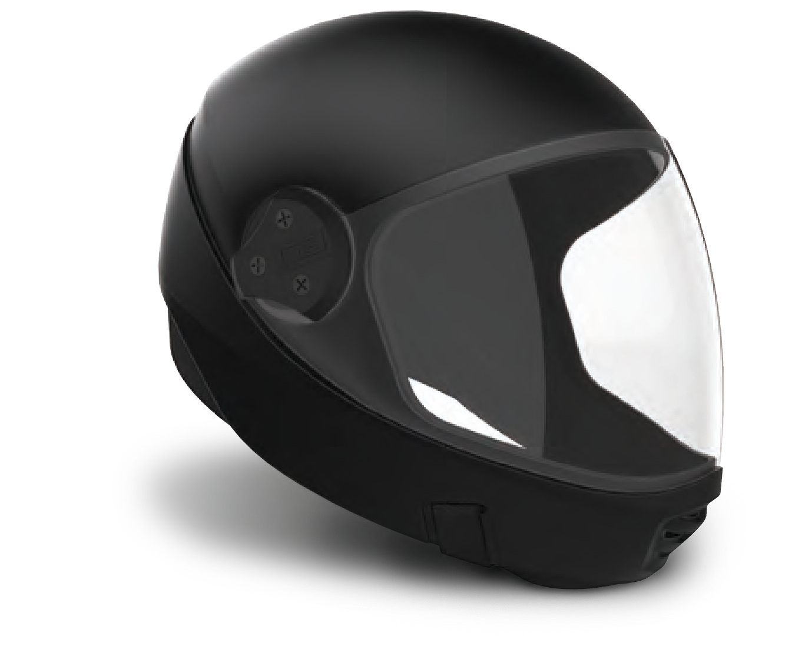
PARACHUTING
ACCESSORIES
Scan The Code

22 MILITARY AND POLICE EQUIPMENT WWW.TARIDEAL.COM 23

MINI EXPLODER
TA01042

NONEL SYSTEM
TA01085

MEDICAL TENT FIELD HOSPITAL

TA04116 TA04117

A one handed operation exploder, operating from
commercial “off the shelf”: batteries. Utilizes
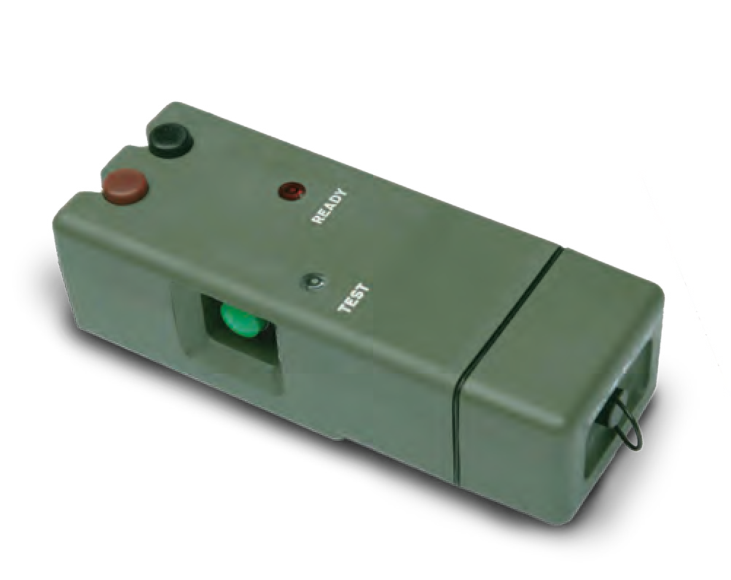
proven technology for a variety of EOD and IED
applications.
DOOR BREACHING EXPLOSIVE

TA02124
Provides a rapid method of entry through walls and other barriers. The system comprises of a plastic shell, the frame acts as a support for the explosive, and as a container for water which surrounds the explosive.
Versatile non-electric initiation system. Consists of 3 main components: Grip Switch, Percussion Cap, and Shock Tube Detonator.
4 available lengths: 30m, 65m 100m & 320m.

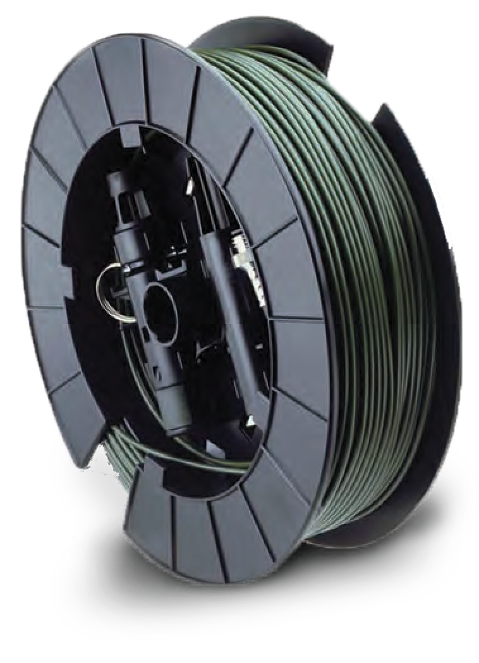

12G DOOR BREACHING AMMO

TA01048
For use with 12 guage shotgun, pump action or semi automatic.
The medical tent is used for a wide variety of medical applications, from lifesaving surgical procedures in the field to mobile emergency or disasters situations. Various modes of operation are available according to client-specific needs: indoor & out, single or several units (separated or combined together), fast deployment or standby.
The field hospital comprises several ISO 1 C container modules. Based upon the customers requirements, the following modules may be built:
Surgery preparation room. Sterilization room.
Surgery.
Intensive care unit. X- ray room.
CT room.
Dental care room. Pharmacy.
A ward block located in the tents may be added
to the field hospital.

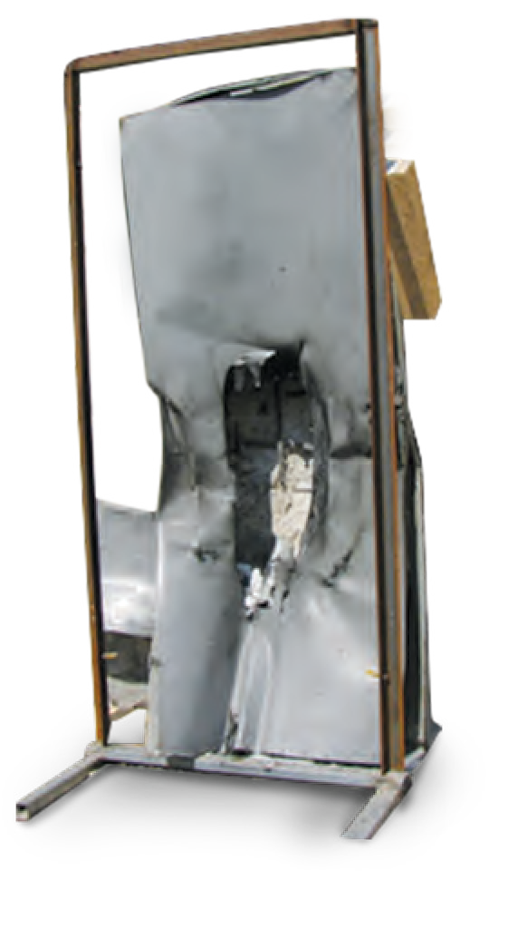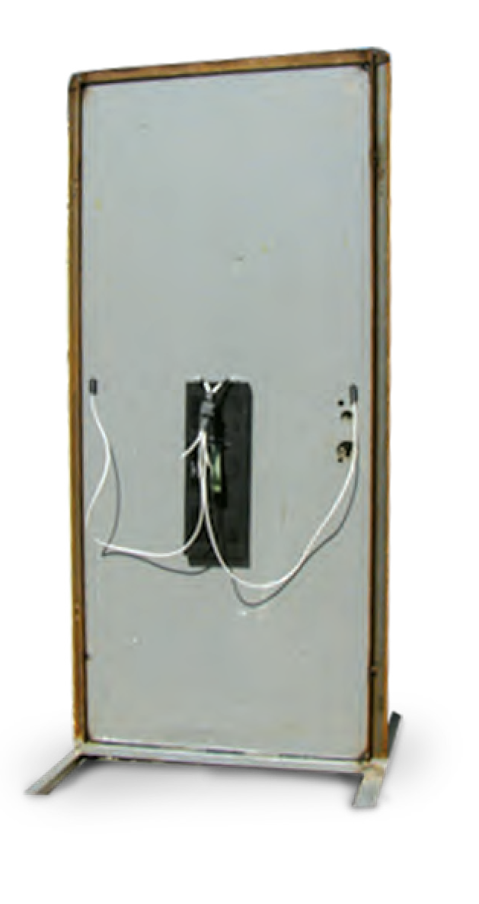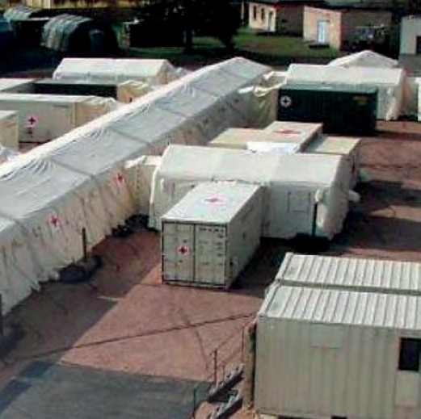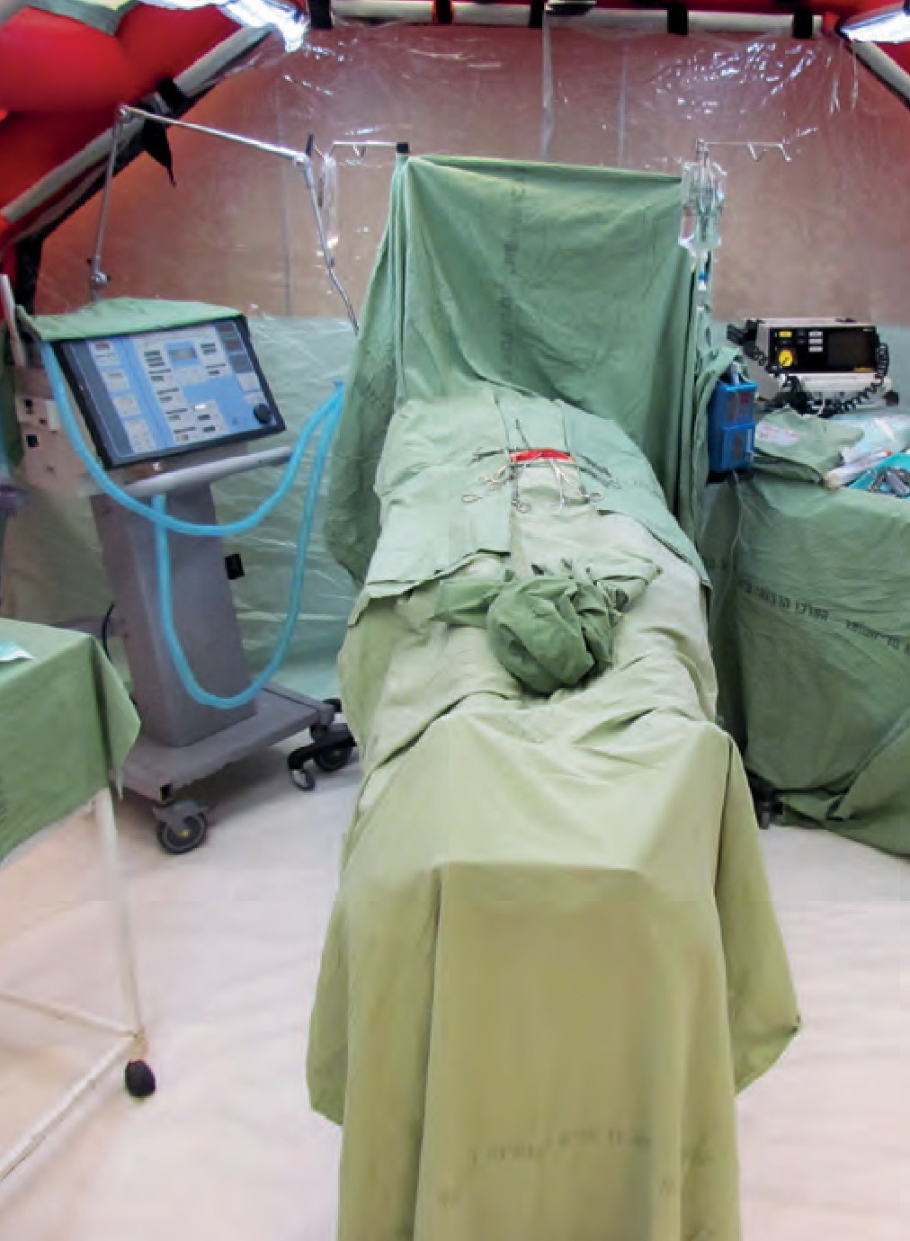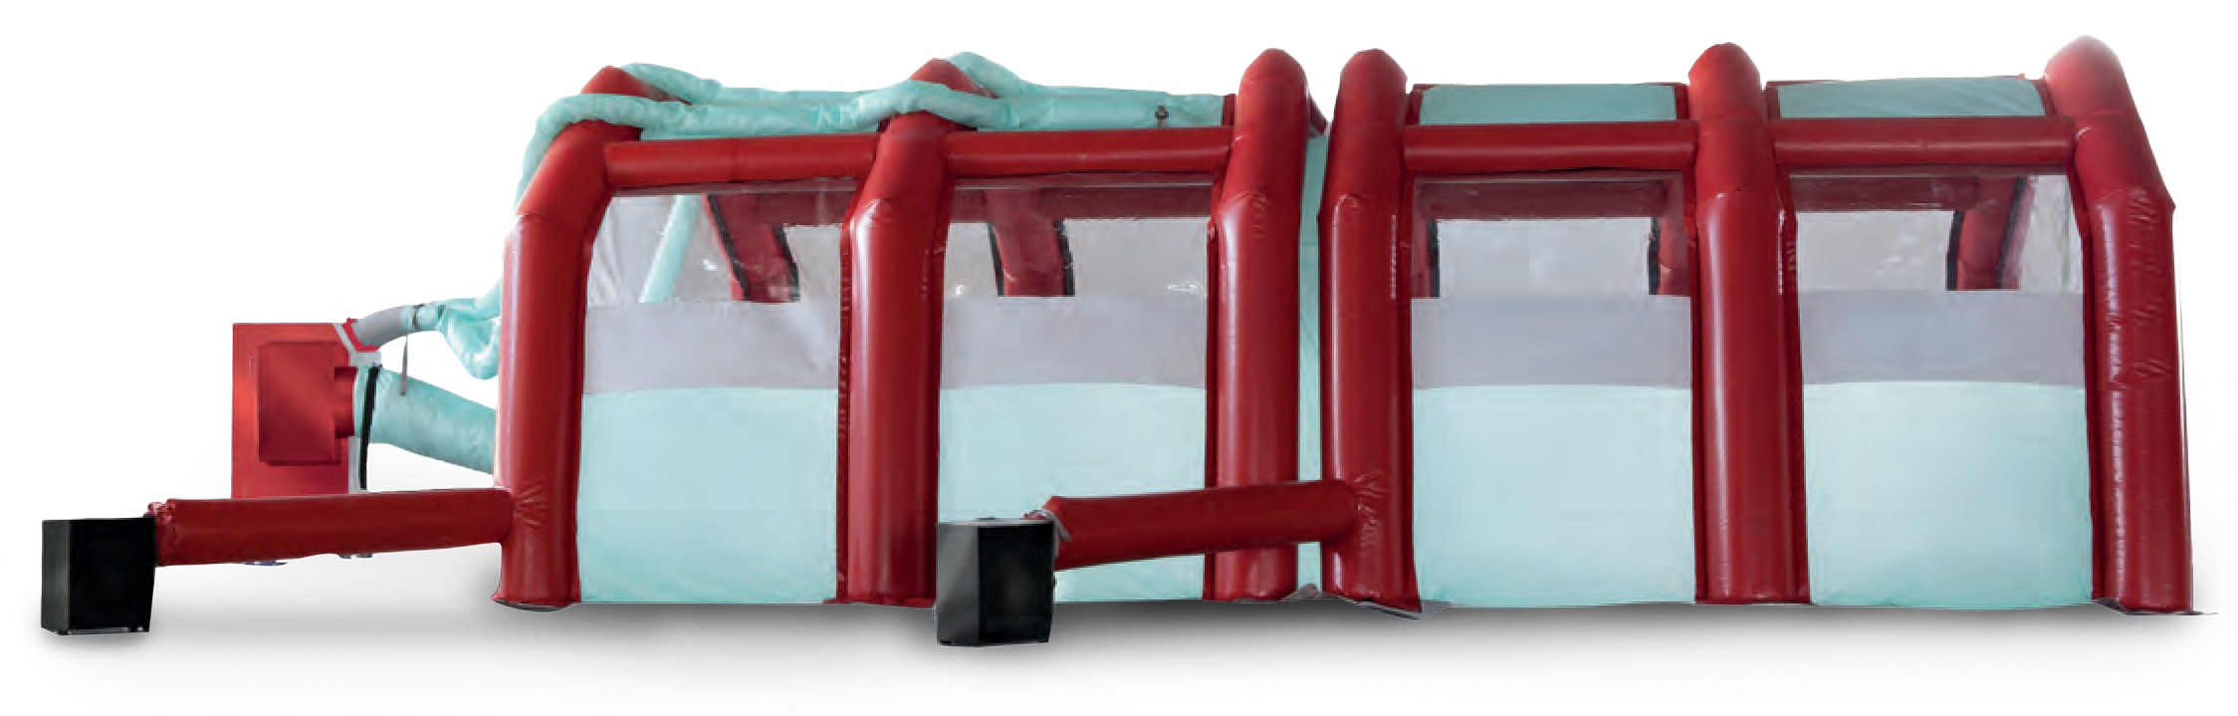
EXPLOSIVE BREACHING
MEDICAL
Scan The Code
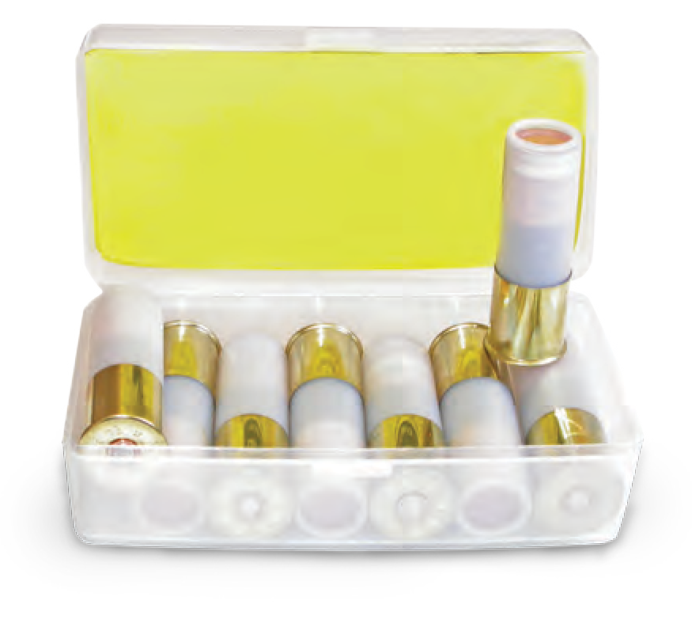

24 MILITARY AND POLICE EQUIPMENT WWW.TARIDEAL.COM 25

8 FOLD STRETCHER

TA04118
Ideal Battlefield Stretcher:
Weighs less than 5kg
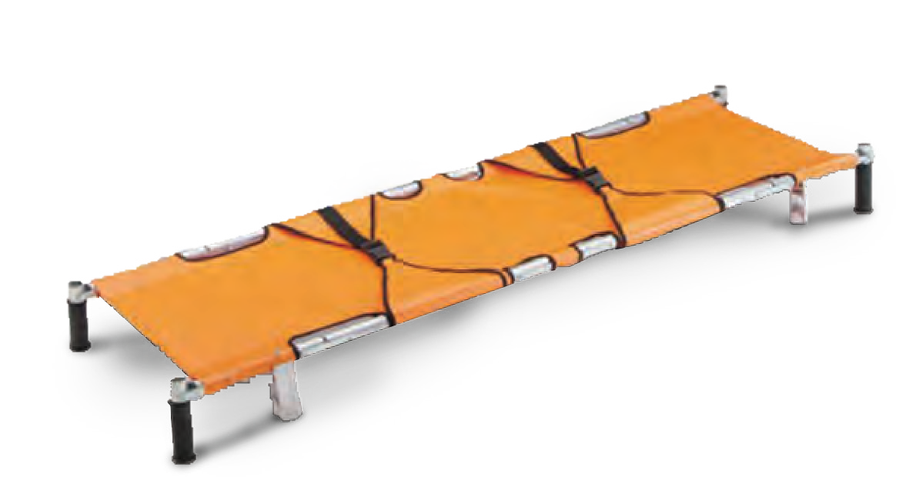Fits into a backpack case. Easily stored in facilities, vehicles and helicopters.

STRETCHER HOLDERS
TA04120

EMERGENCY CONTAINER

TA04119
Mobile and modular material handling crates for smart equipment handling. Provides a necessary rapid deployment tool and methodology for material and equipment handling in the field.
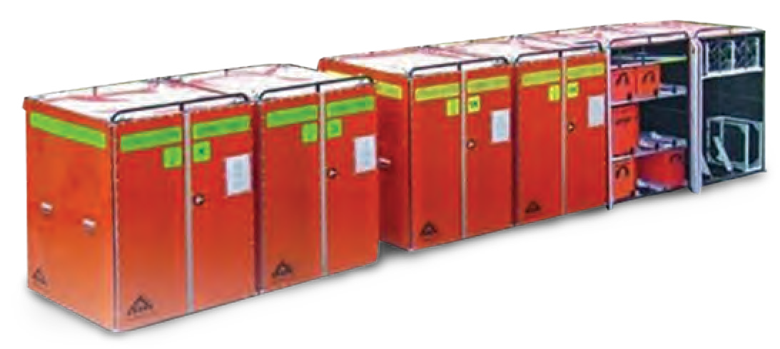

COMPACT FOLDING STRETCHER
TA04114

PARAMEDIC FIELD BAG

TA04198
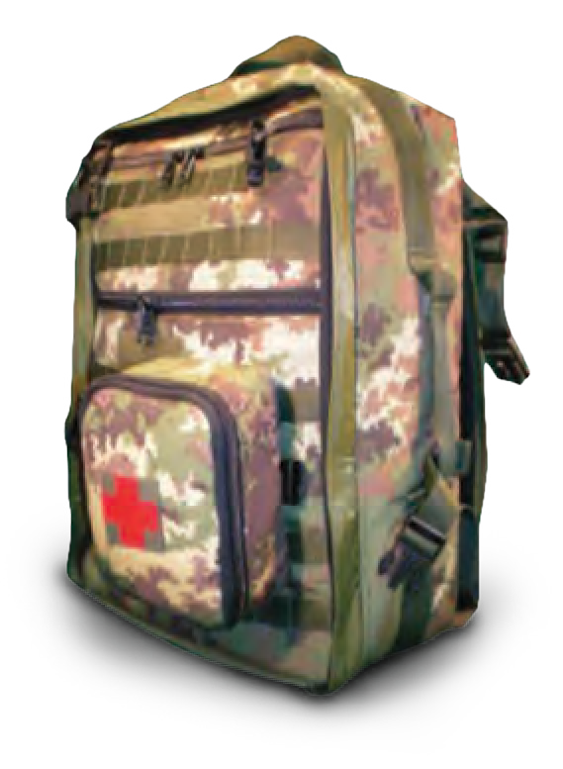
A professional medical bag, which meets the needs of the most advanced paramedic. Adjustable for all medical field requirements.

DROP LEG AID KIT

TA04113
Can be worn on the leg or attached to a MOLLE

EMERGENCY BLANKET

TA14112
Provides essential warmth, preventing and treating the onset of hypothermia. Reflects almost all radiated body heat produced back to the patient.
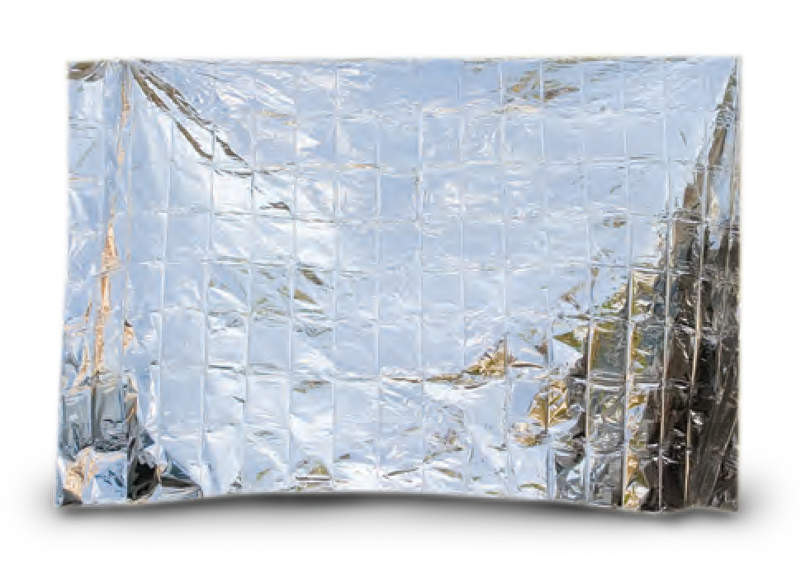
BEDS

TA04121
Folding beds used as field hospital beds, camping

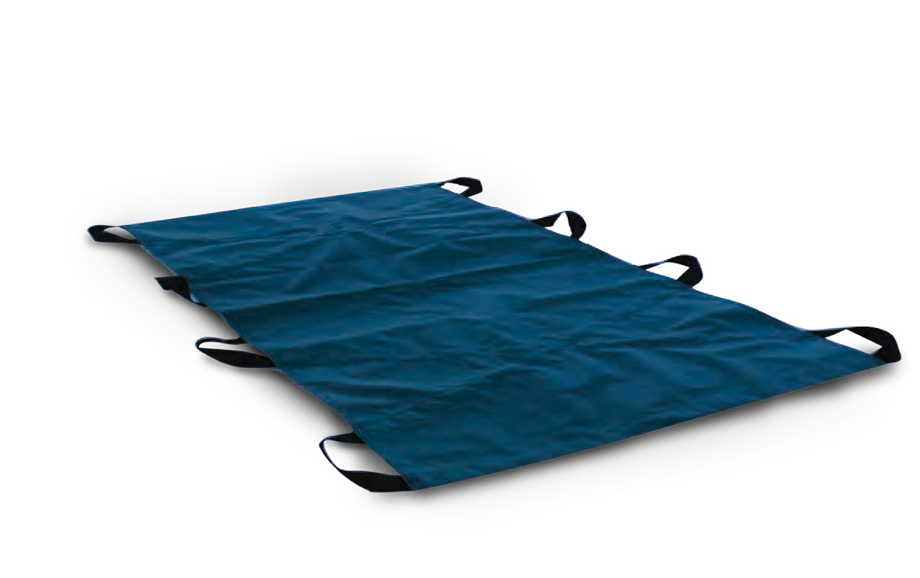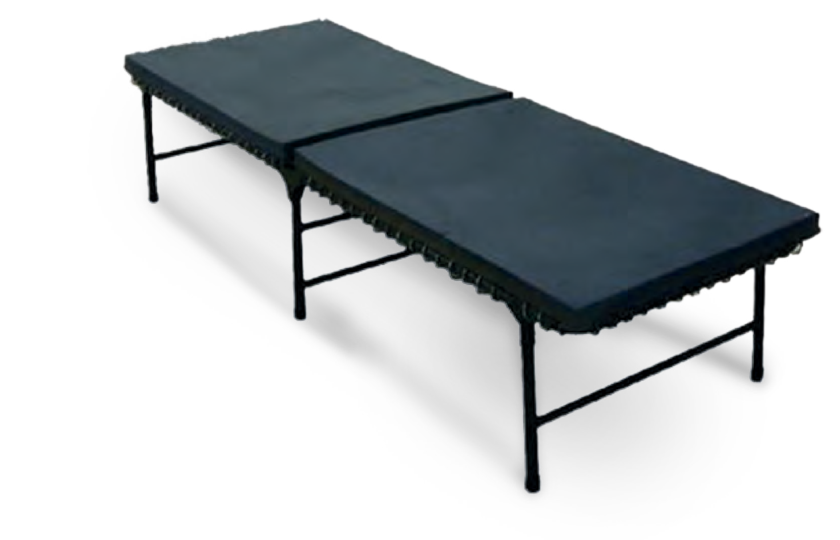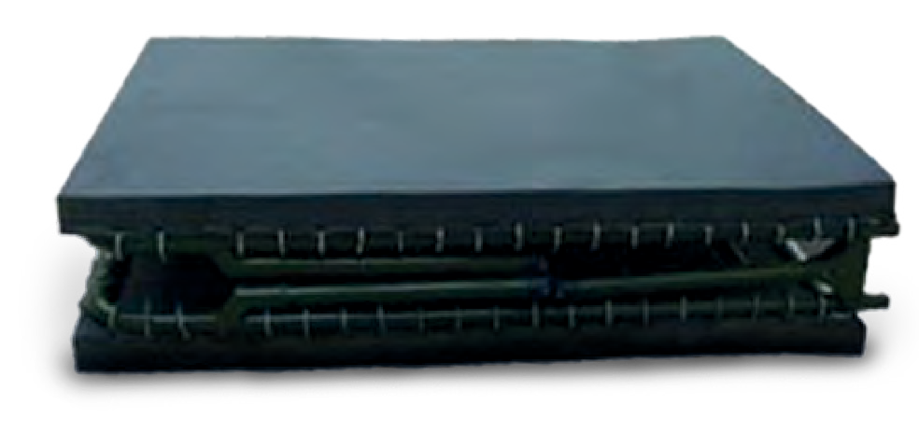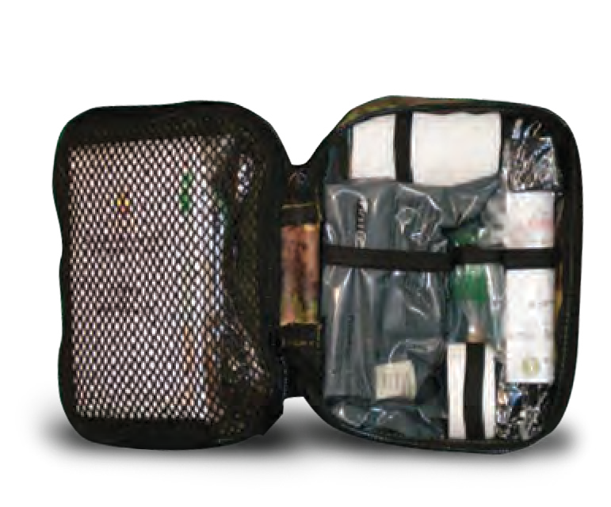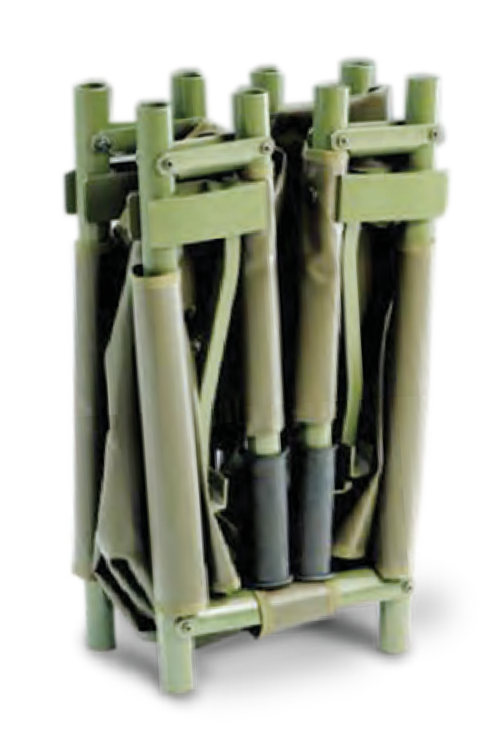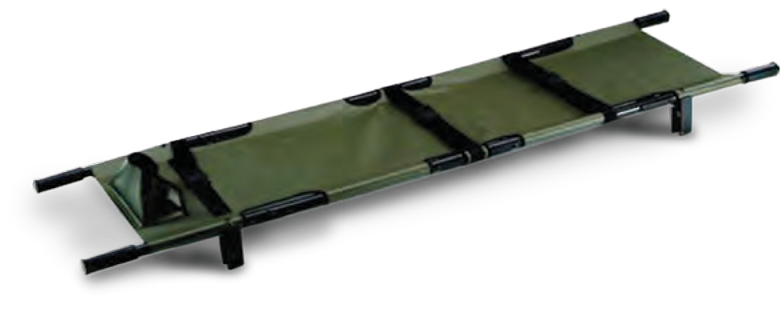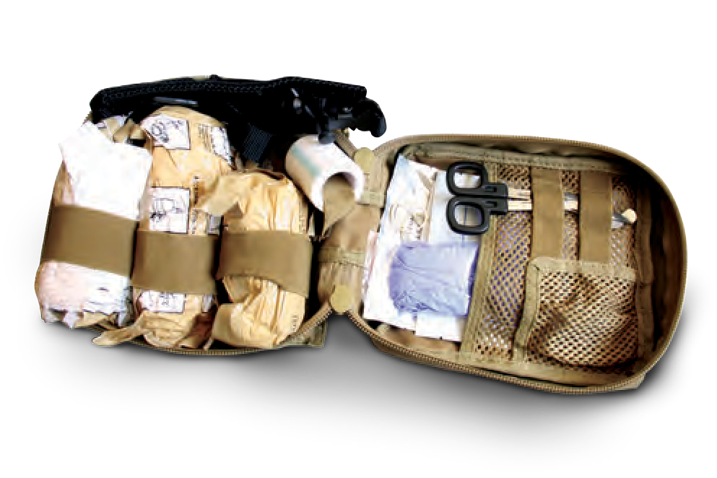
8 Fold, lightweight. Easy to use and can be stored
in facilities, vehicles & helicopters.
style vest. All kits can also be custom packed to
meet your specific mission requirements.
& emergency operations sleeping kits.
SOFT STRETCHER
TA04197
MEDIC FIRST AID KIT
TA04115
Assorted types of medical bandages and medical aids.
26
MILITARY AND POLICE EQUIPMENT
WWW.TARIDEAL.COM
27
MEDICAL & RESCUE
Scan The Code
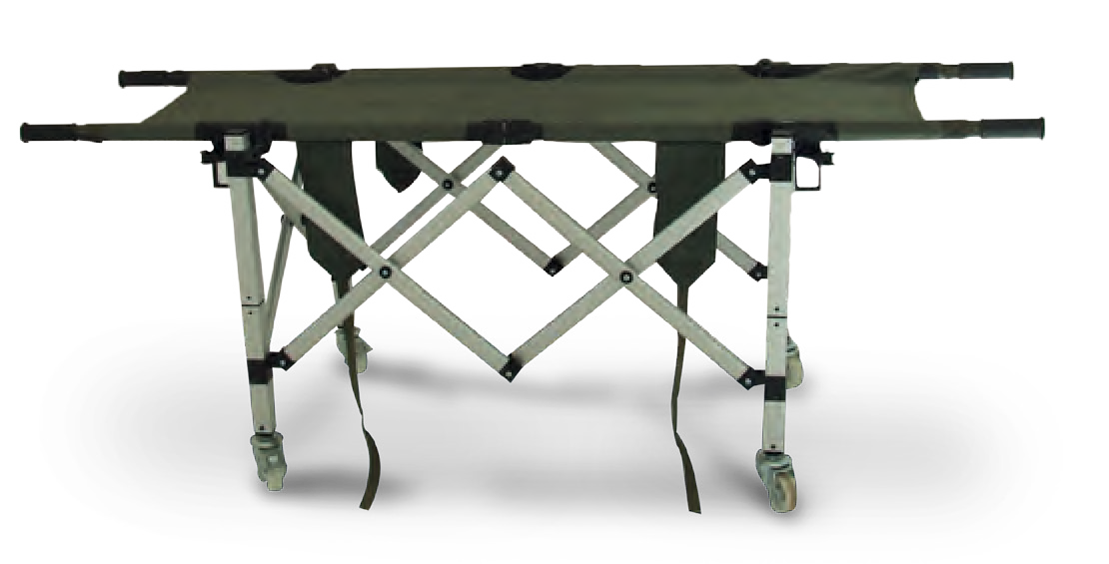

K9 K9 ACCSESORIES

Scan The Code

K9 TACTICAL VEST

TA07003
Light-weight 3 piece design includes full chest, back, and underbelly protection. Perfect fit, “one size fits all” vest. Available in NIJ level 2 (ballistic material).

K9 FIRST AID KIT

TA07019
A fully equipped kit to meet initial First Aid
requirements in the field.

EXPLOSIVE DETECTION DOGS
Displays a passive response to indicate explosives sitting / lying or in an active way: barking. Detects explosive compounds, including ammunition and firearms (inc. people carrying explosives) on buses, trains, planes, etc.
Trained to be non- aggressive to strangers and behave passively in populated areas such as train stations, airports, etc.
Trained to mark their findings in an active or passive way.
Trained to detect explosive charges in different terrains and environments.

K9 COOLING VEST

TA07001
Constant temperature when charged Cooling duration: 2 hours
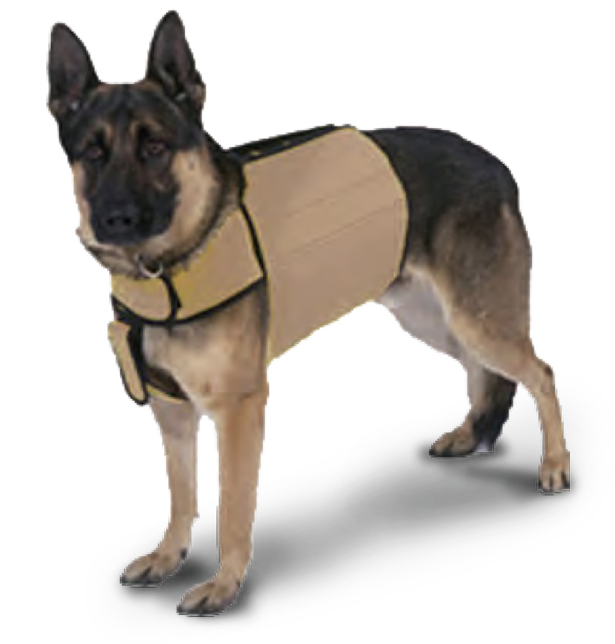
Washable, removable cool - packs.

PINCH COLLAR NYLON PROTECTOR

TA07015
Reduces contact with water.
Protects against excessive light reflection.
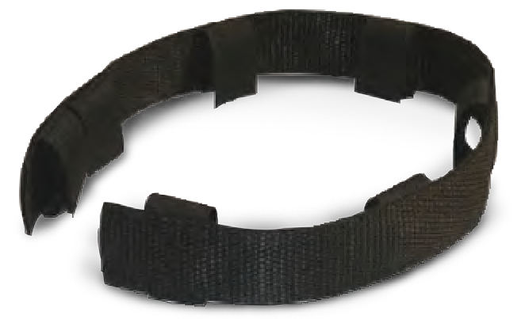
Collar makes less noise.

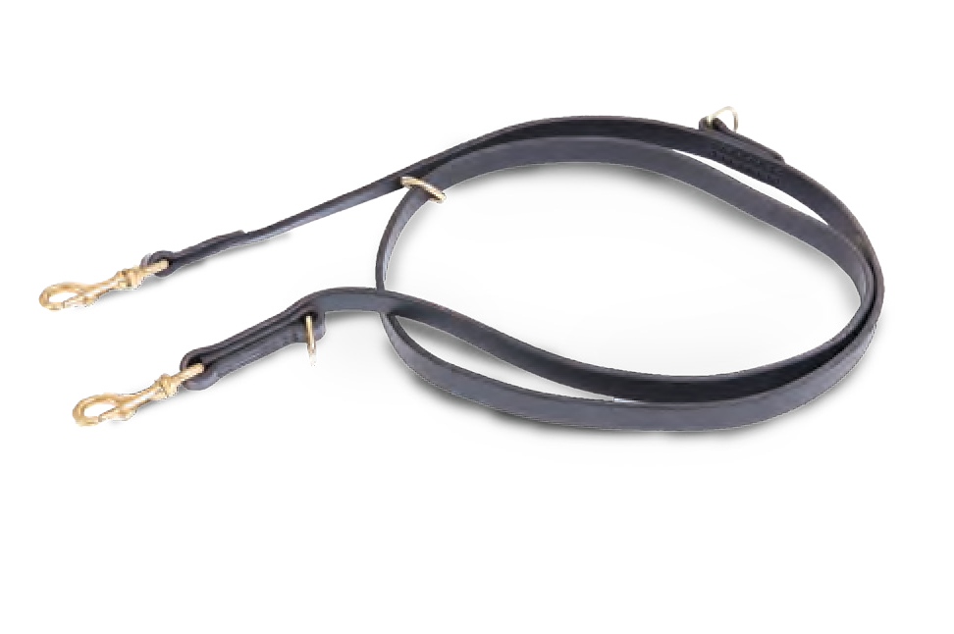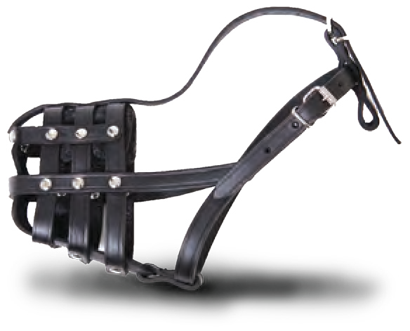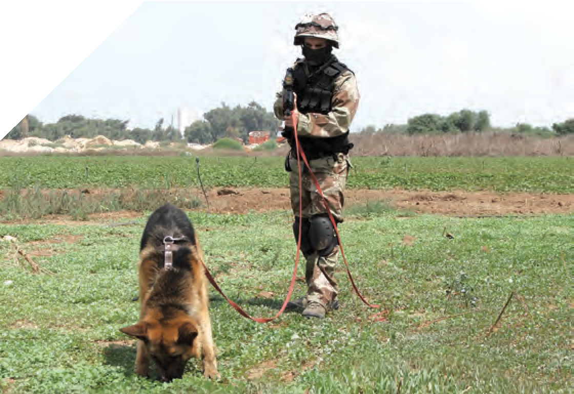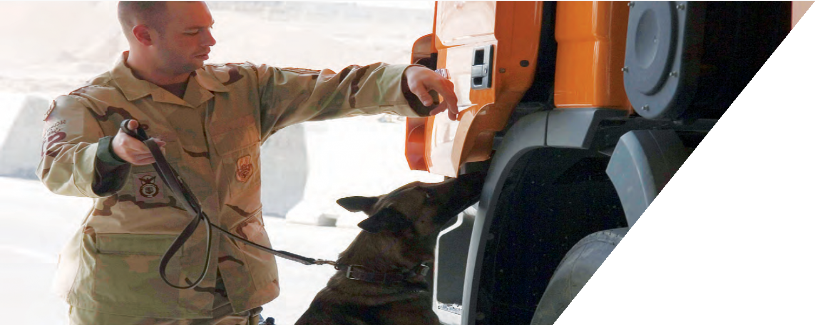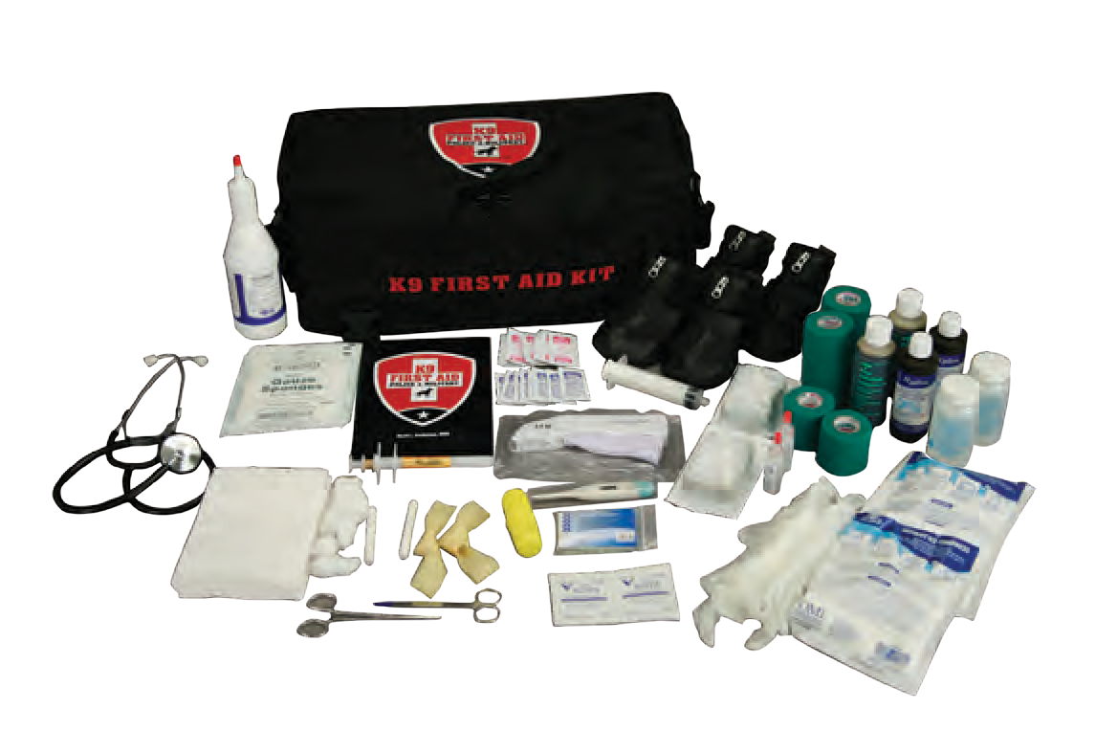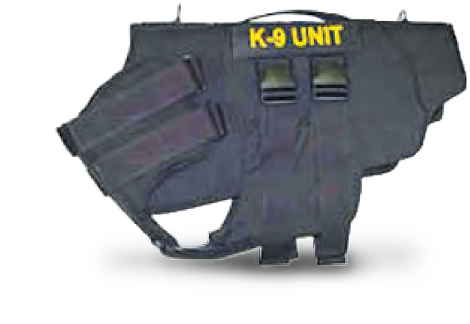
TRACKING DOGS
A “tracking” dog follows the scent trail left behind
by a person or animal.
Ideal for Police Patrol Forces, Security Teams and Police Detectives.
The Tracking dogs are trained to:
Assist handlers in tracking missing persons, suspects or lost items.
Track through various terrains, following tracks made several hours before.
Trained to locate any clues on the way.
LEASH
TA07010
Leather dog leash for tracking. Stitched with snap hook.
MUZZLE
TA07005
Practical muzzle for training, travelling, patrolling and guarding. The muzzle is safe and non-toxic.
28
MILITARY AND POLICE EQUIPMENT
WWW.TARIDEAL.COM
29

COMBAT MILITARY UNIFORM

TA04058
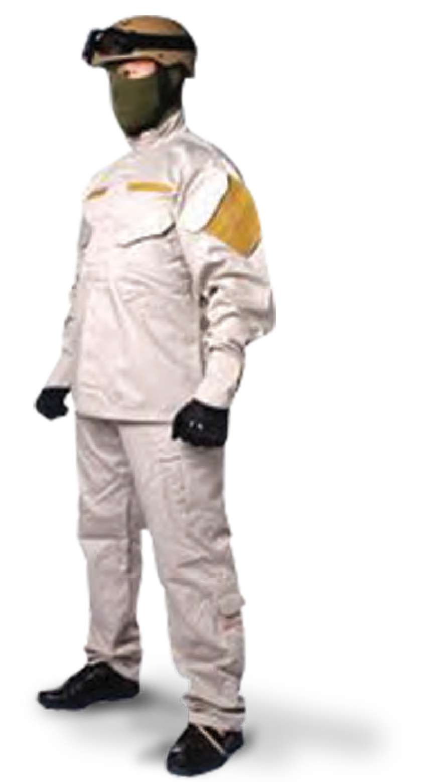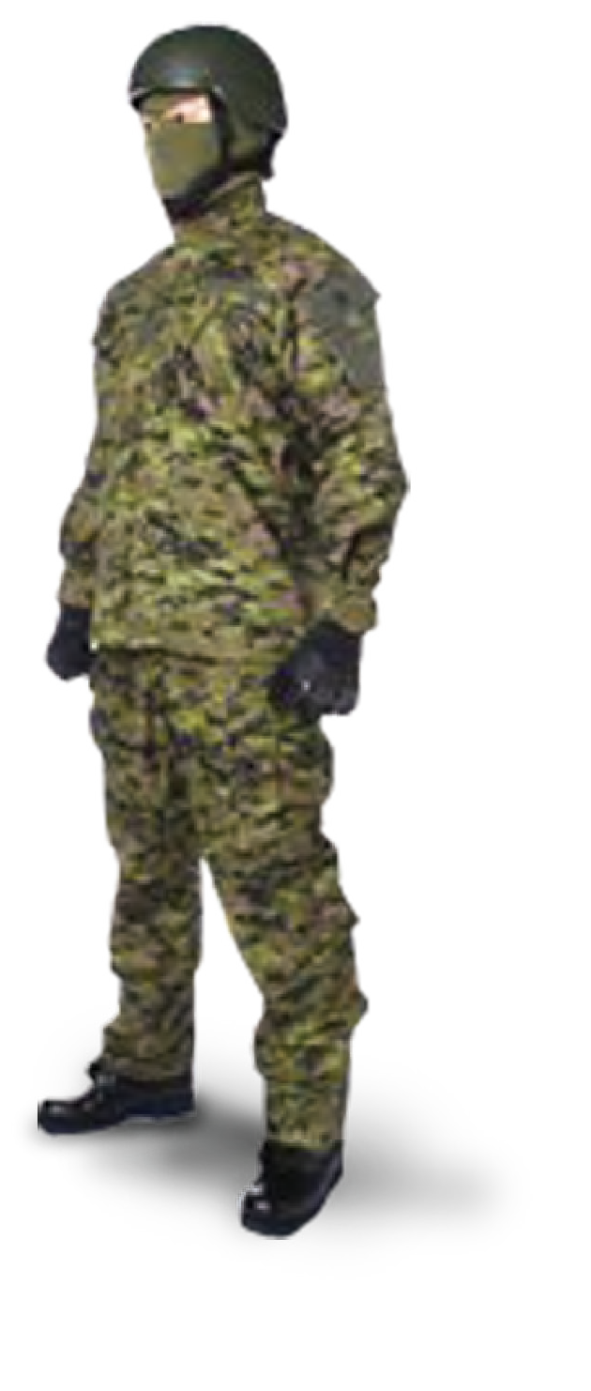Two-piece military uniform made of breathable fabric. Available in various colors, according to customer request.

TACTICAL BREATHING SHIRT/PANTS

TA02074/ TA02075
Highly breathable FR combat shirt and pants designed for Special Operations, International Forces, and Special Response Teams.

DRESS UNIFORM
TA04173

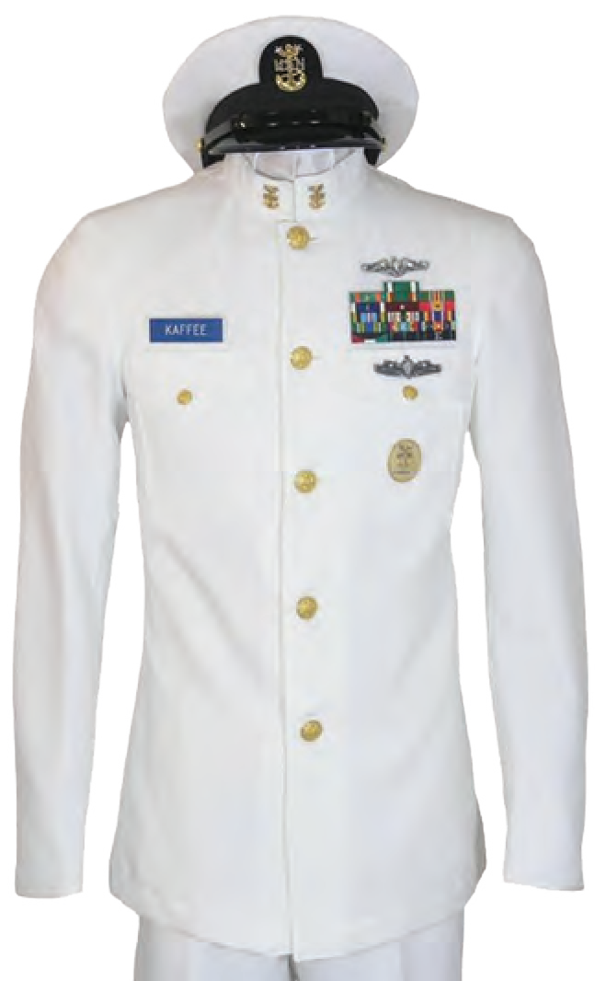

EPAULET

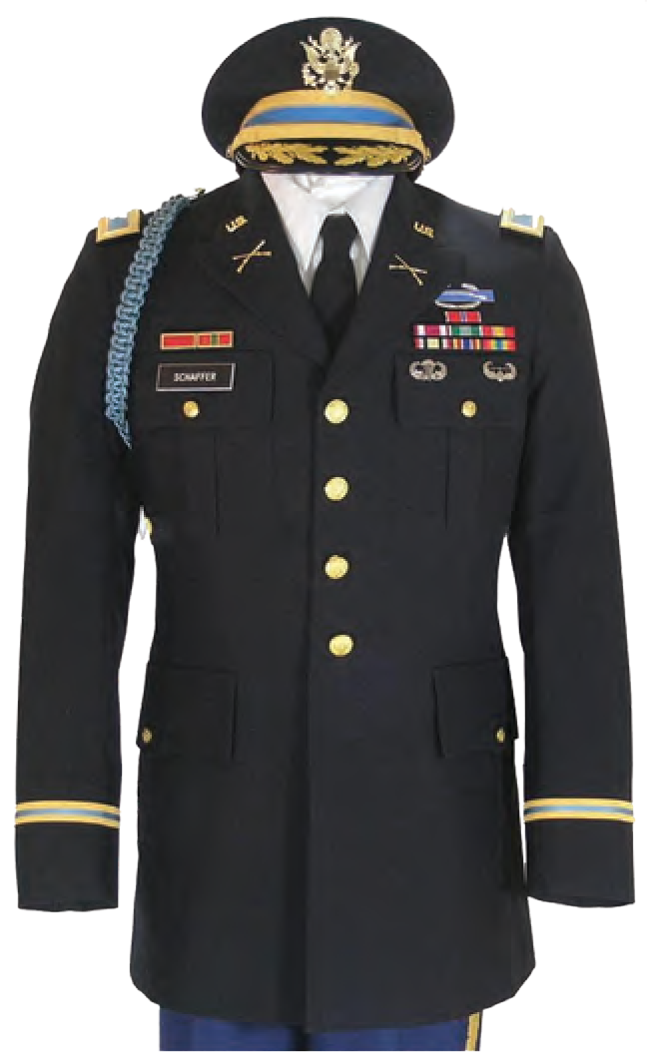
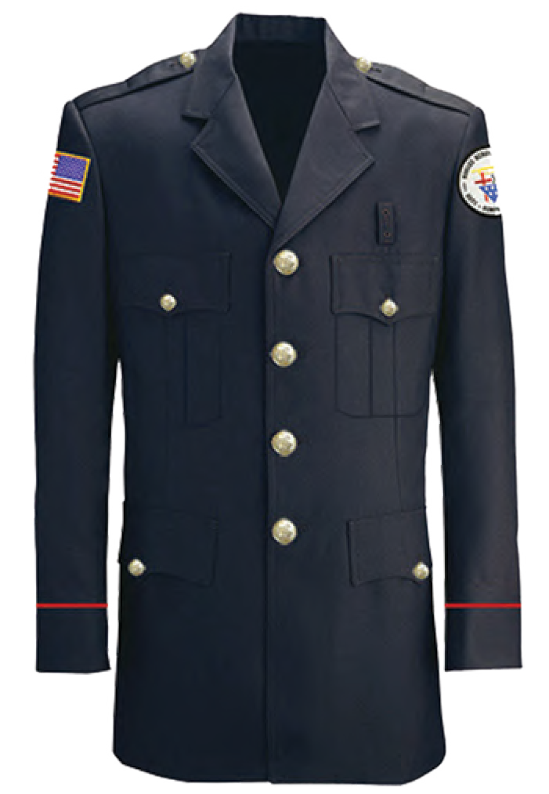

INSIGNIA

COMBAT MILITARY BELT

TA04199
Maximum compatibility to field condition.
TA04174 TA04175

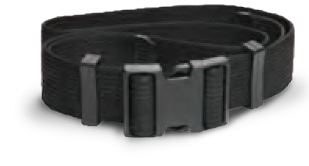
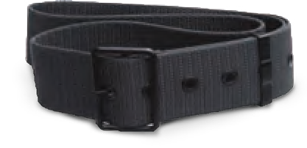
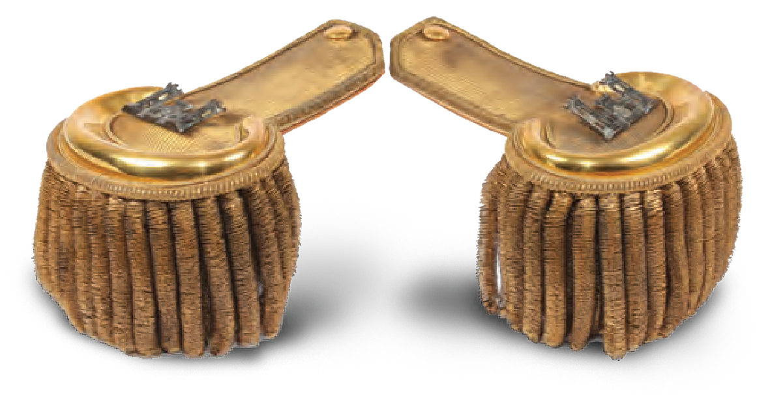
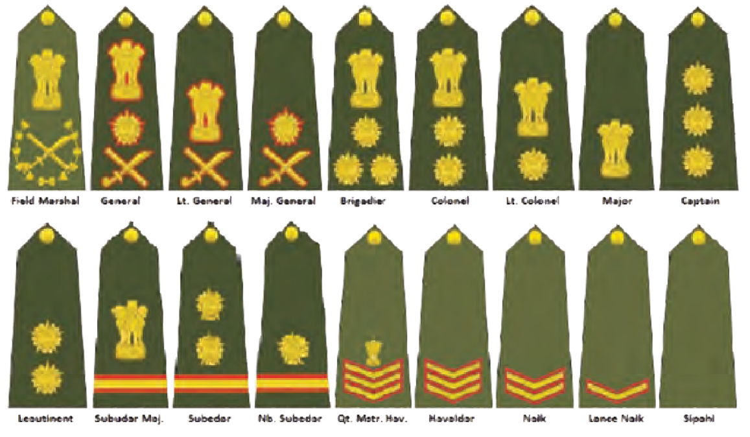
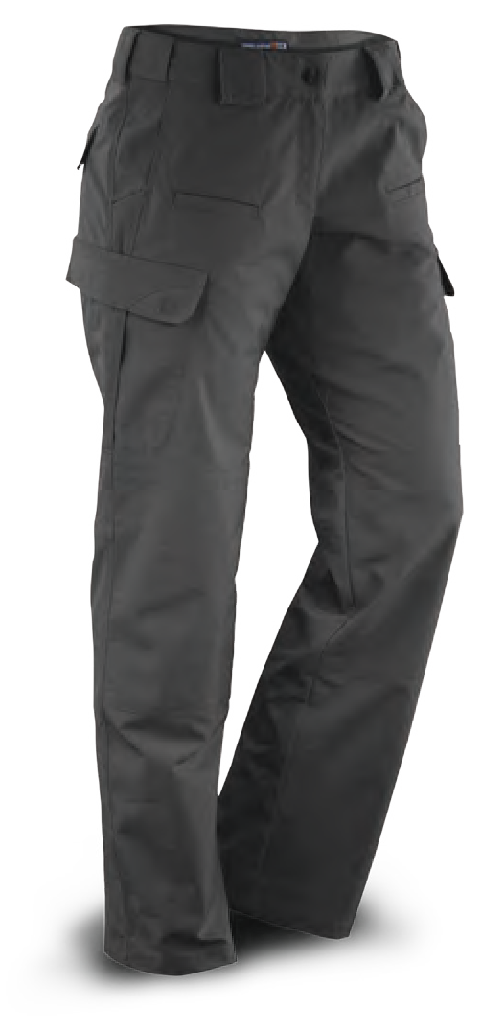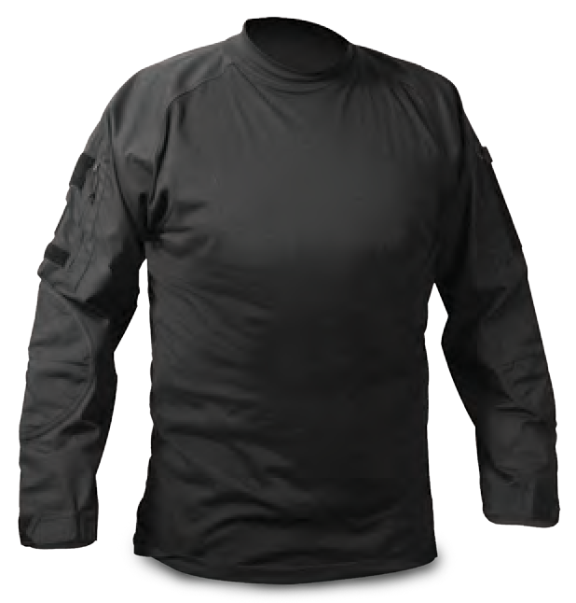 DESERT BOOTS
DRESS BOOTS
DRESS SHOES

TACTICAL BOOTS

TA02077
Designed for speed and mobility, with airflow channels and extra cushioning.

TA04059
Designed for hot climates the desert boots are padded to suit extreme desert weather.
TA04176 TA04177

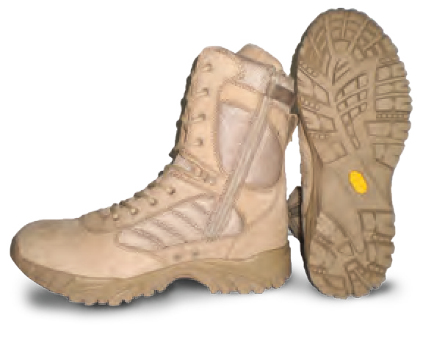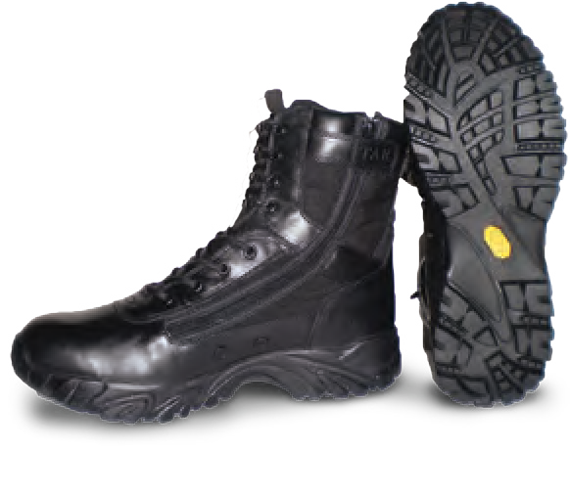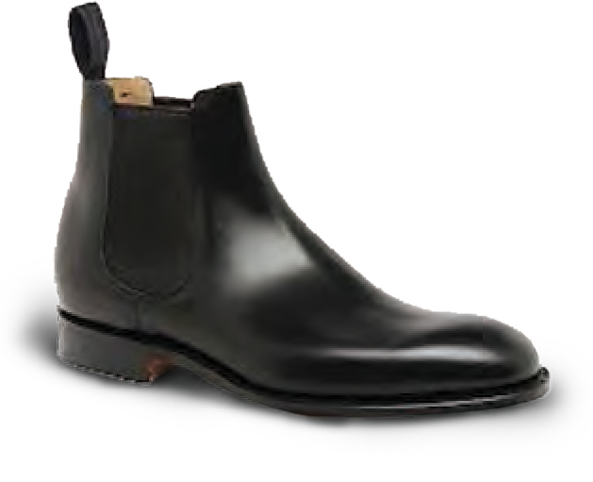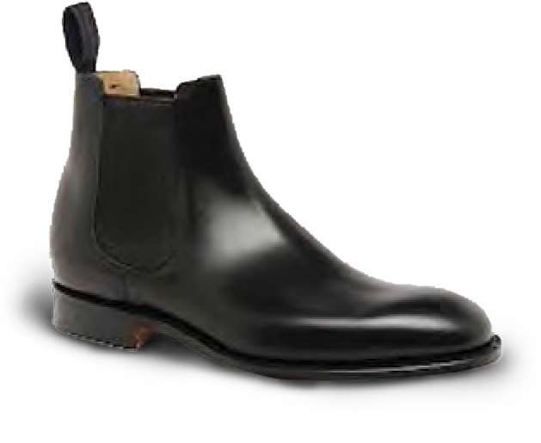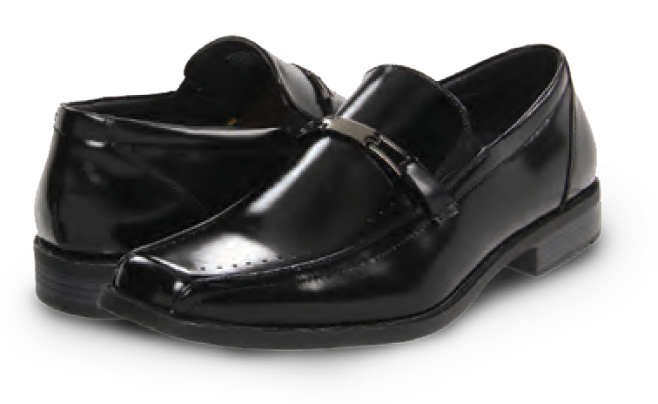
UNIFORMS
DRESS UNIFORMS
Scan The Code

30 MILITARY AND POLICE EQUIPMENT WWW.TARIDEAL.COM 31

THERMAL UNDERSHIRT

TA04069
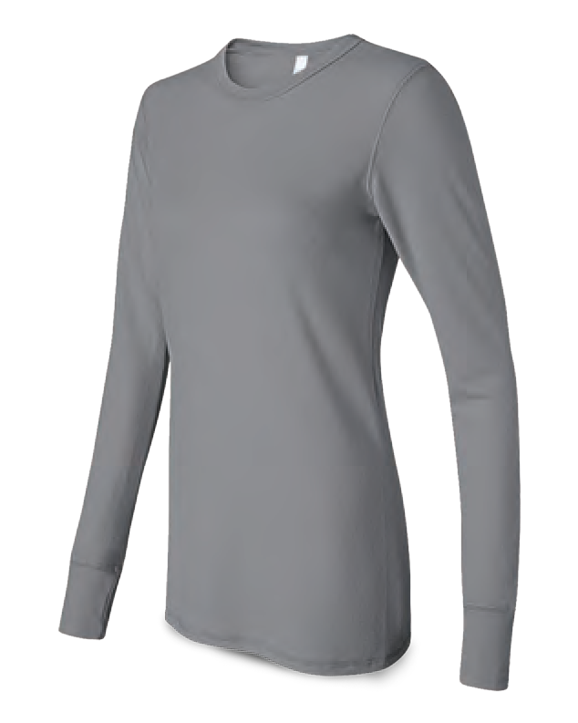
Ideal during high exertion and cold weather conditions. Ultra-lightweight insulating layer engineered for core temperature consistency.

T-SHIRT PADDED COVERALL

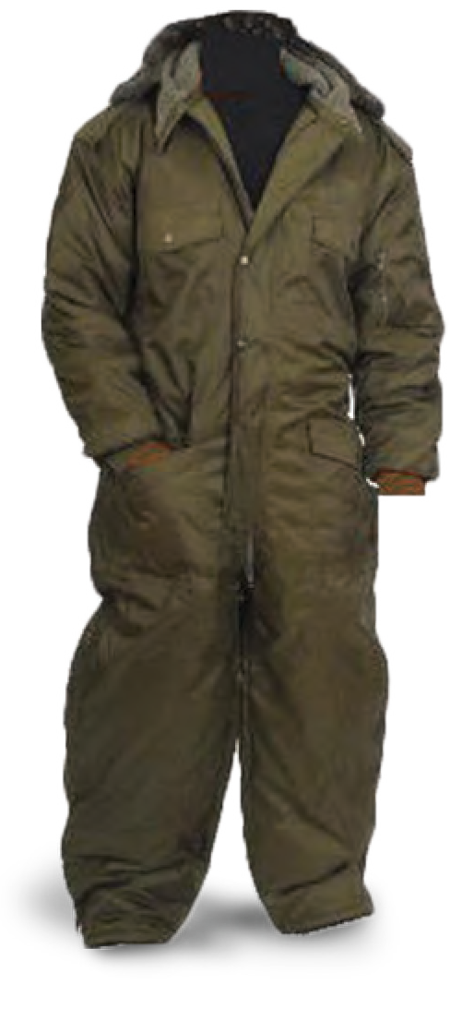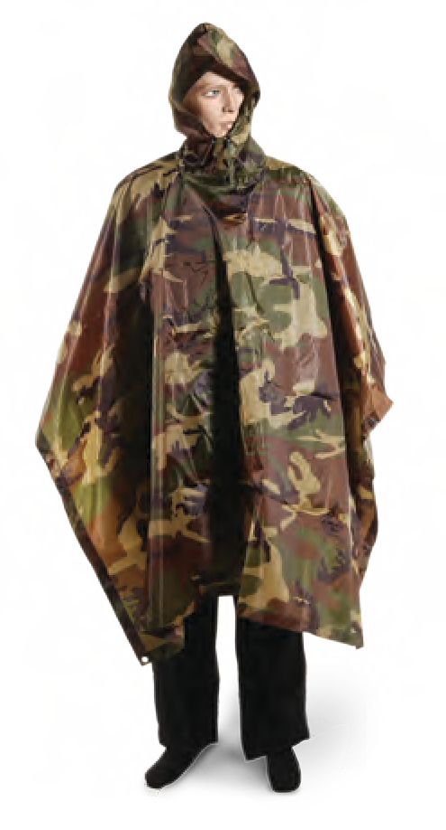TA04068 TA04074
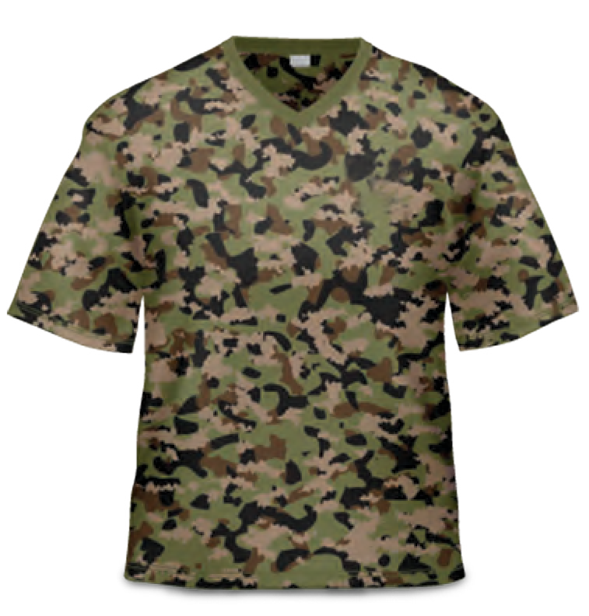
Protects against extreme cold weather, maintains body temperature.

SOFT SHELL SUIT

TA04077
Waterproof jacket and pants suit.

LONG UNDERWEAR

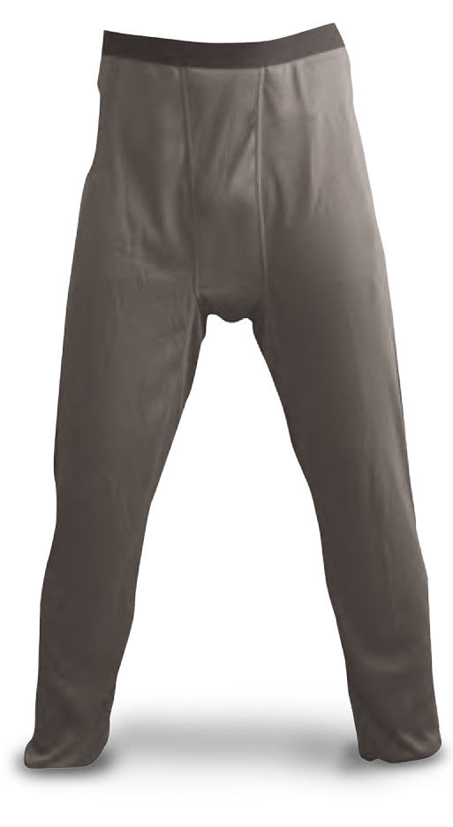
TA04071
Maximum thermal regulation, from waist to ankle. Brushed cold gear fabric and a performance waistband, enhance comfort.

UNDERWEAR
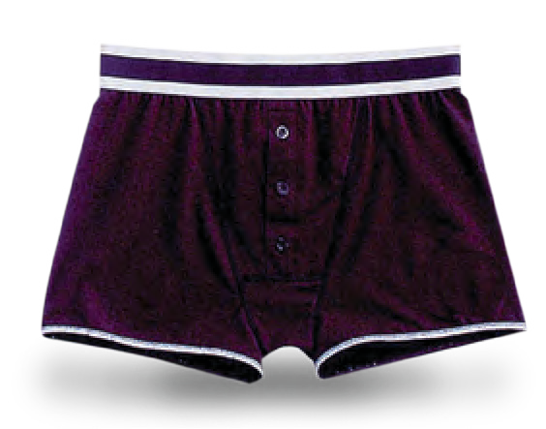
TA04070

SPORT SHORTS

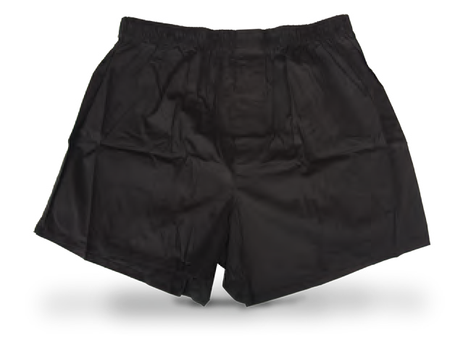
TA04073

NYLON PONCHO

TA04076
Nylon Poncho with drawstrings and stoppers. Water repellent and windproof.

RAIN COAT

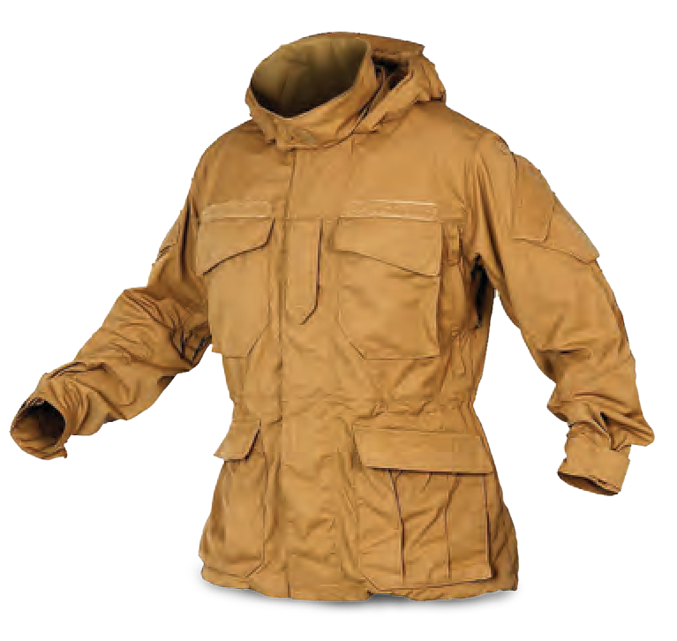
TA04178
Front zipper 100% water repellent nylon Rain Coat with hood.

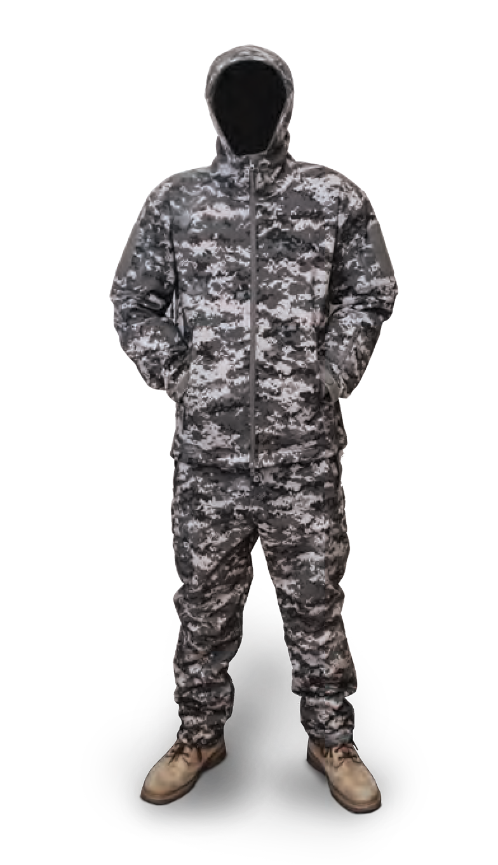
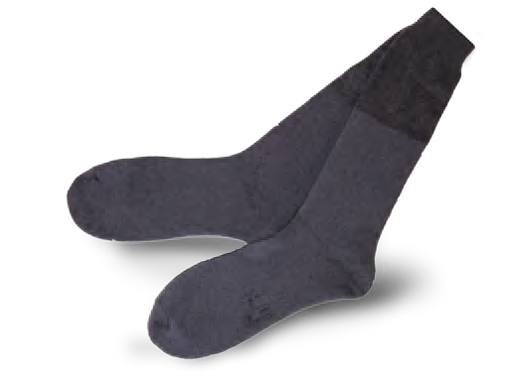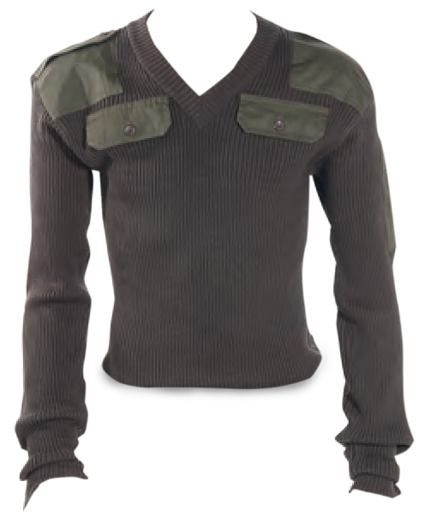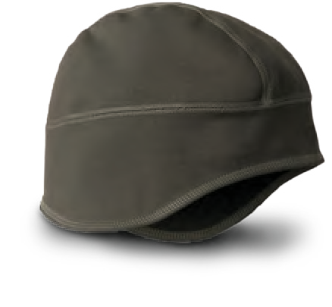
TOWELS
TA04067
WOOL SOCKS
TA04072
UNDER-HELMET COVER
TA04078
The Under-Helment Cover protects the head and the ears from the cold.
COLD WEATHER PULLOVER
TA04075
Made of wool, comfortable and warm.
Can be worn over the uniforms.
32
MILITARY AND POLICE EQUIPMENT
WWW.TARIDEAL.COM
33
CLOTHING
EXTREME WEATHER
Scan The Code

BERET
TA04060

COOLING MASK
TA04179

COLD WEATHER GLOVES COMBAT GLOVES

TA04080 TA02079

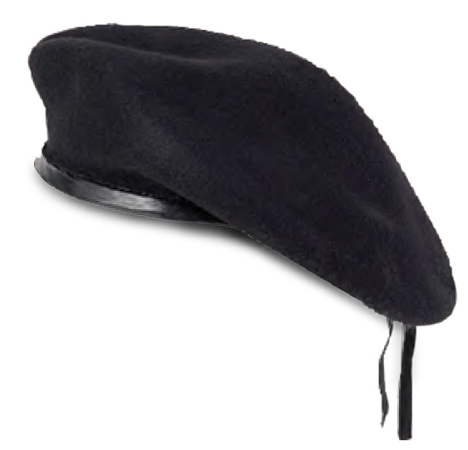
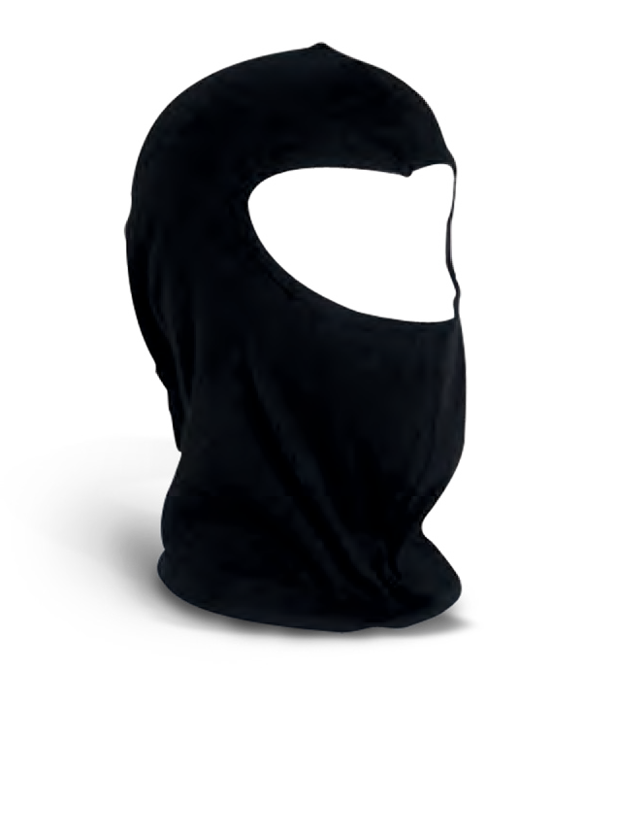
Wind and water resistant ideal for military use.
Ideal for combat operations that require maximum
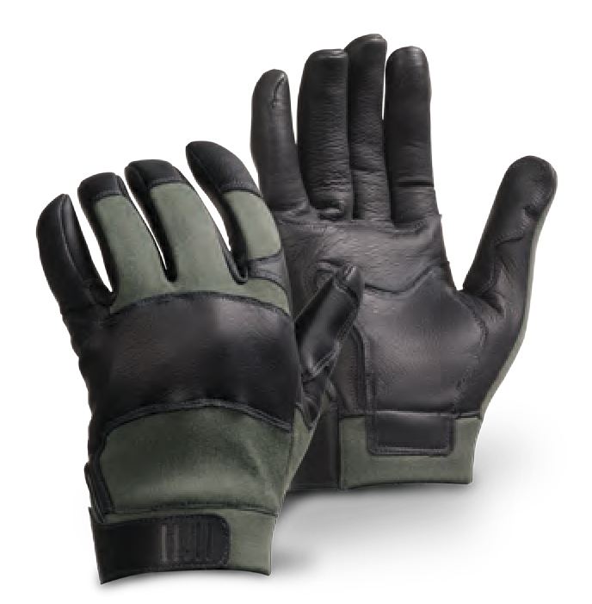
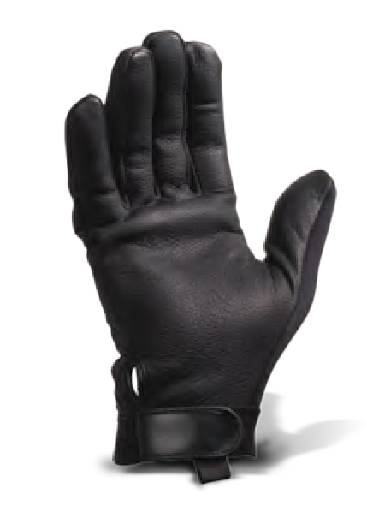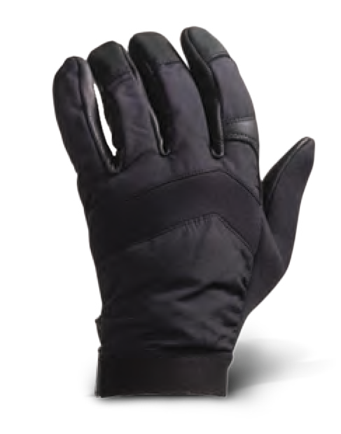finger dexterity.

HELMET COVER

TA04062
High quality for military, exploring and outdoor use.

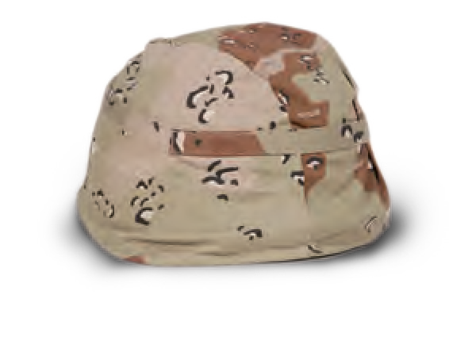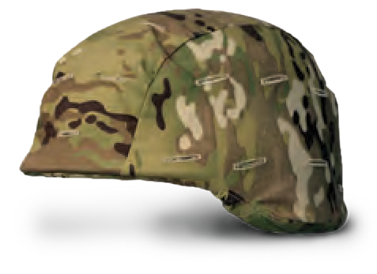 NOMEX MASK

BOONIE HAT

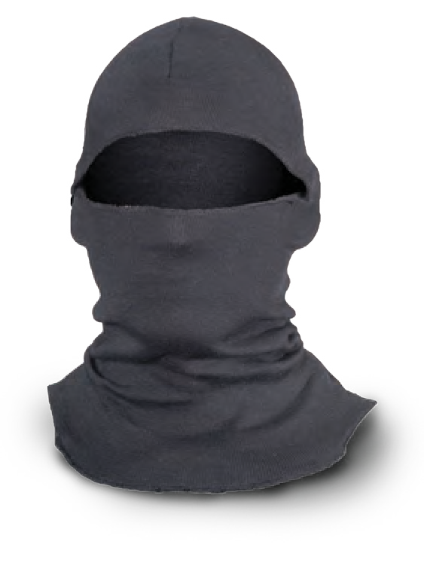
TA04061

IMPACT GLOVES DRESS GLOVES

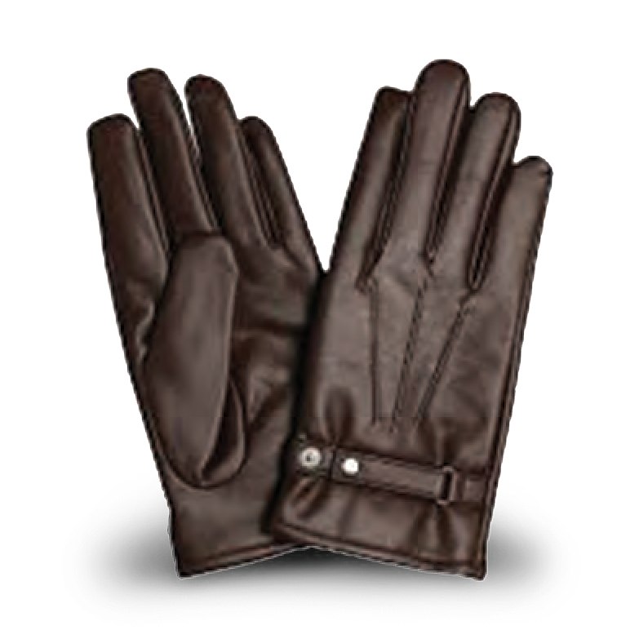
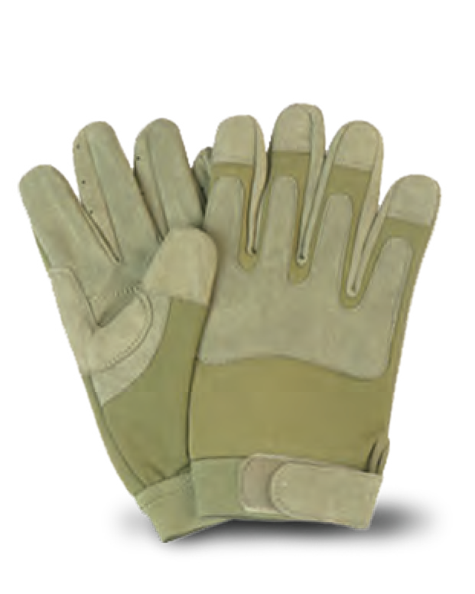
TA04081 TA04180
Fast roping gloves suitable for combat operations.

TA04064
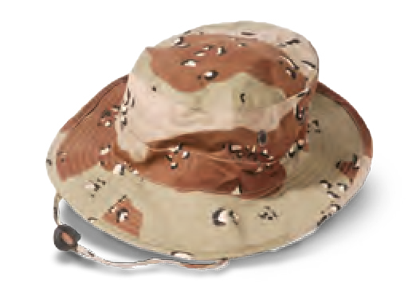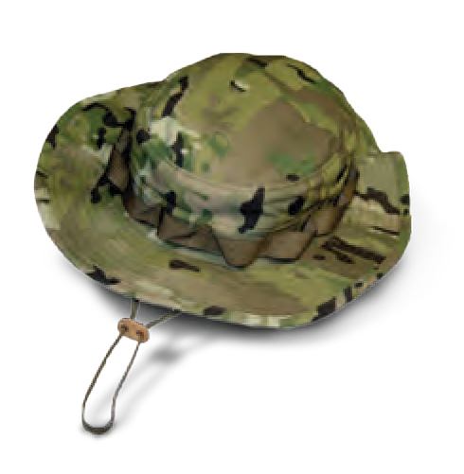Complete with chin strap - protects the face and the nape from the sun.

ARMY CAP

EXTREME WEATHER CAP

TA04065
Insulated to keep the head warm in the coldest temperatures.

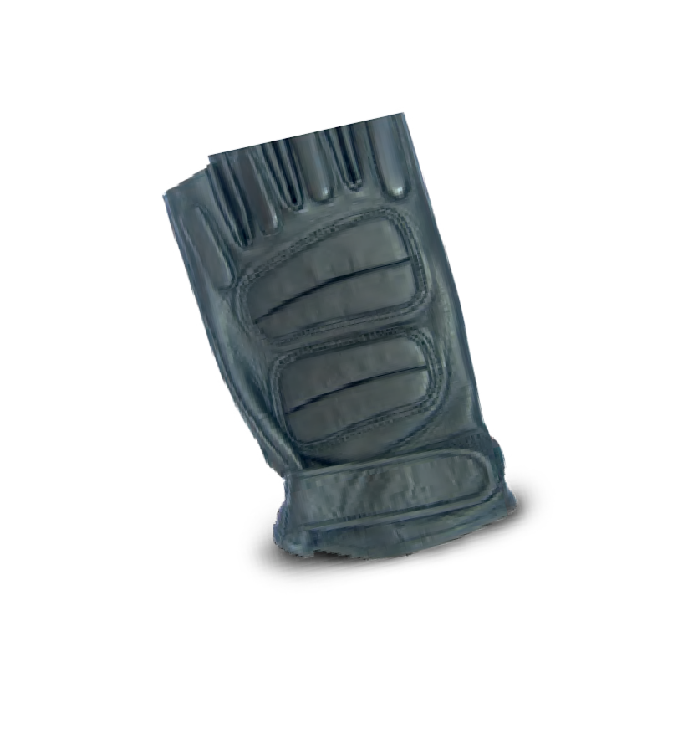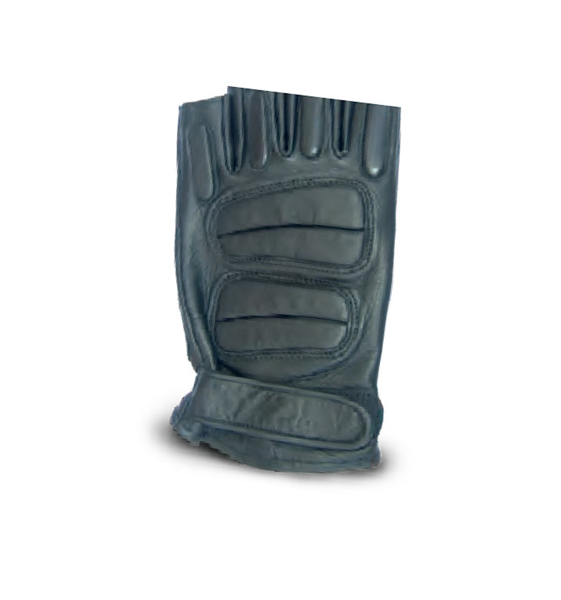 NOMEX GLOVES

FINGERLESS GLOVES

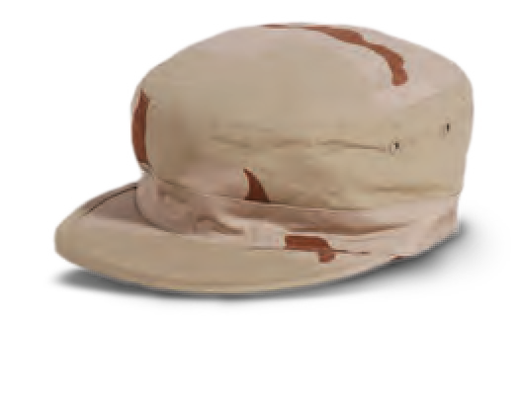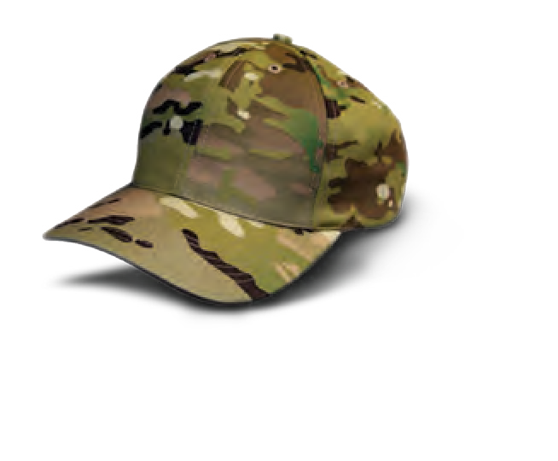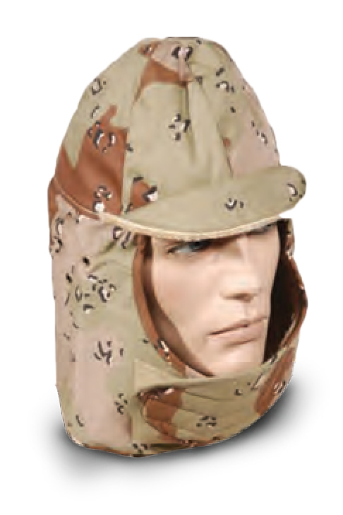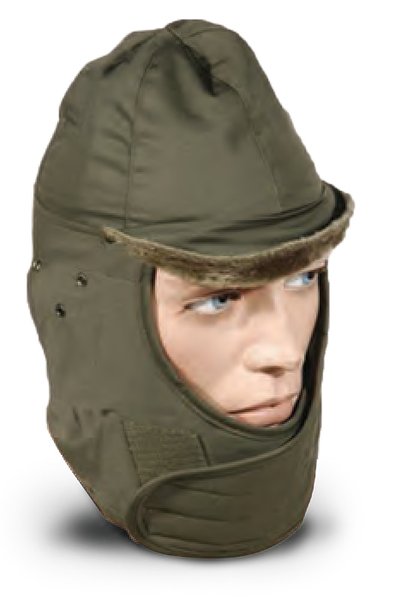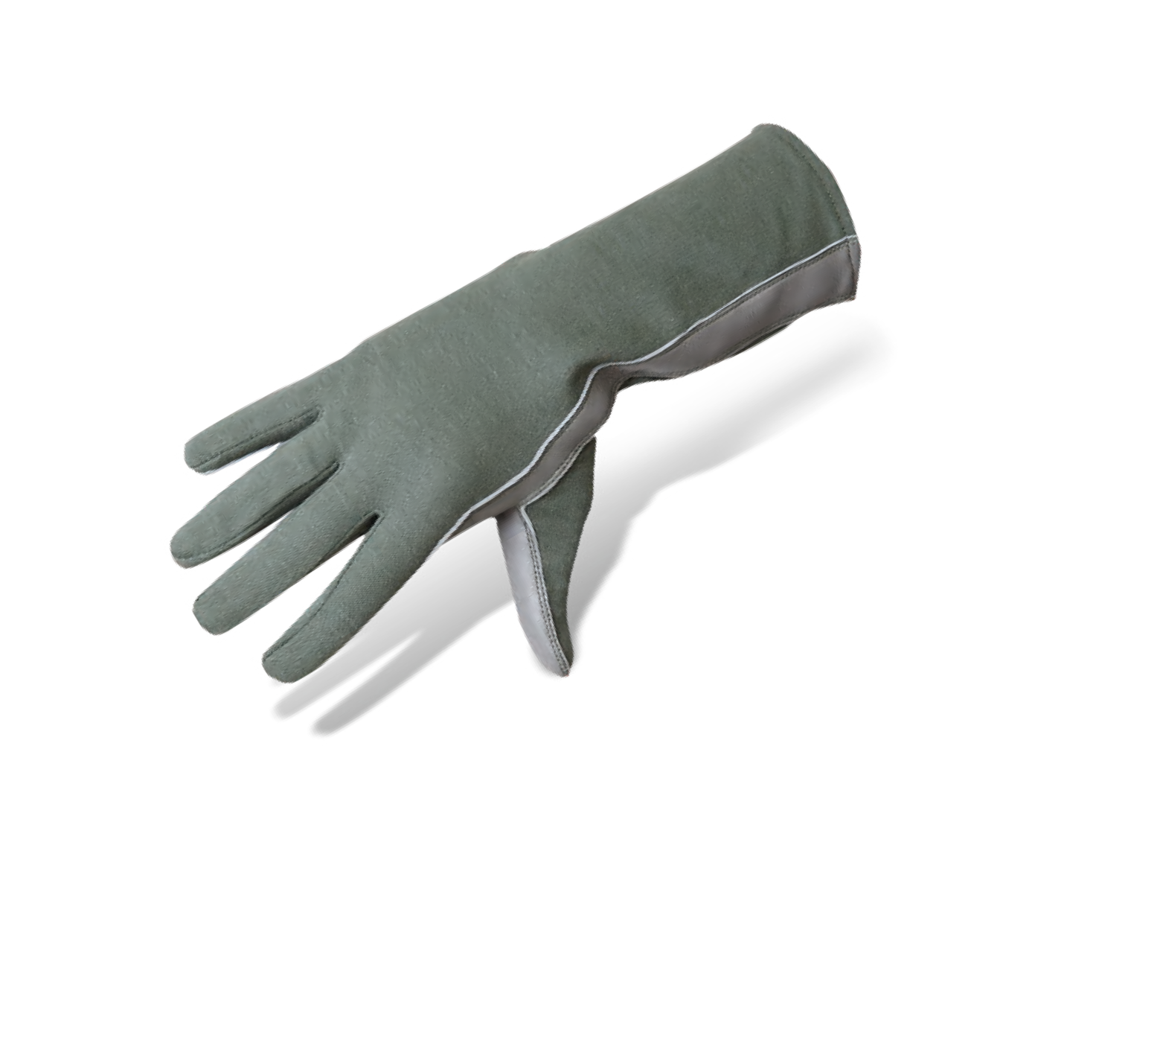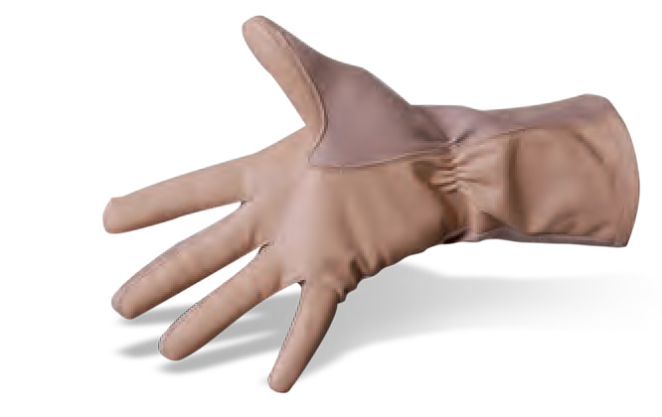
TA04083
Constructed with a 100% Nomex.
TA04066
Protects the face and crown from the sun.
TA04181
Fingerless gloves allow the wearer to move about freely while keeping in warmth.
34
MILITARY AND POLICE EQUIPMENT
WWW.TARIDEAL.COM
35
HEAD GEAR
GLOVES
Scan The Code

DUFFEL BAG
A.L.I.C.E. FRAME 25L RESERVOIR PERSONAL WATER

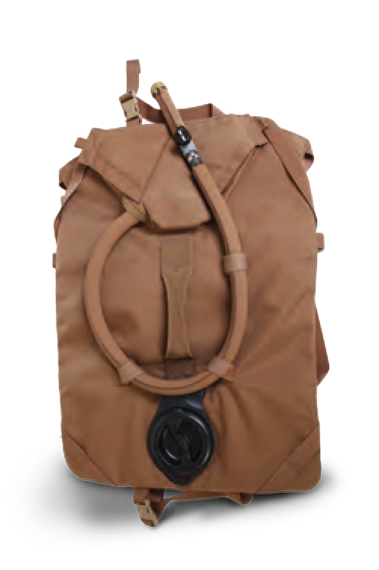
TA04046
TA04047 TA04052

RESERVOIR 3L

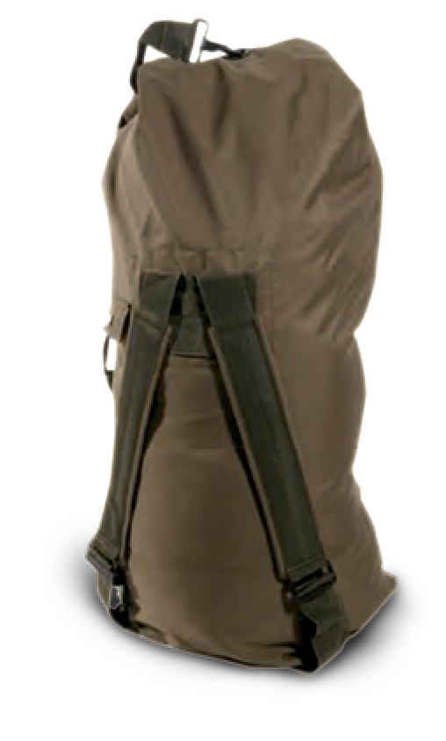
Top loading duffel bag
with snap hook closure.
Programmed flex pattern. Allowing natural and fluid movement of the upper body. The saved angular momentum protects the back.
The 25L reservoir eliminates the need for inefficient jerry cans in the field.

TA04053
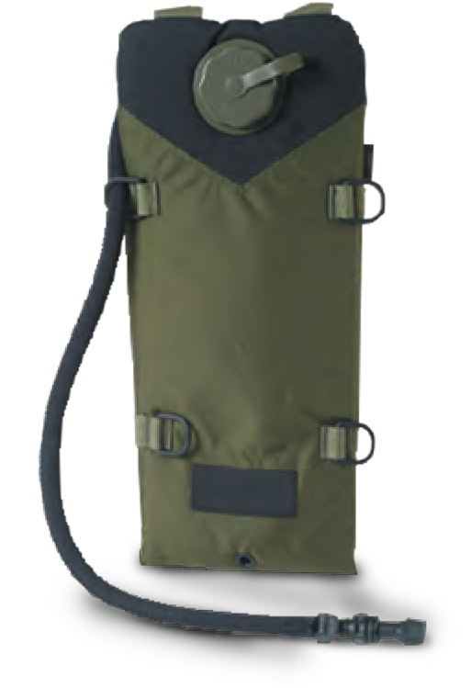
Includes hydro-link modular connection system with positive shut off hydrolock exterior fill port for filling up on the go.

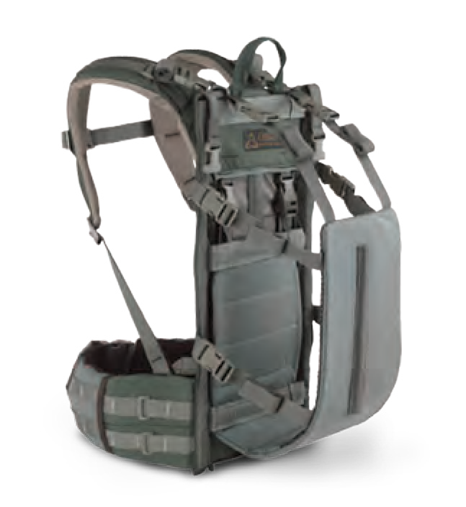
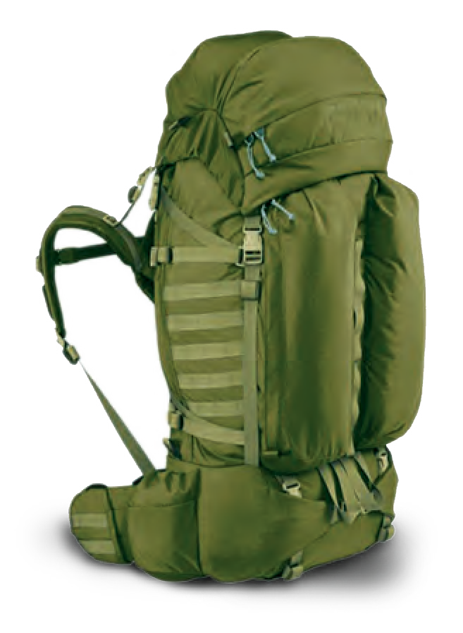
BACKPACK EQUIPMENT BAG
TA04048 TA04049

3L RESERVOIR WITH STORAGE

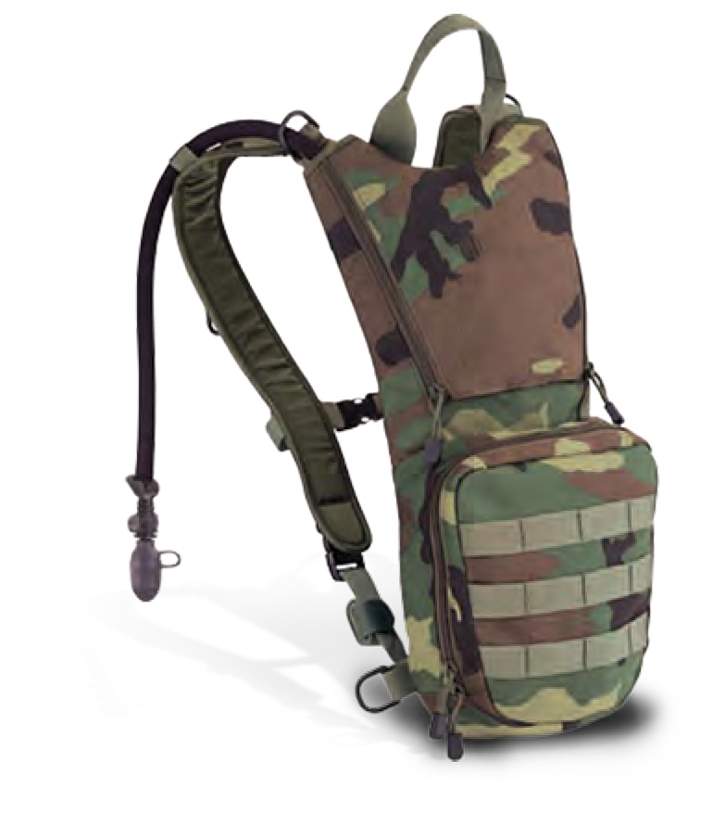
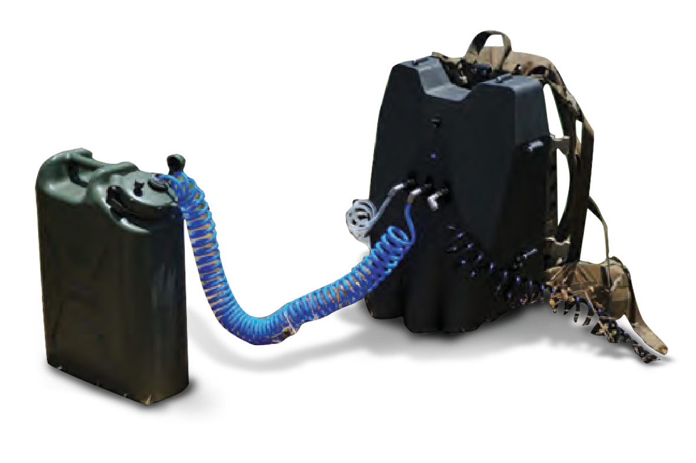TA04055
WATER FILTER
TA04182

Fully adjustable to fit different sized objects.
Designed to carry infantry gear. Made of 1000 denier, water resistant. Heavy duty zippers and removable nylon web strap.
Closed cell insulation and neoprene tube cover keeps water cool or warm for hours.

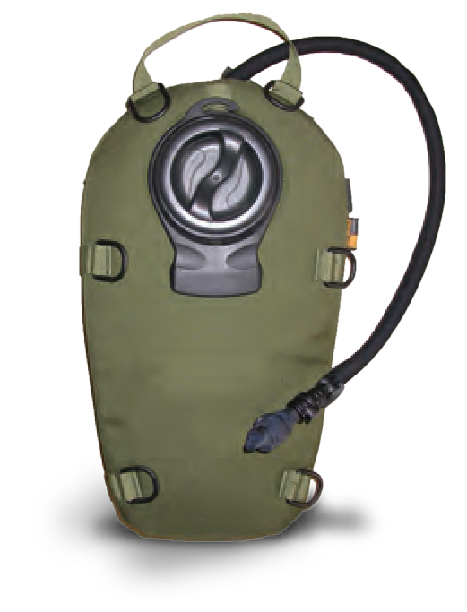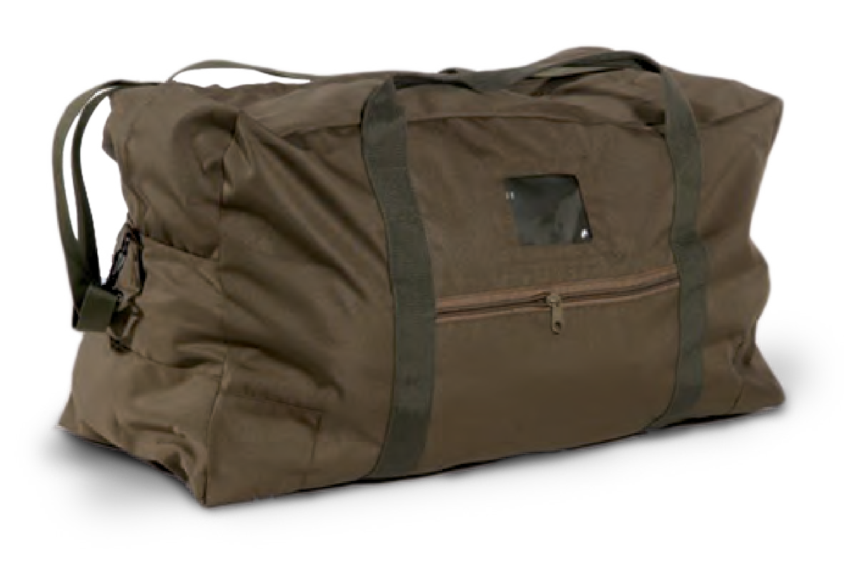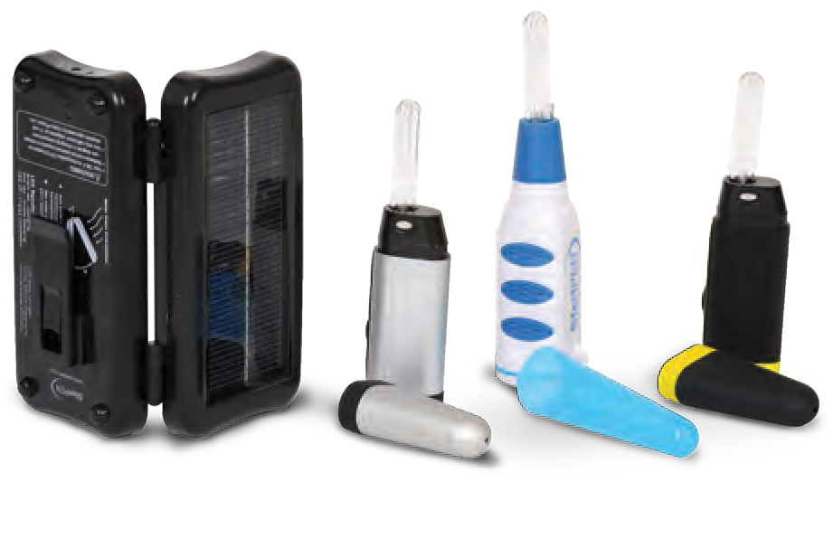
up with 200L of
gear and up to 3L water.
Without any chemical taste, smell or side effects.
TA04057
36
MILITARY AND POLICE EQUIPMENT
WWW.TARIDEAL.COM
37
TACTICAL PACKS
WATER SOLUTIONS
Scan The Code

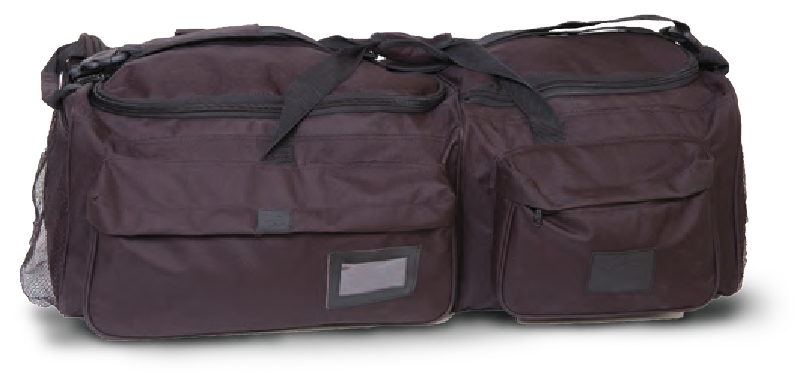
BACKPACK WITH RESERVOIR

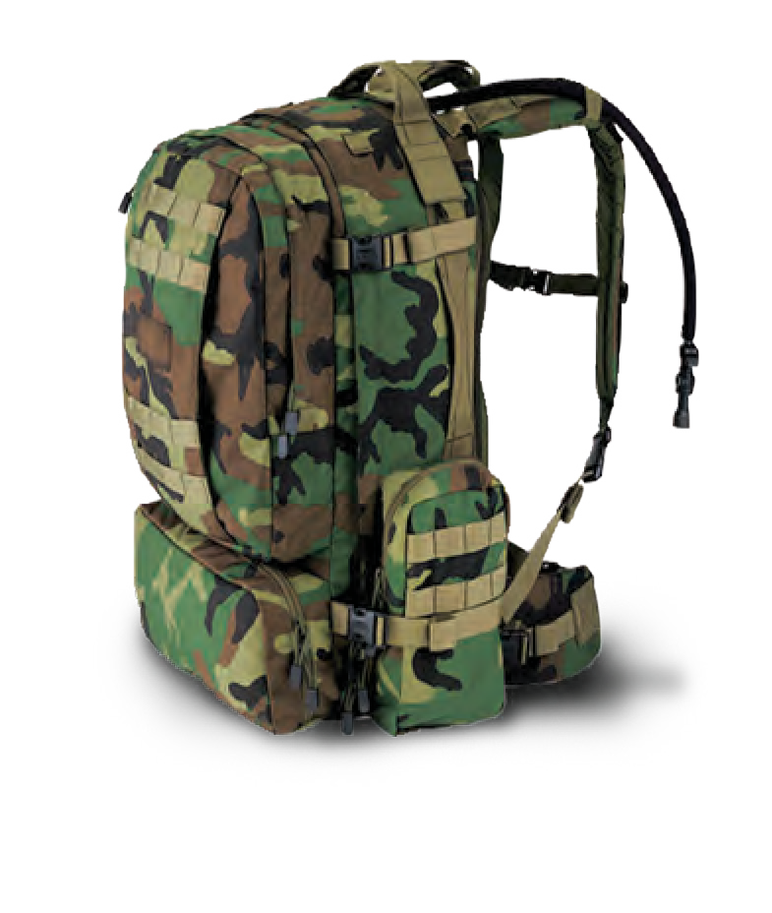
TA04051
Can be loaded

PERSONAL BAG

TA04050
Fully adjustable to fit different sized objects.

WATER PURIFIER

TA04056
Chemical-free water treatment solution. Uses ultraviolet light to destroy waterborne microbes.

1.5L RESERVOIR

BALLISTIC GOGGLES

TA02083
TPM 46
TA03046

ELBOW/KNEE PADS CLIP-ON KNEE PADS

TA04094 / TA04092 TA04093

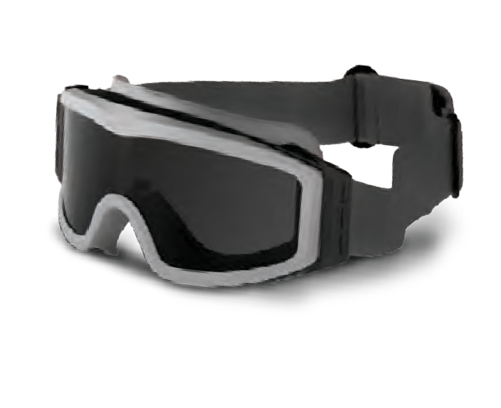
Lightweight eye protection offers a unique combination of high level protection and an unrestricted field of view.

VENTILATED GOGGLES

TA04086
Goggles with 2-speed fan utilizes micro-rotor technology to eliminate fogging in only seconds. Designed for Infantry, S.W.A.T. and Special Forces.

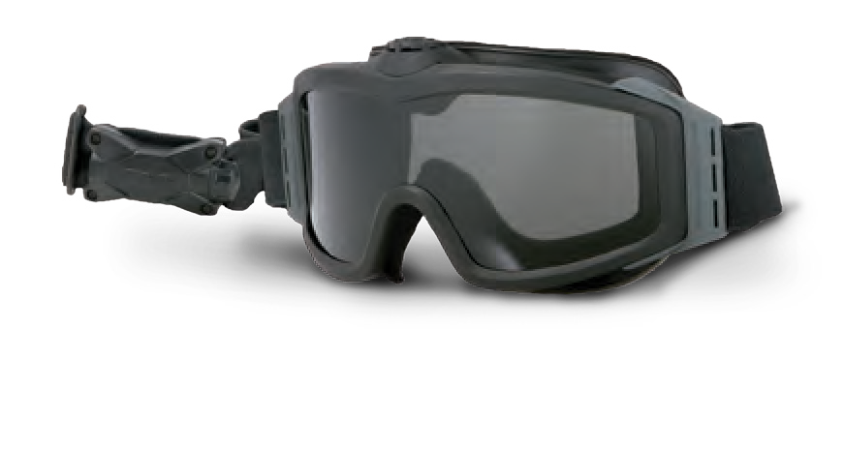

”FLY-EYES” GOGGLES

TA04088
Tactical eye wear with ballistic lenses.
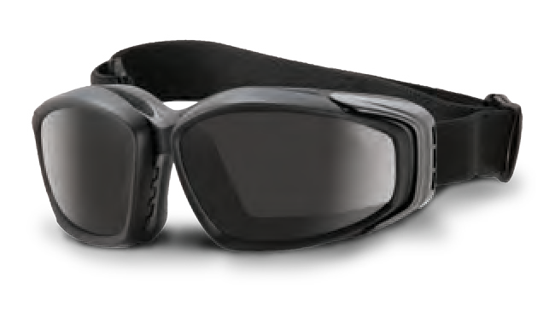

SHOOTING GLASSES

TA04090
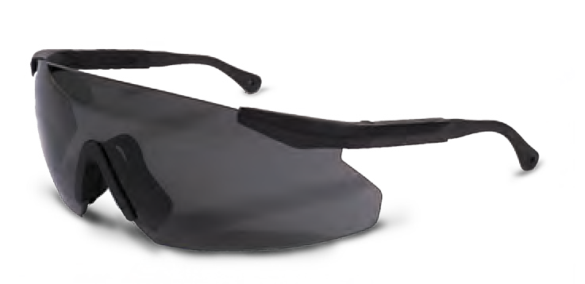
A revolutionary new approach to ballistic eye protection with premium anti fog/anti-scratch lenses.
Full unobstructed vision panoramic face shield. Voice diaphragm to facilitate voice communication.

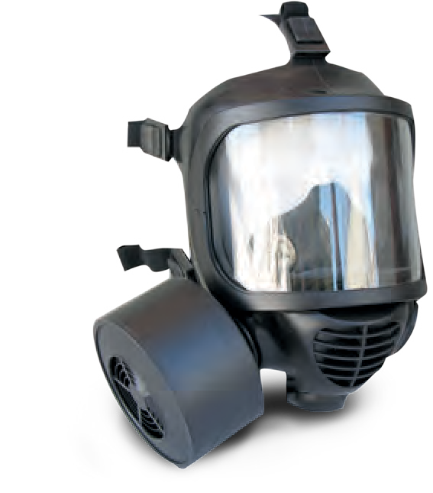
PROTECTIVE EARPHONES
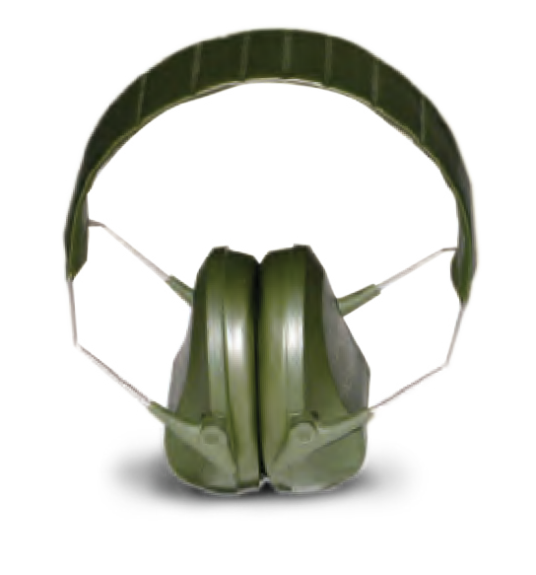
TA04087

EAR PLUGS
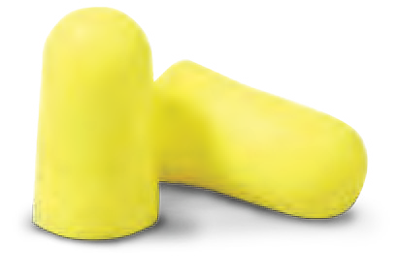
TA04089

MILITARY COMPASS

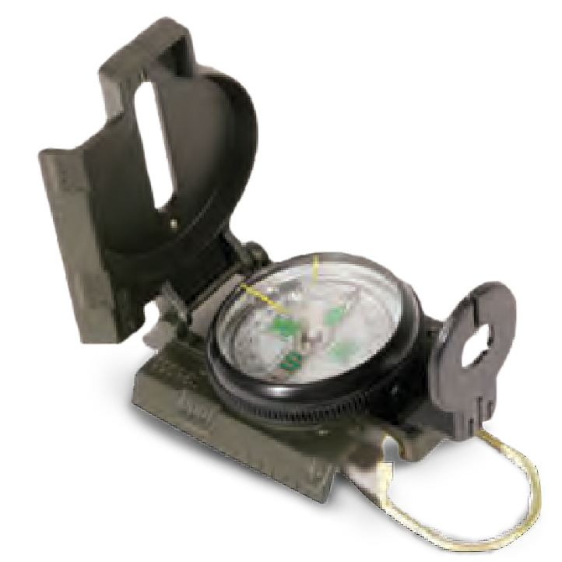
TA04091
Lightweight compass, used by armies around the world.
Designed for high-intensity Infantry
units. One size fits all.
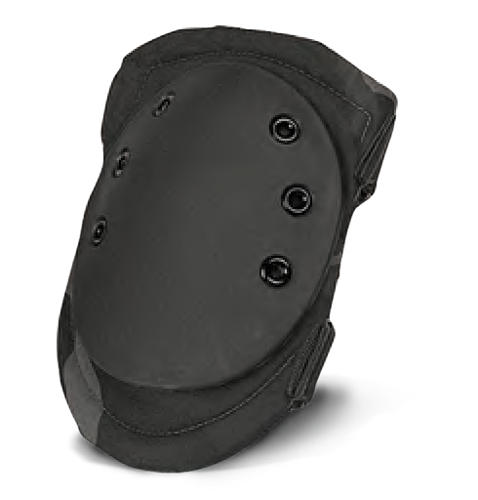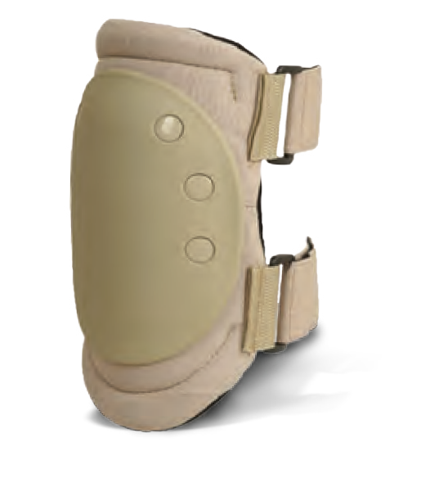

ADVANCED KNEE PADS

TA04096
Hybrid construction which combines high and low density materials to deliver maximum “cush” with knee pad support.
Heavy duty clip-on kneepads are clipped onto the field pants, then the clip-locks over the clip to lock them down. Velcro back to the kneepads for a long lasting comfortable fit.
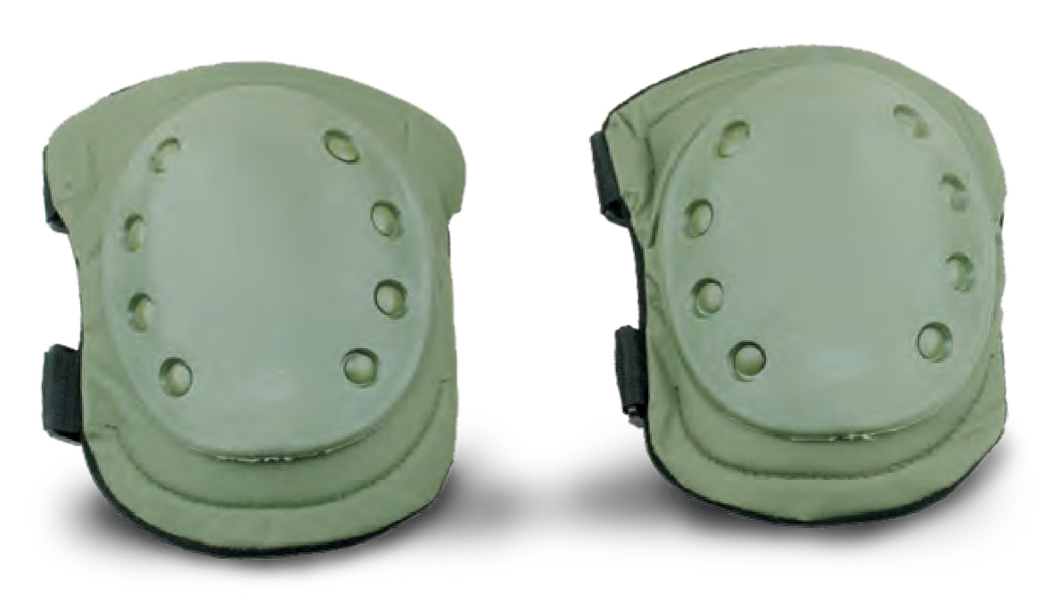

NEOPRENE KNEE PADS

TA04097
Extremely flexible and fit comfortably under or over clothing, making them ideal for long-term wear.

COMBAT KNIFE
TA04095

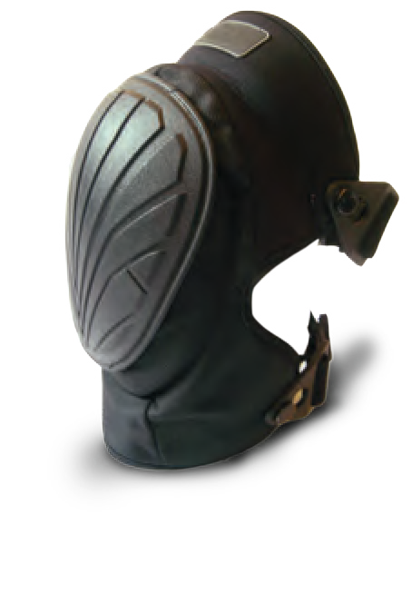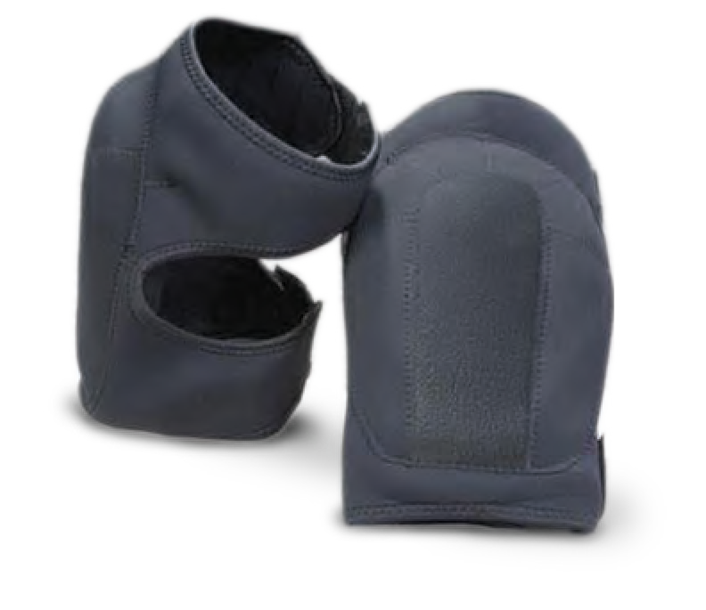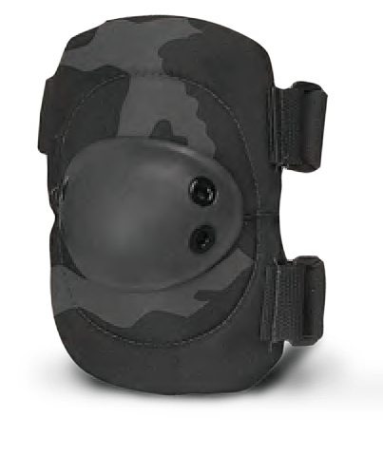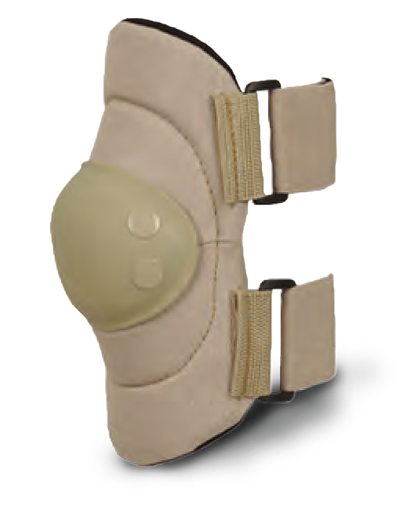
PERSONAL GEAR
Scan The Code
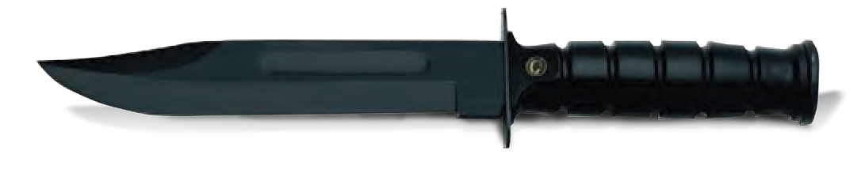

38 MILITARY AND POLICE EQUIPMENT WWW.TARIDEAL.COM 39

TACTICAL VEST WITH
MOLLE TACTICAL VEST
TACTICAL HELMET
BALLISTIC HELMET

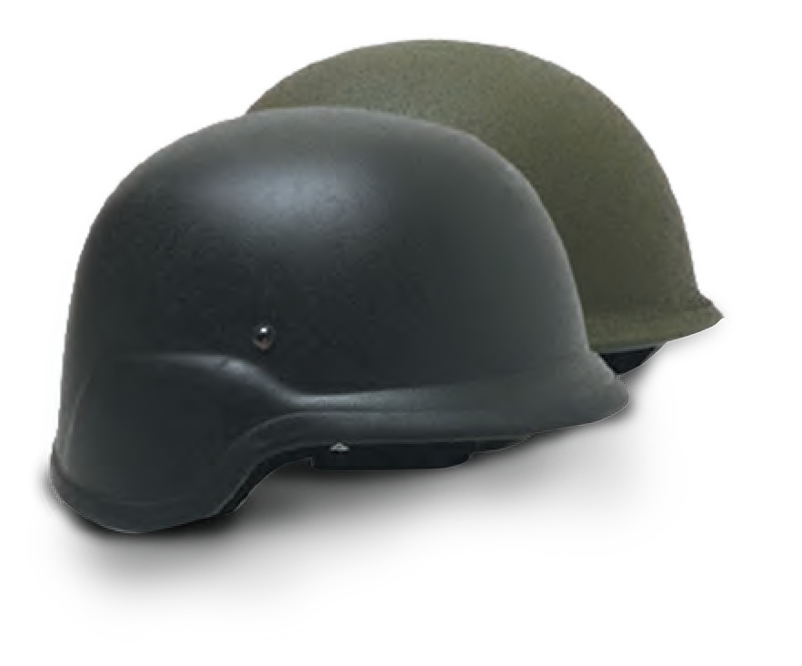
3L RESERVOIR TA02080
TA04200
TA02136

TA04098
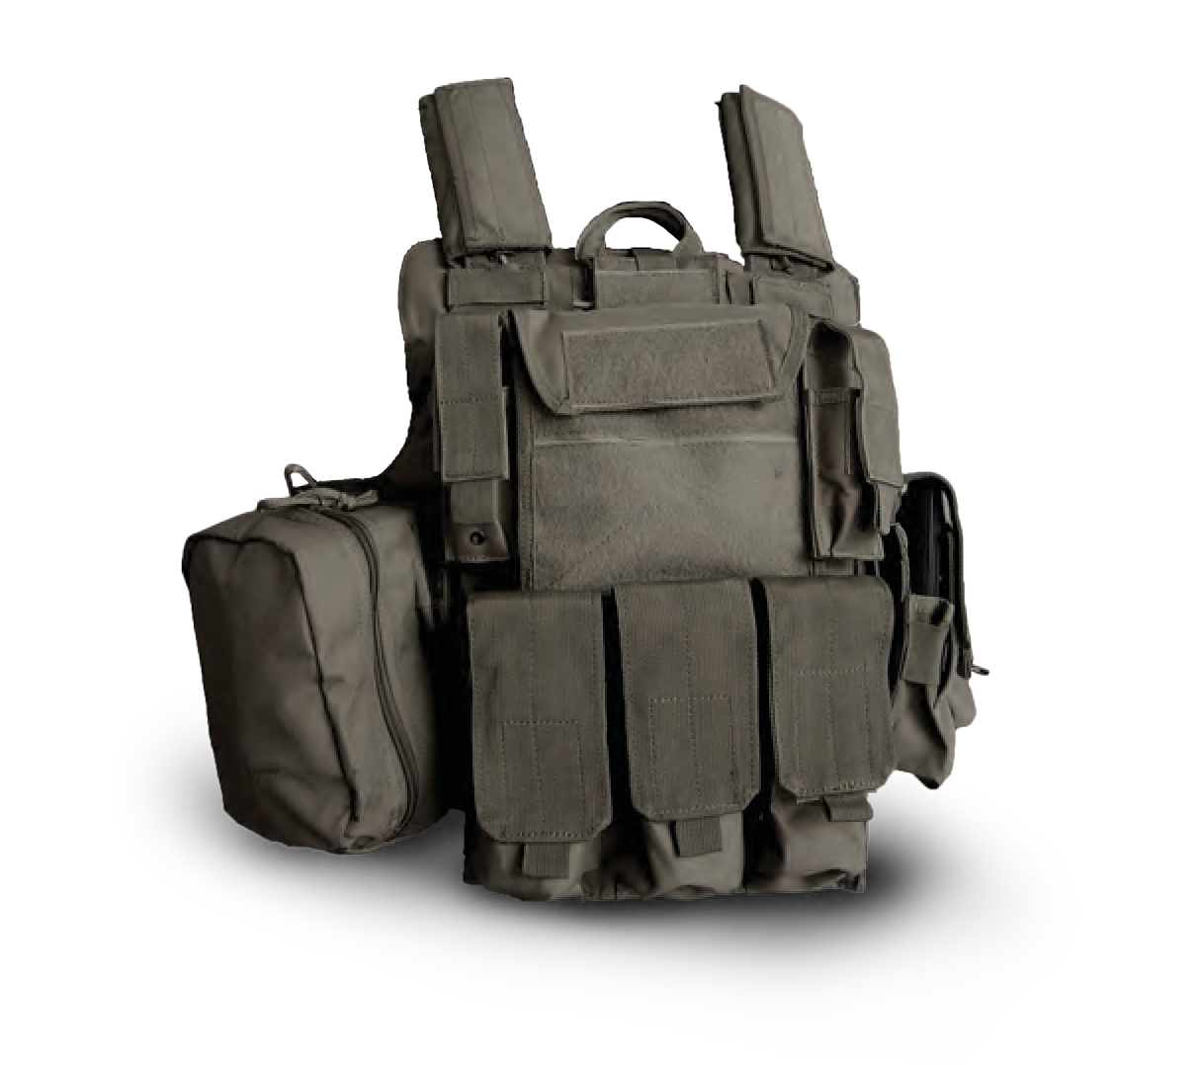
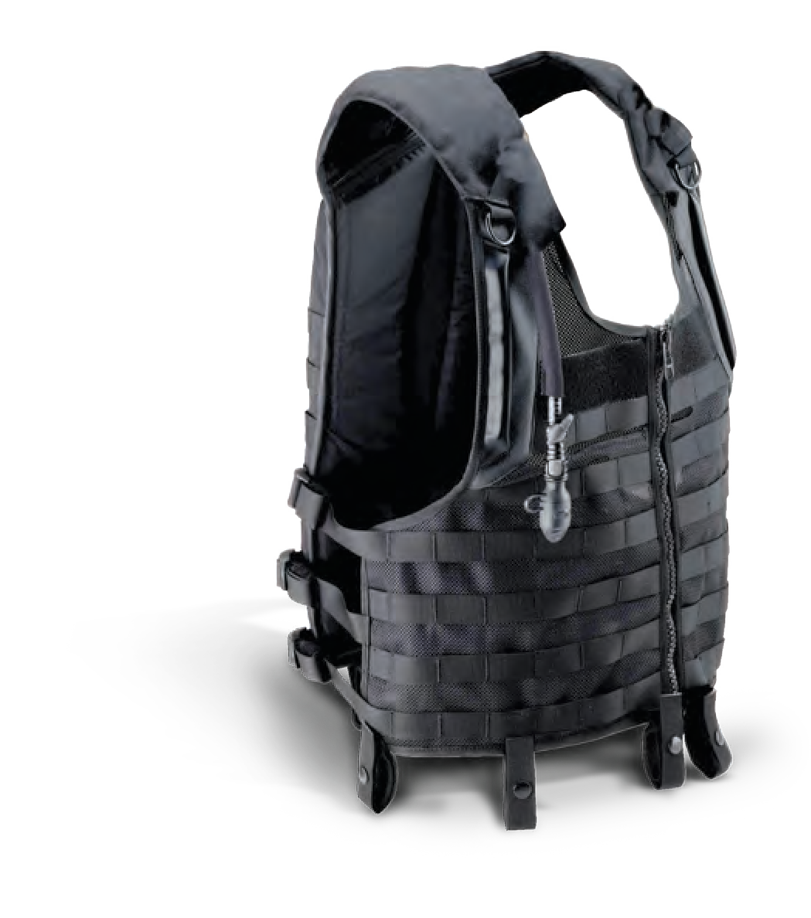Fully integrated hands free hydration, rugged pouches and ergonomic comfort. Available in black & foliage green.

MOLLE COMBAT VEST
Modular lightweight combat vest designed to provide exceptional comfort and functionality in the field. The vest has a full modular Molle paneling on the front, sides, and rear for attachment of additional user specified pouches.
Lightweight and multi-impact with ventilated line. Impact pads and comfort foam that is not affected by temperature, altitude or moisture.
TAR offers a range of helmet options to suit your mission needs, with varying weights and protection levels.

TA04100
The vest is made of 2 separate parts (front, back). This structure enables the inserting of ballistic plates into each part for maximum protection.

MULTI PURPOSE TACTICAL VEST

TA04101
Lightweight and designed to carry different types of accessories. One size fits all.

ADDITIONAL PROTECTION FOR TACTICAL HELMET

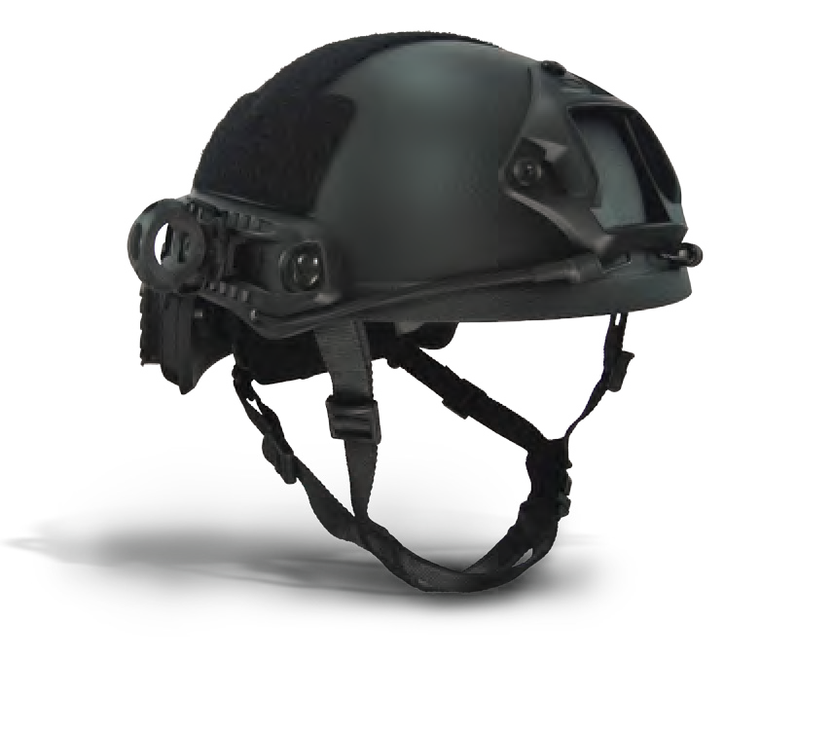TA04111
Protection against 7.62 round.

ENHANCED BALLISTIC COMBAT HELMET

TA04183
The enhanced combat helmet’s (ECH) shell is made of an ultra-high-molecular-weight polyethylene (UHMWPE) material. Additional devices may be attached.

CERAMIC BP PLATES

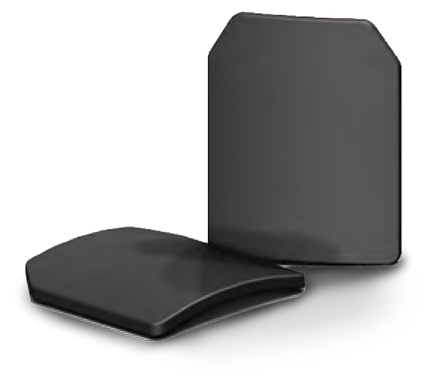
TA04103
Lightweight ballistic protection for military use and personal protection.

PE LIGHT BP PLATES

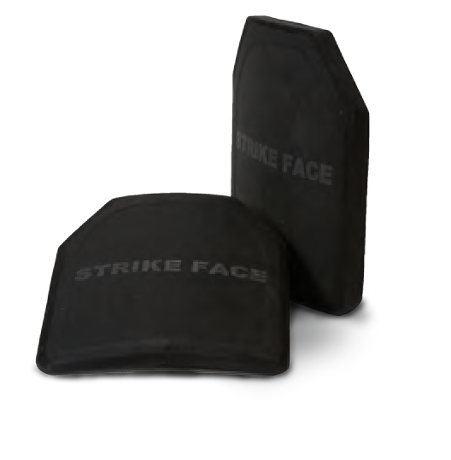
TA04102
Provides lightweight protection against high power armor piercing piercing, improvised explosive devices, shrapnel and artillary fragments.

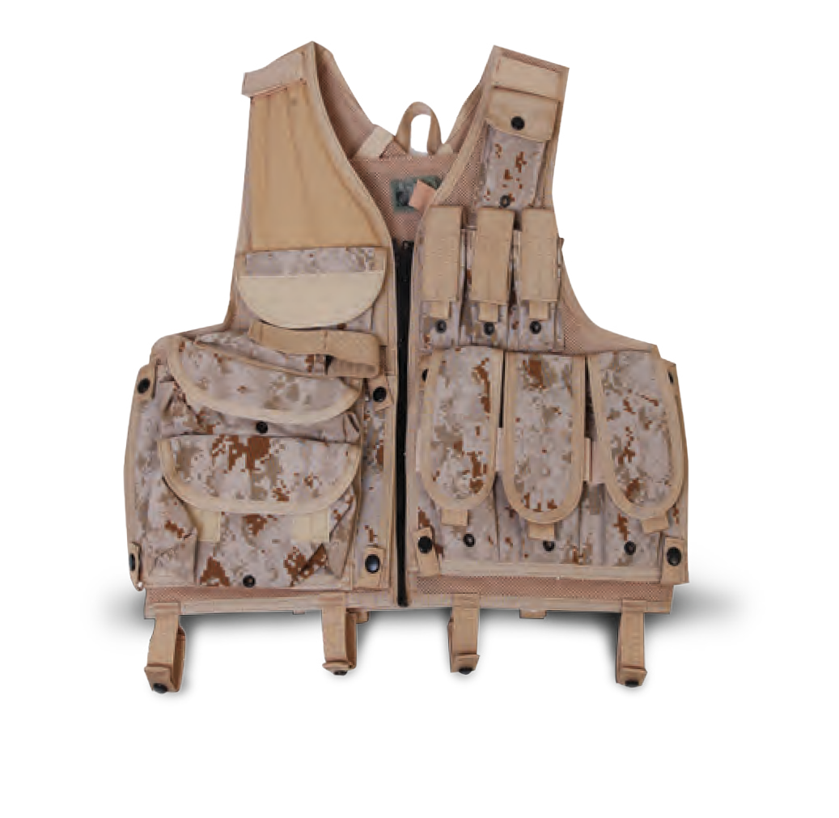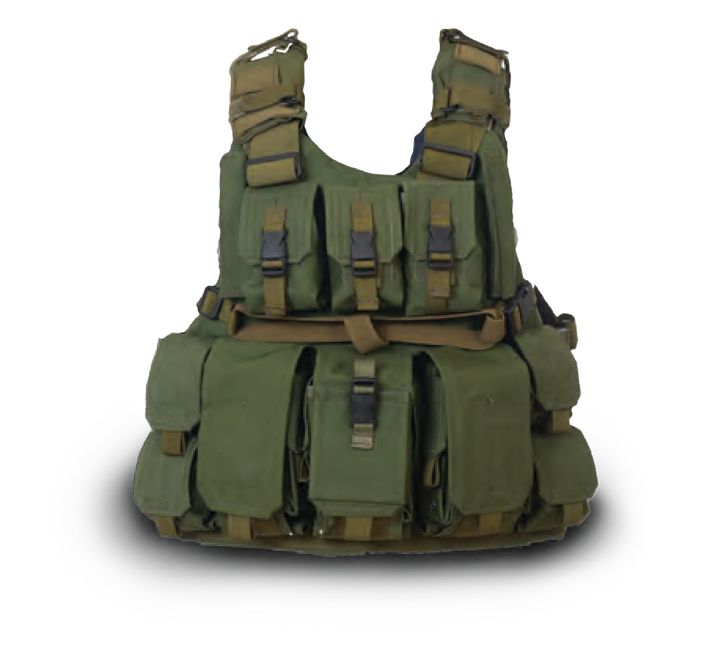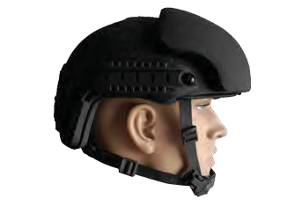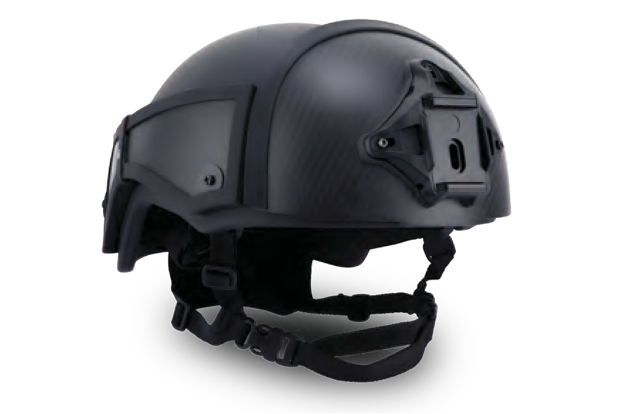
VESTS & BALLISTICS
Scan The Code

40 MILITARY AND POLICE EQUIPMENT WWW.TARIDEAL.COM 41

COMPASS BINOCULARS
STABILIZED BINOCULARS
NIGHT VISION GOGGLES
COMBINED NIGHT & THERMAL

TA03116 TA04032
TA03121

VISION BINOCULAR

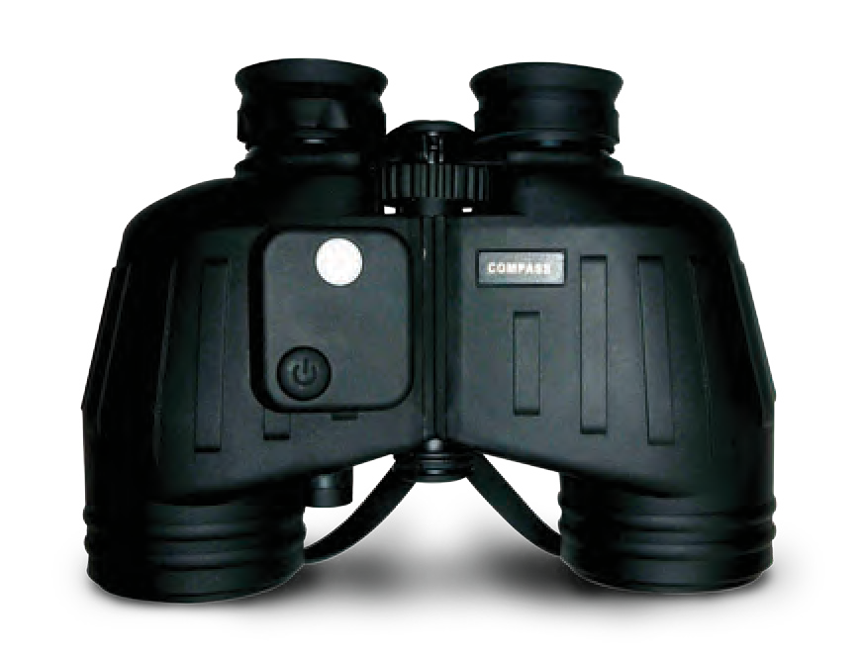
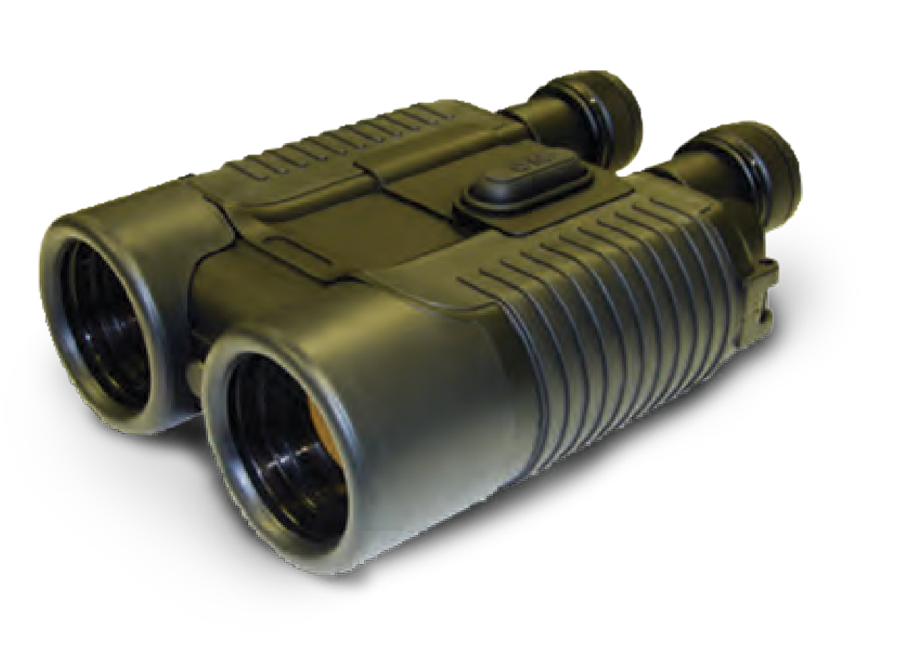
Impressive light transmission for surveillance, navigation & other low-light applications.
The stabilized binoculars can easily view, record and/or transmit people and events from any mobile platform. Can be converted to night vision unit.
The most widely recognized and dependable
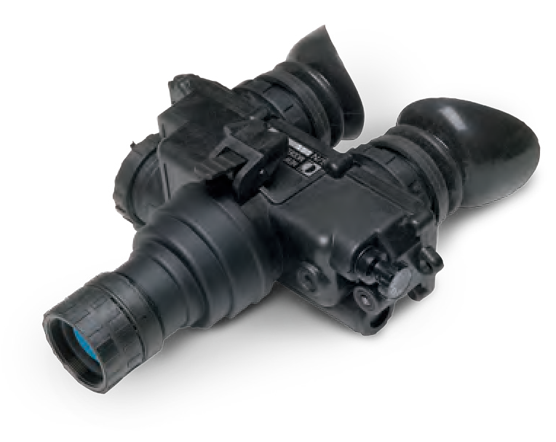
U.S. Military night vision goggle system available. Combat proven with rugged, ergonomic design. Thermal technology can be incorporated.

TA04213
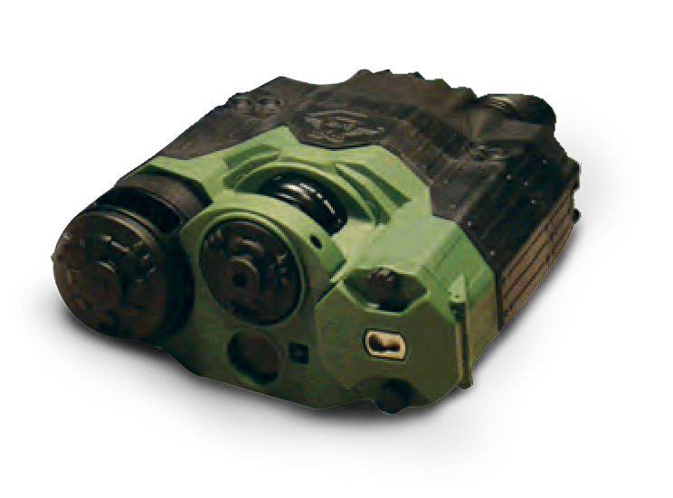
This binocular has a combination of thermal and high-sensitive night vision channels and is a highly effective tool both combined day and night observation in any climate or terrain.

LONG RANGE BINOCULARS
TA03118

LASER RANGE FINDER

TA04201

NIGHT VISION MONOCULAR

THERMAL MONOCULAR

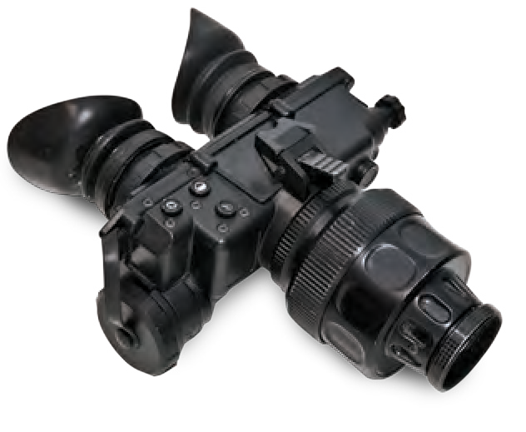
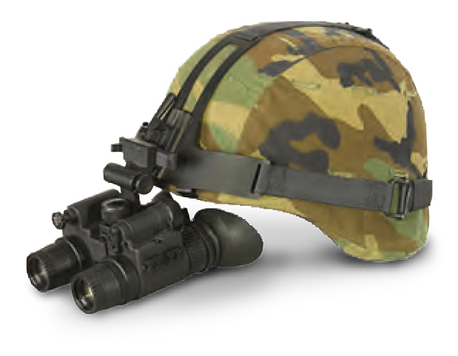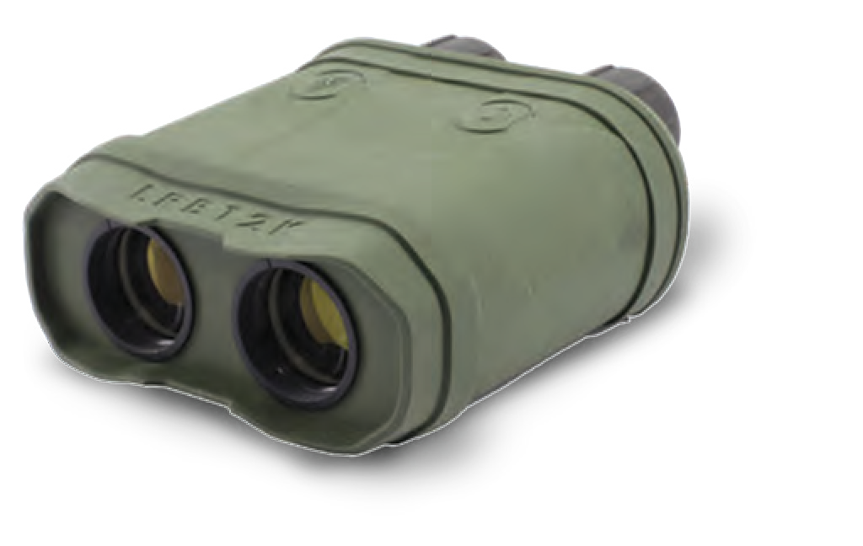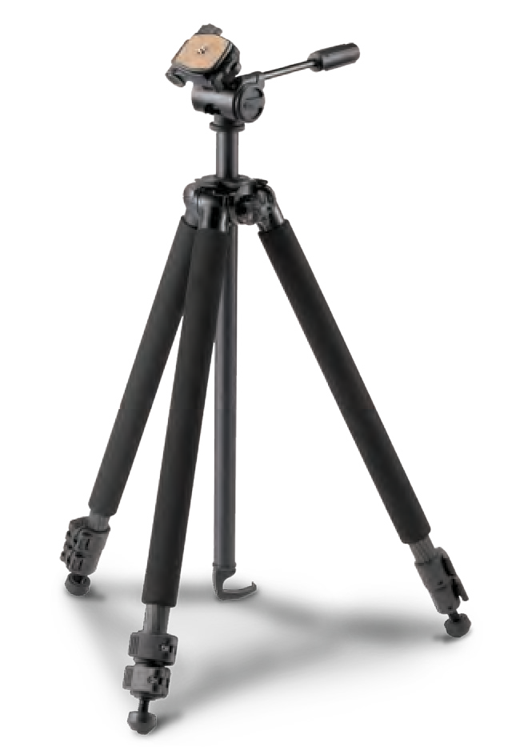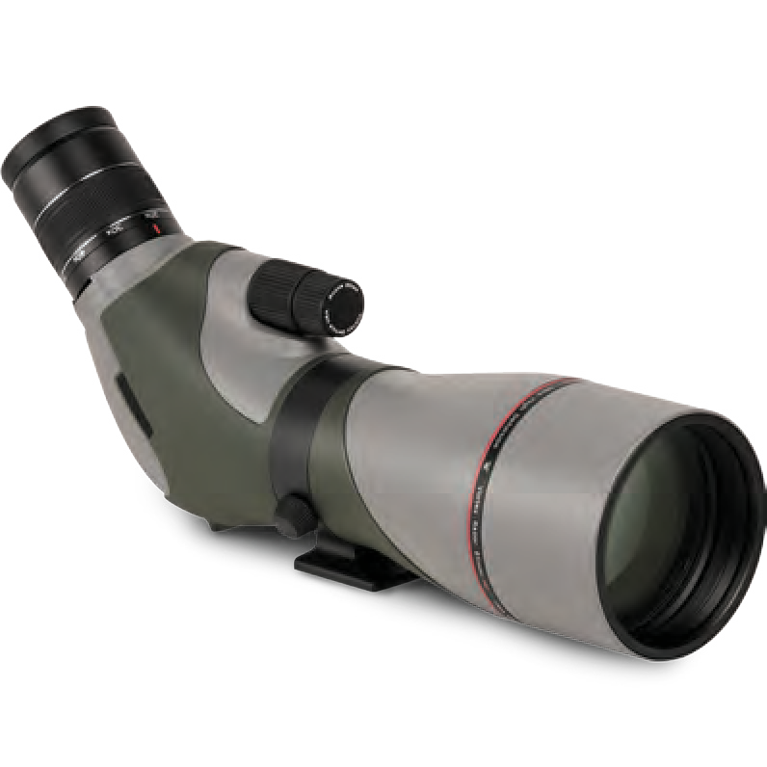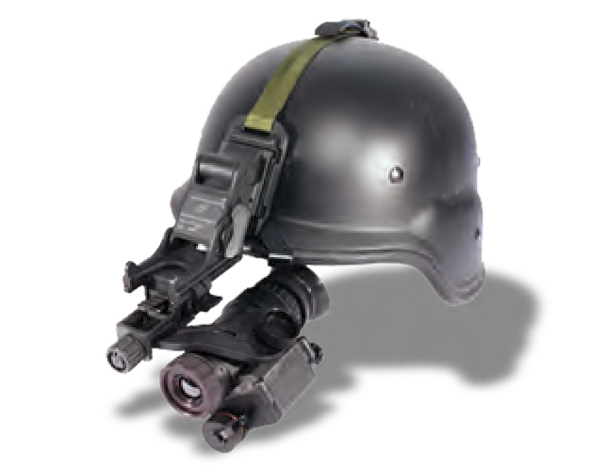
Resilient, waterproof, shock resistant and rubber
armored binoculars. Although light enough to be held. A tripod mount is included.
TA03119
The night vision monocular is equipped with manual variable gain control so that the image brightness level can be selected by the user.
TA2220
High-end thermal monocular for all military needs. The high-precision all-terrain system combines the most sophisticated technologies to form a clear and distinct thermal image.
SPOTTING SCOPE
TA04033
Small portable telescope with added optics
TRIPOD
TA04184
to present an erect image, optimized for the
observation of terrestrial objects.
NIGHT VISION BINOCULAR
TA04034
Dual tube night vision binocular for enhanced depth perception and performance. Ideal for night driving or any tactical situation.
THERMAL GOGGLES
TA02094
The thermal goggles made for all military needs and provide enhanced depth perception performances.
42
MILITARY AND POLICE EQUIPMENT
WWW.TARIDEAL.COM
43
DAY OPTICS
NIGHT OPTICS
Scan The Code

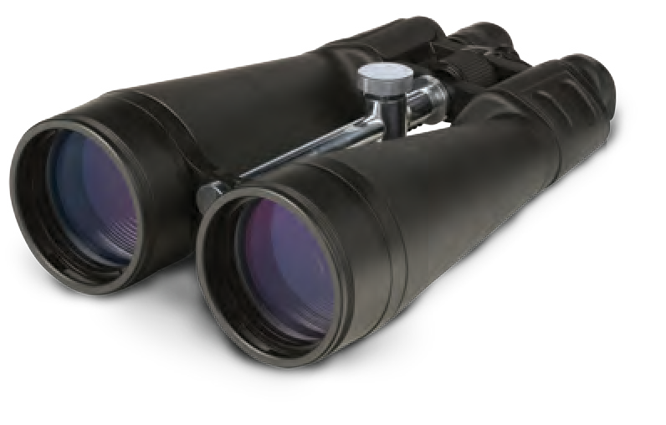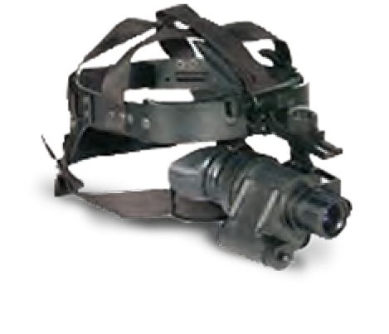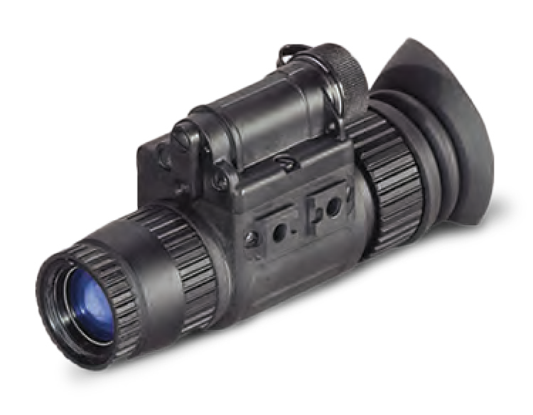

SCOPE X4-16
TA02026
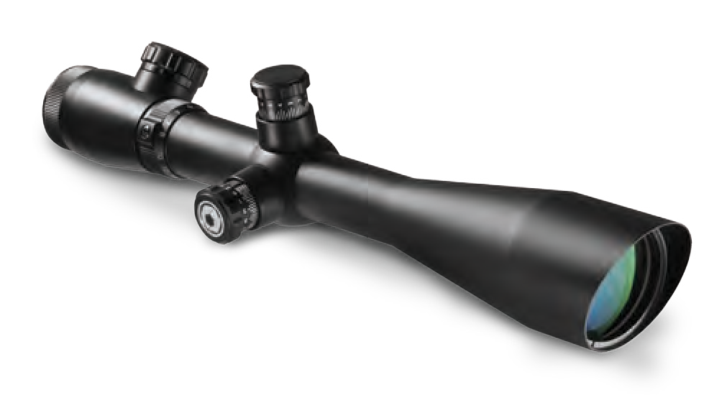

SCOPE X5-25

TA02028
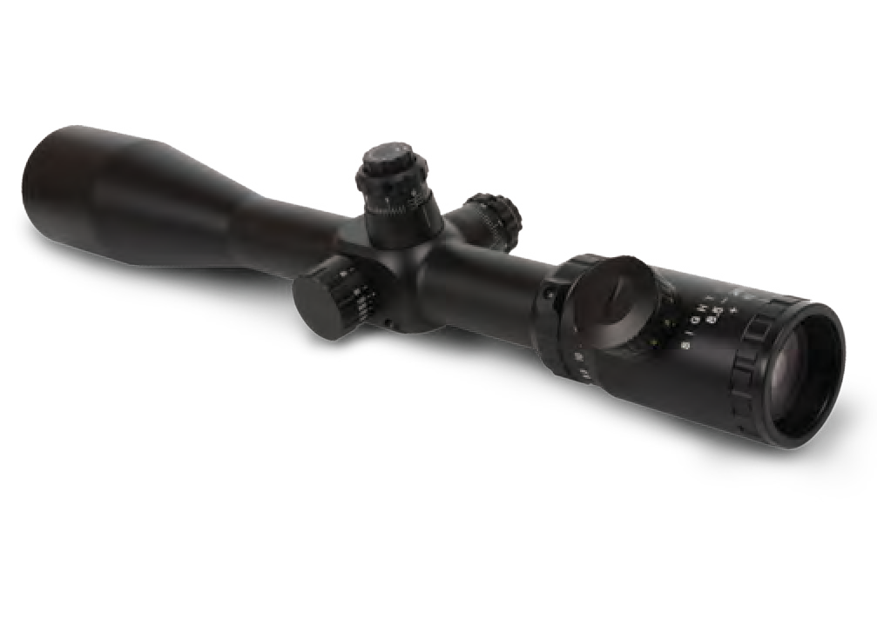The X5-25 provides a full 5x and a wide field of view. The scope features high elevation and windage ranges for bullet drop compensation.
X1.5-6
TAROS

TA02086
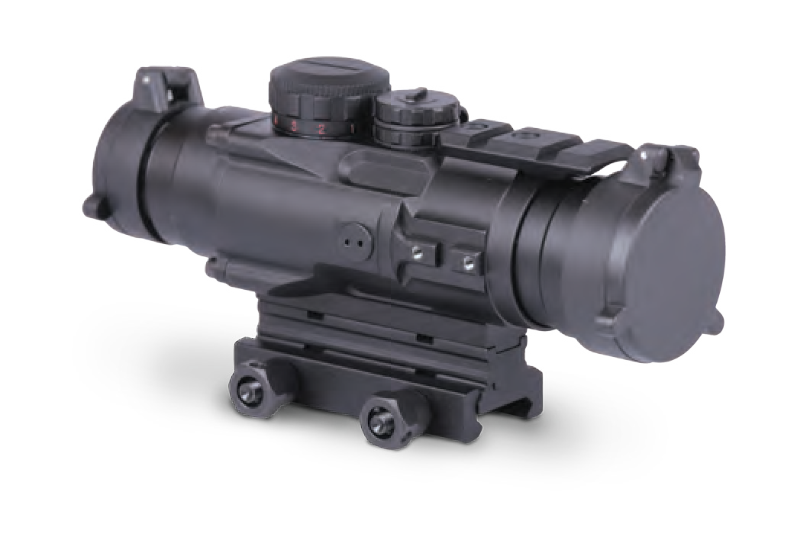The 4 prism scope is a compact “close quarters” optic. Waterproof and fog-proof. The scope features fully multi-coated lenses for bright see- through capability.

DAY SIGHT

TA02103
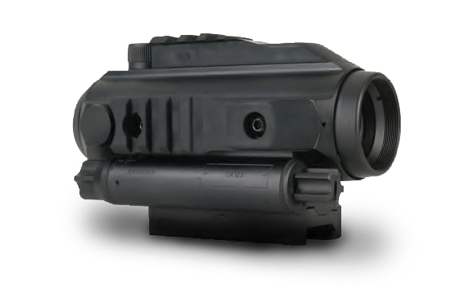
Provides instant all-light capabilities. Battle proven, easy to use. Accurate and reliable.
CLIP ON

TA02029
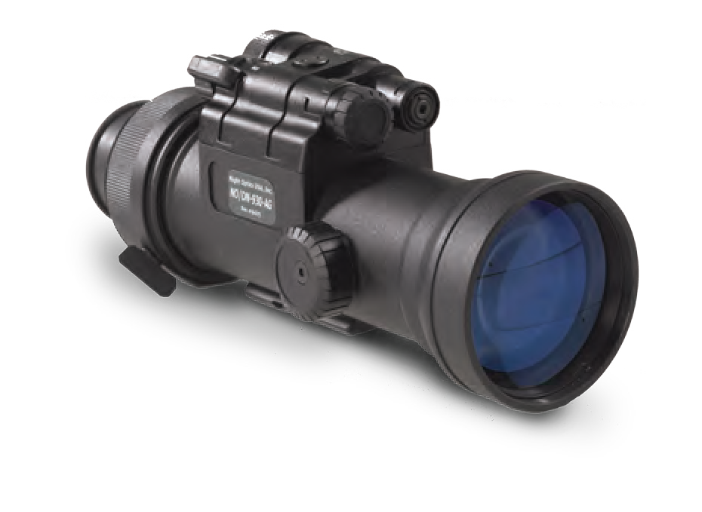The night vision unit is mounted in front of an existing scope to give the day scope night vision capability. Suitable for use with most commercial & military day sights.

WEAPON MOUNTED

MONOCULAR
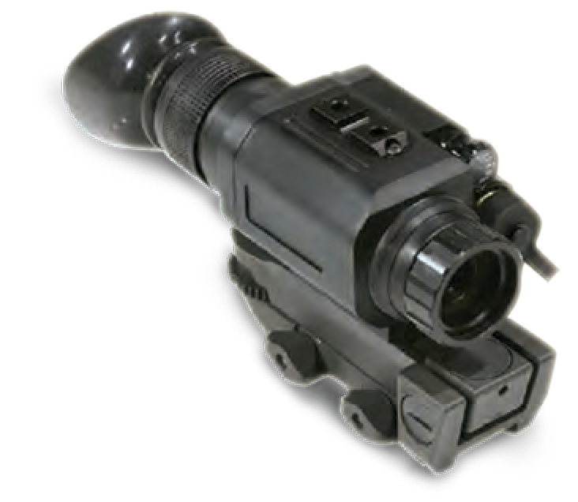
TA04202

NIGHT VISION RIFLE SCOPE X4 OR X6

TA02027
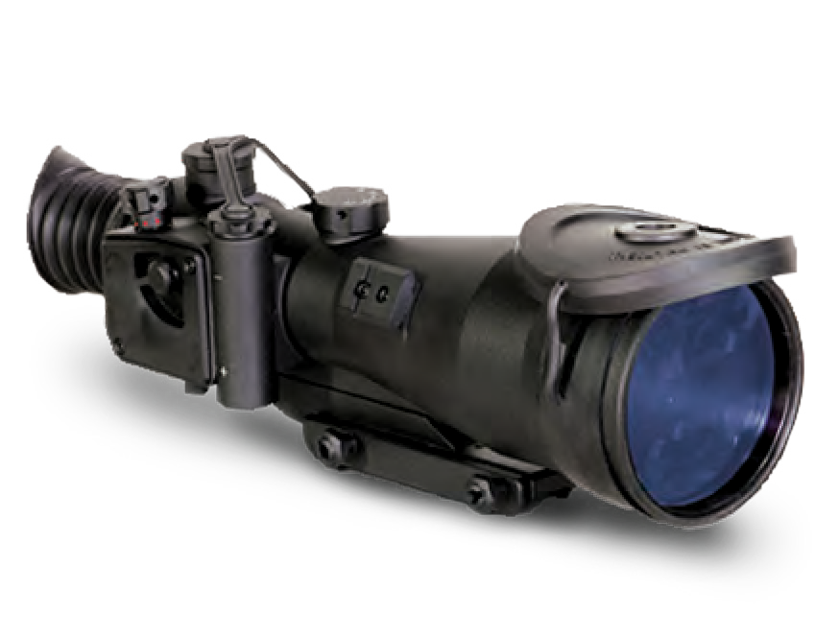Provides exceptional quality image resolution under varying light conditions. The scope is easy to service and maintain. X4 or X6 powerful magnification available.

DIGITAL NIGHT VISION

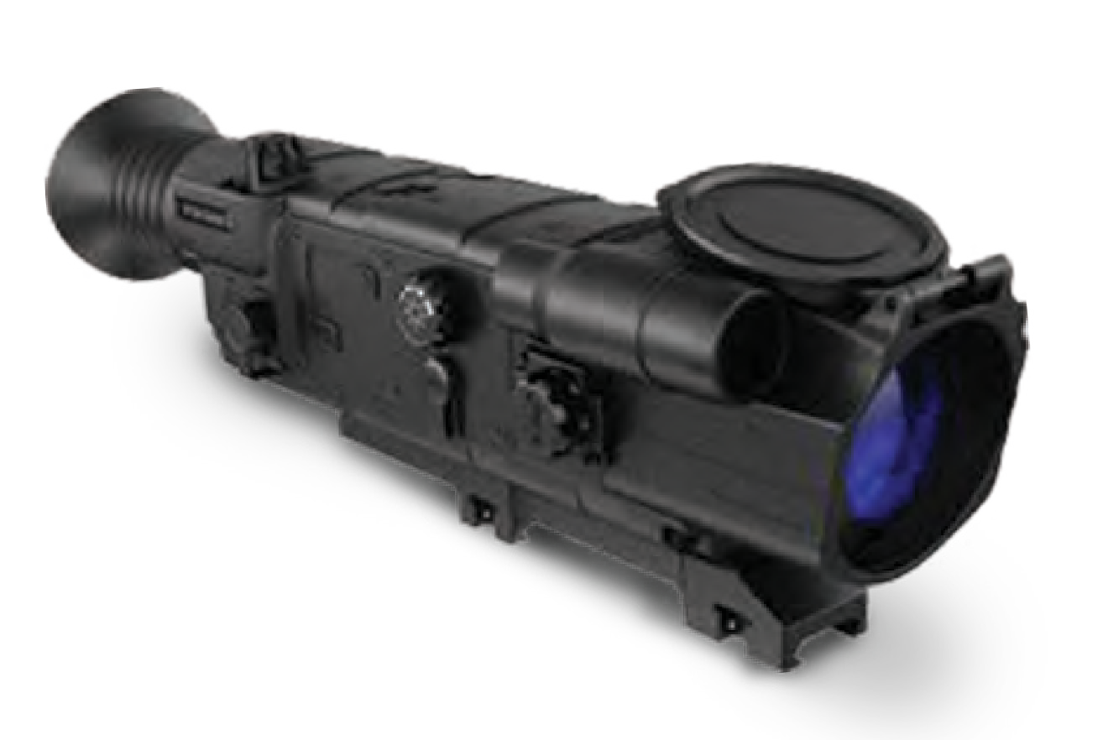TA04185

THERMAL SIGHT

TA02030
The multi function combat day sight uses a revolutionary optical design that combines close combat & precision fire, and high efficiency for extended low light performance.

RED-DOT SIGHT
TA03168

LONG RANGE INFRA-RED SIGHT

TA04186

TA2222
High-end thermal sight is an innovative high- precision all-terrain weapon sighting system. It combines sophisticated technologies to create a clear and distinct thermal image.

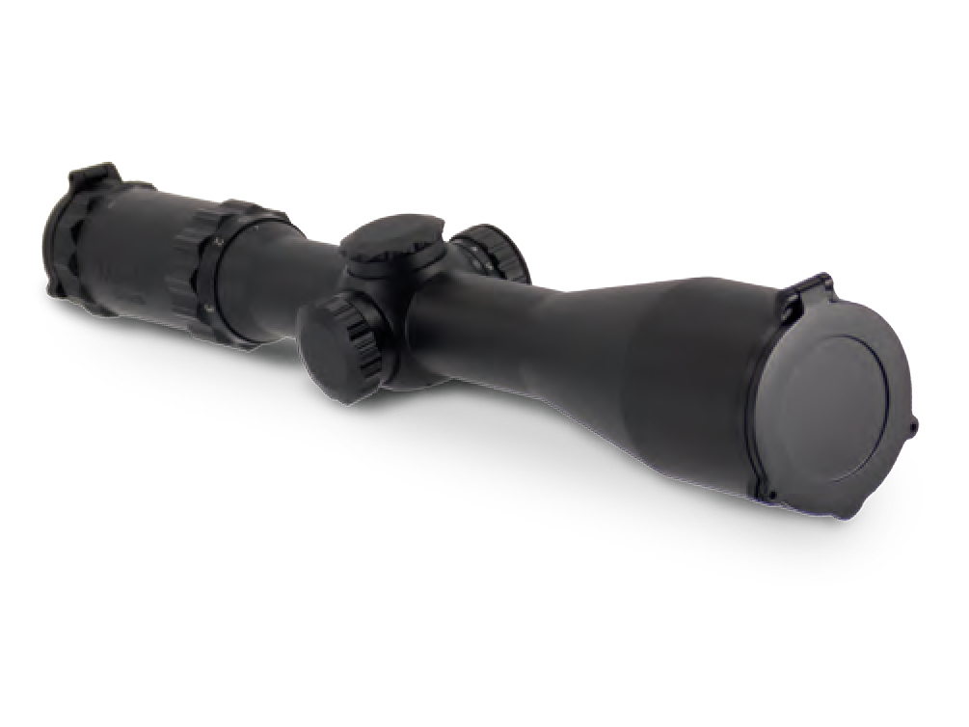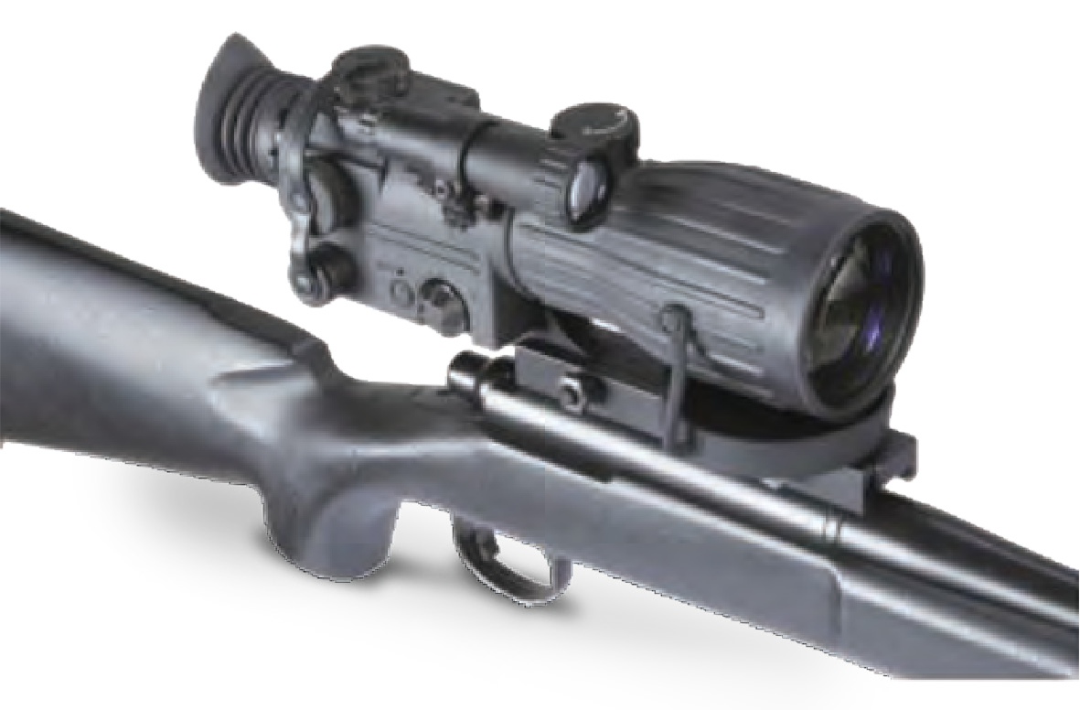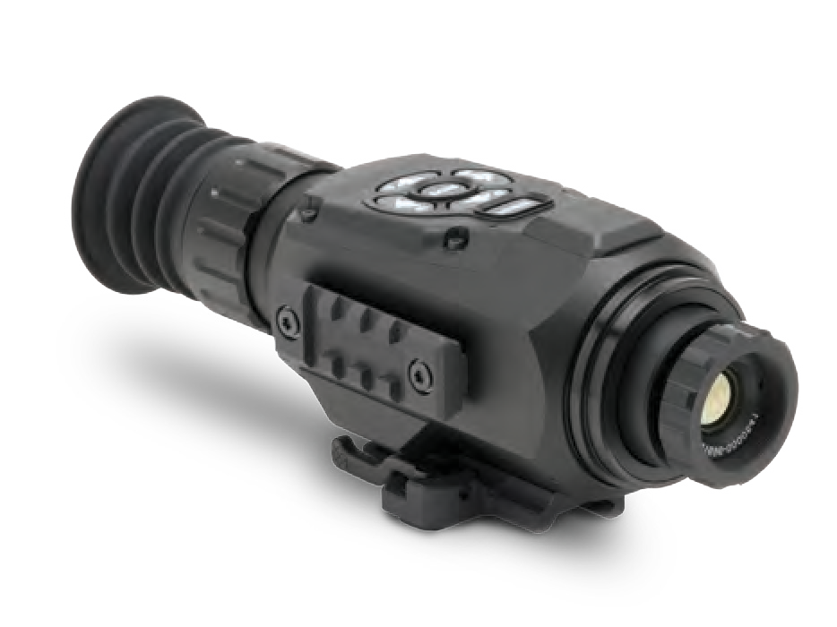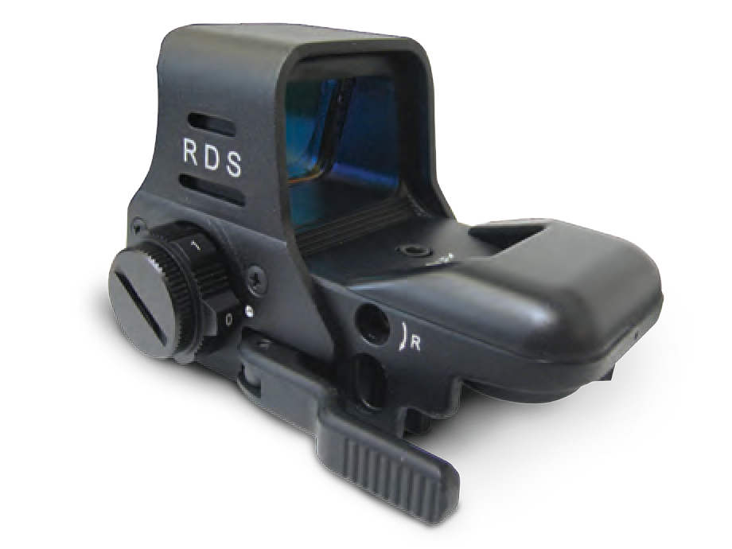
DAY SIGHT
NIGHT SIGHTS
Scan The Code

44 MILITARY AND POLICE EQUIPMENT WWW.TARIDEAL.COM 45

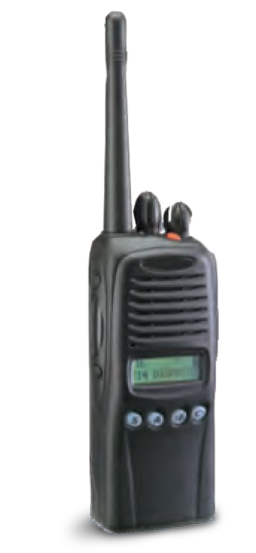
RADIO SYSTEM

TA04107
Professional 2-way radio.

PORTABLE COMMUNICATION SYSTEM
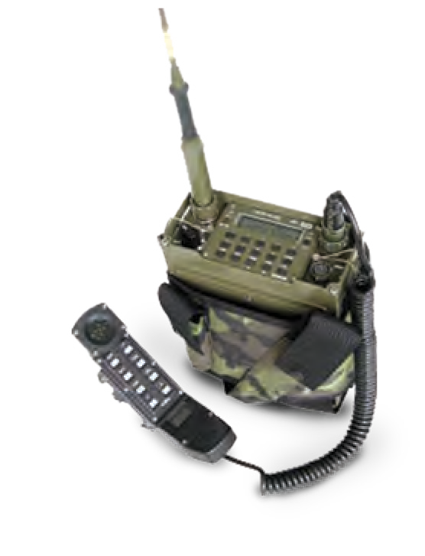
TA04187

TACTICAL HEADSET

TA04203
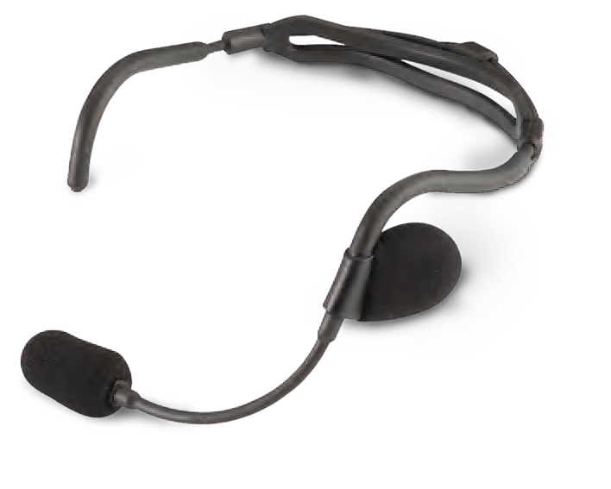
Flexible behind the head headset with left boom microphone.

THROAT MICROPHONE
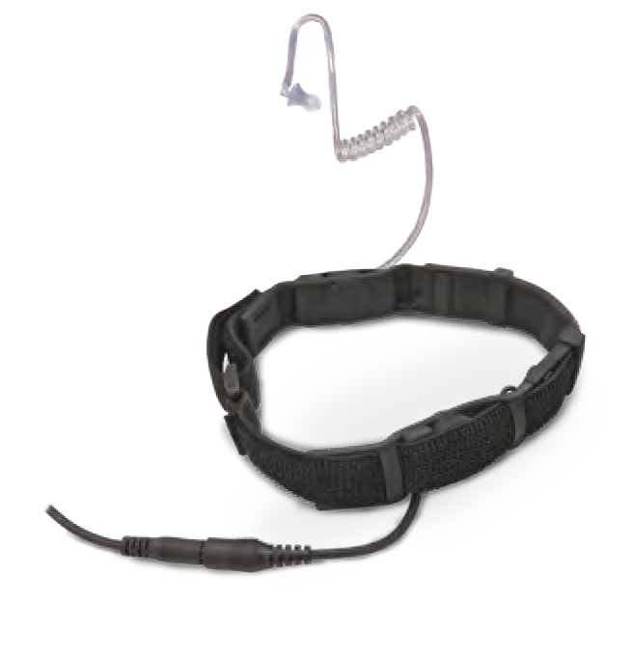
TA02143

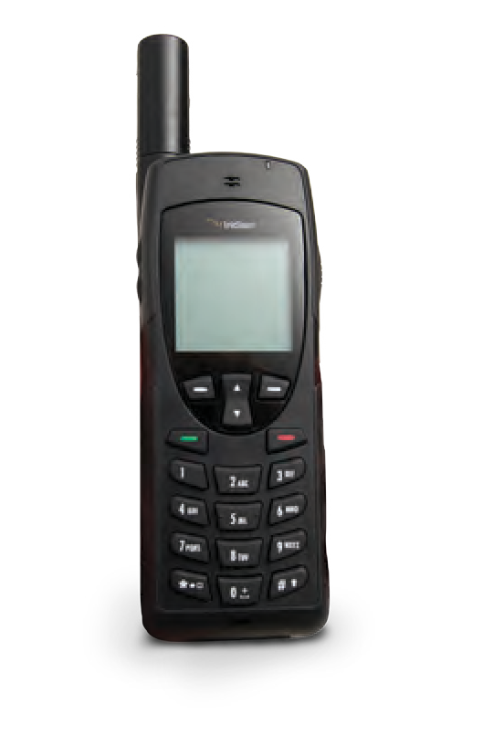
IRIDIUM HANDSET
TA03179

PUSH-TO-TALK IRIDIUM SATELLITE PHONE

HEAVY DUTY HEADSET
ARMY HEADSET

TA04188

The iridium handset satellite phone is compact, lightweight, and easy to use, with industrial- grade ruggedness. You can enjoy your handset ANYWHERE on the globe.

BGAN LAND/VEHICLE SATELLITES

TA04209
Provides simultaneous voice and broadband

TA04207
Designed for global use, even when access to fixed or mobile telecoms infrastructure is limited or non- existent. The PTT uses the Iridium satellite network for worldwide connectivity. Provides secure one- to-many voice and data connectivity. Ruggedly engineered to support high intensity users in the harshest conditions.

IRIDIUM ANYWHERE

TA04210
TA04189 Swivel earpiece is attached to the helmet clip.
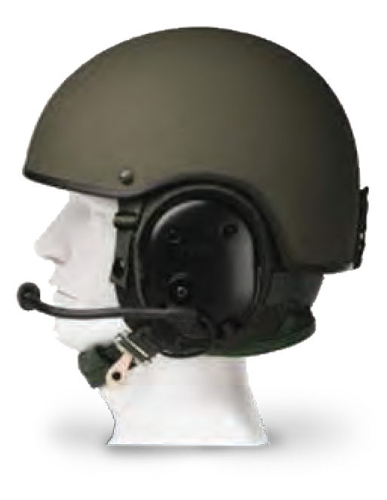
Noise cancelling, attached to the chin strap.
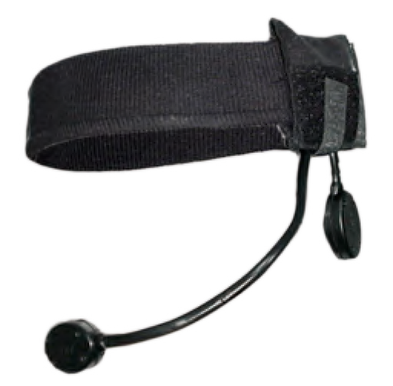

MESH BANDED HEADSET THIN WIRE HEADSET

TA04204 TA04205

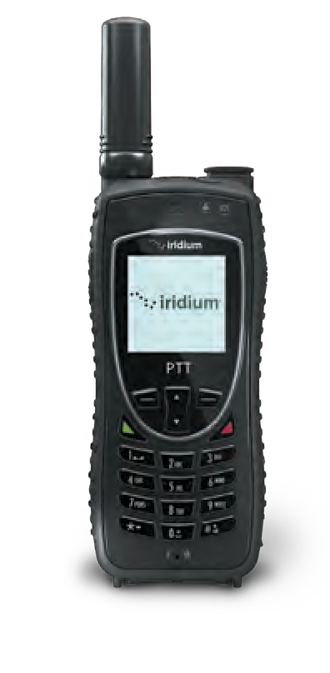
data communications globally from lightweight
satellite terminals. Connect the BGAN terminal to a portable device to access the internet for web browsing, email, or streaming IP rates to meet all your data, voice and video needs.
Turn your smartphone into a satellite phone using the Iridium Anywhere device which enables your smartphone to work anywhere on the planet. Supports daily functions including social networking, email use, SMS, GPS tracking, smartphone applications and more.
Comfortable and flexible under-the-helmet,
mesh headset.
Combines hearing protection technology to protect ears and reduces unnecessary ambient sounds.

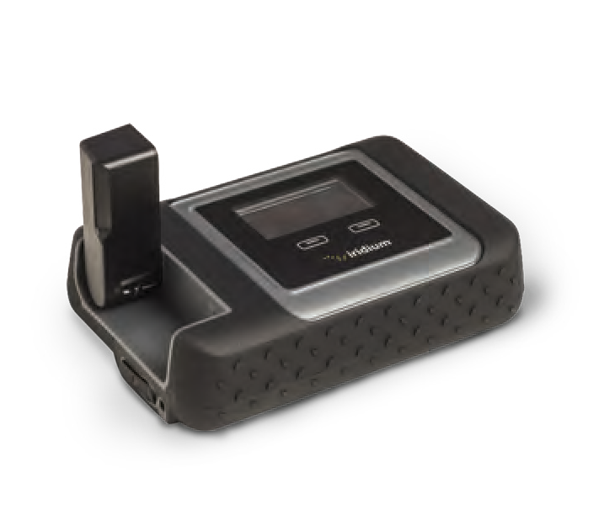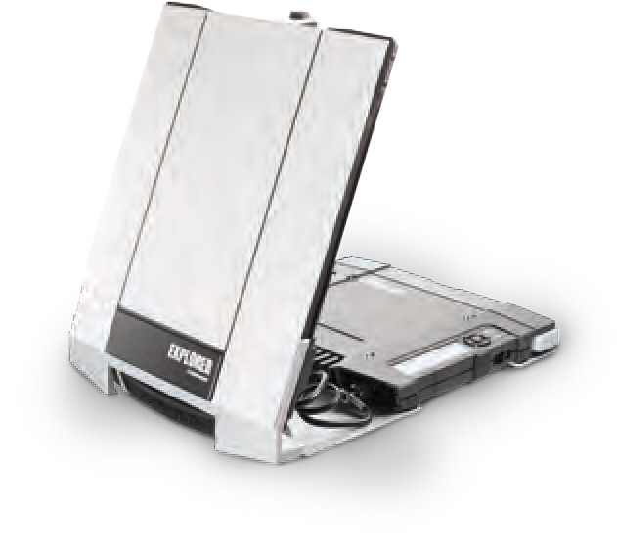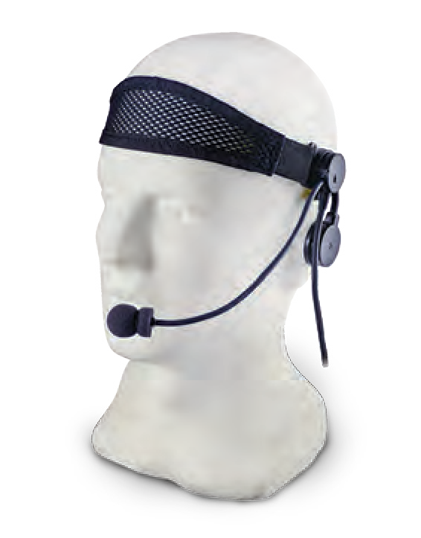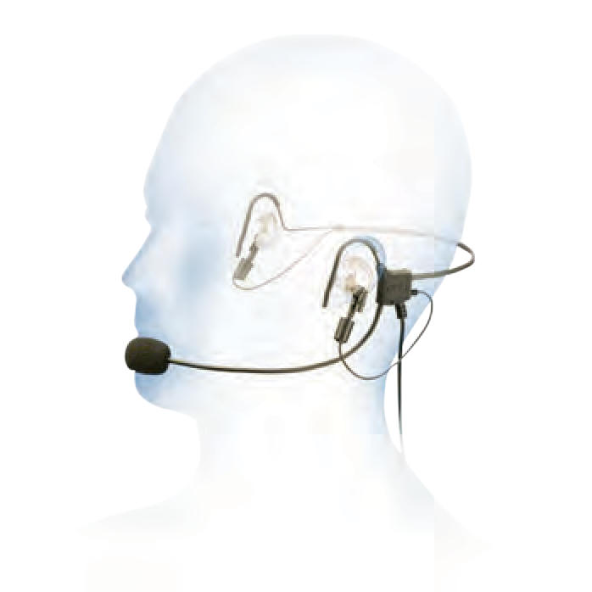
COMMUNICATIONS
Scan The Code

46 MILITARY AND POLICE EQUIPMENT WWW.TARIDEAL.COM 47

TRACKING & JAMMING TL5 PRO

Scan The Code

ELECTRONIC WARFARE JAMMING VEHICLE

TA04109
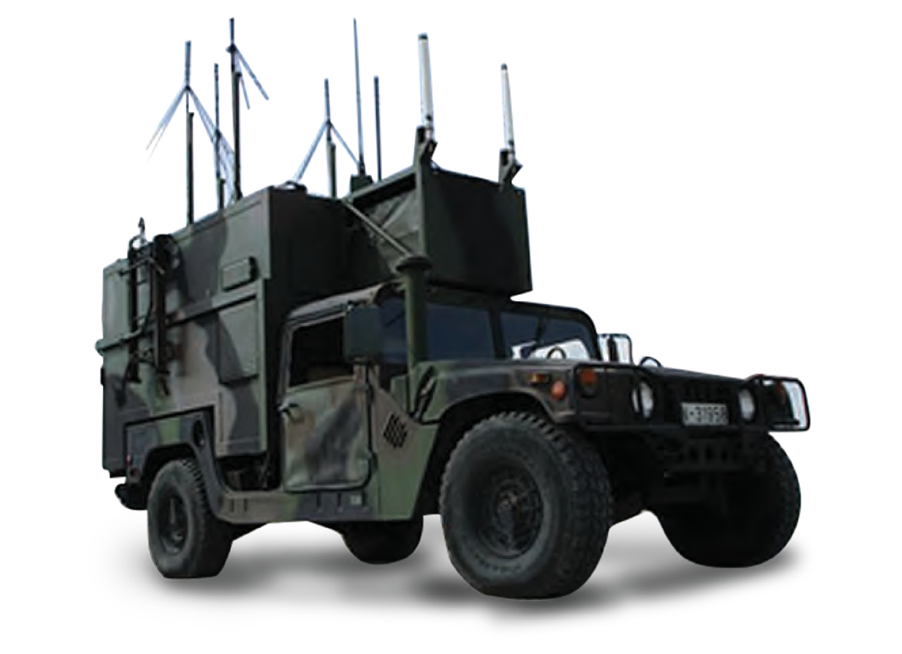The RCJ HF-VHF-UHF, high power jammer is designed to block FM communication. The system operates on a microprocessor for DDS programming, using mixed signals for maximum jamming efficiency. Each unique noise signal creates a “firewall” between the transmitter and receiver, and allows a selective jamming area through Broadband Directional Antennas that can be used with long wire and Omni directional antennas for 360° jamming.

LIE DETECTOR

TA08052
Applications: Interrogation.
Real-time intelligence gathering & suspect interrogation in combat zones. Agents and informers reliability test.

SATELLITE PERSONAL TRACKING DEVICE

TA04212
A handheld, global, two-way satellite messaging and personal tracking device, which includes a distress button.

MANPACK JAMMER
TA04300

TL5 PRO IR & VISIBLE BEACON

TA03166
The TL5 PRO was developed in collaboration with special forces and military experts, to detect and identify friendly forces in enemy territory.
Signaling the soldier by infra-red or by using visual illumination that may prevent friendly fire situation. The TL5 PRO may be used as a personal flashlight. In addition, the TL5 PRO personal marker is easy to activate and operate.
Made of PA (Nylon) + 30% GF (Glass Filled) and PC (Polycarbonate).
IP53 compatible: splash resistant, O-ring sealed. Fits Standard picatinny rail.
4 Circular infrared LED’s (830 nm).
Centre high power colored LED: white / blue / red. Dimensions (mm): 60w x 33h x 80l.
90Gr. without battery.
Operates on a single 3V lithium CR123 battery, GPCR123A (recommended) / 1 x AA.
In IR and visible mode the TL5 PRO allows visibility to be increased or decreased to the following distance: 100 / 300 / 800 / 1500 meters.
Impact Proofing: compliance with MIL-STD 810.

THE KIT INCLUDES:
1 x TL5 PRO.
1 x Helmet mount. 1 x Vest mount.

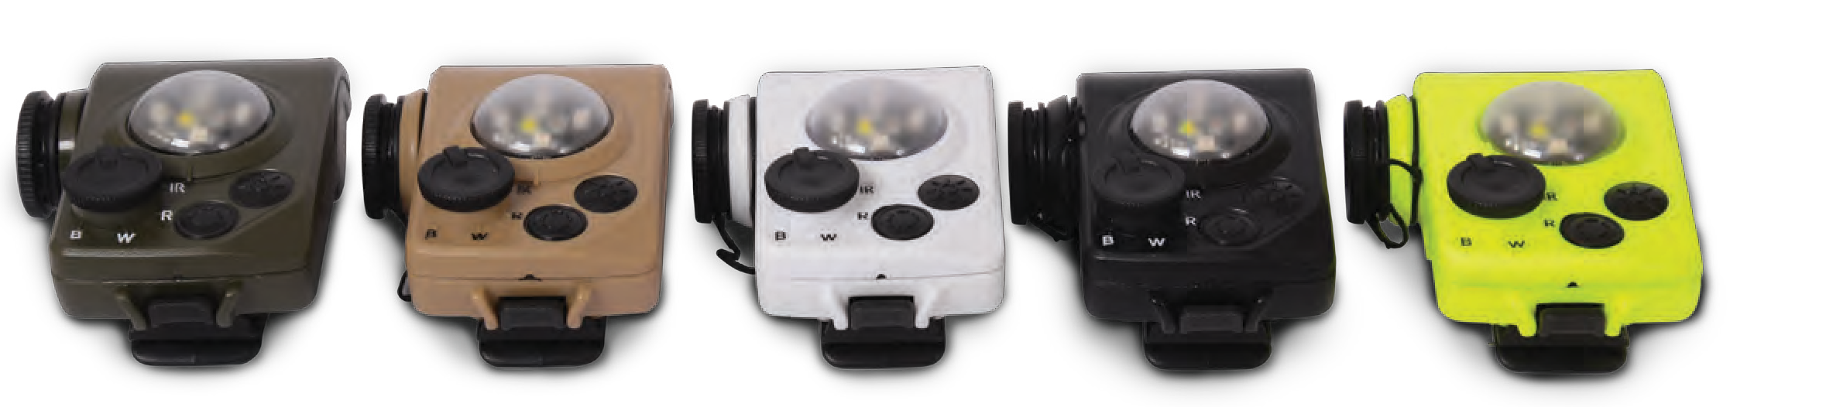
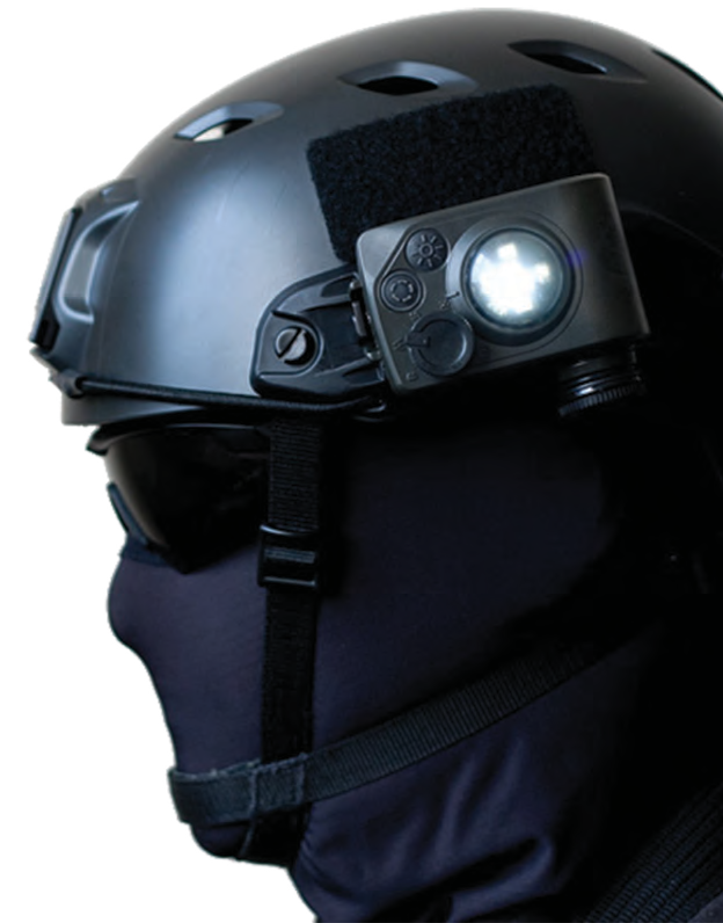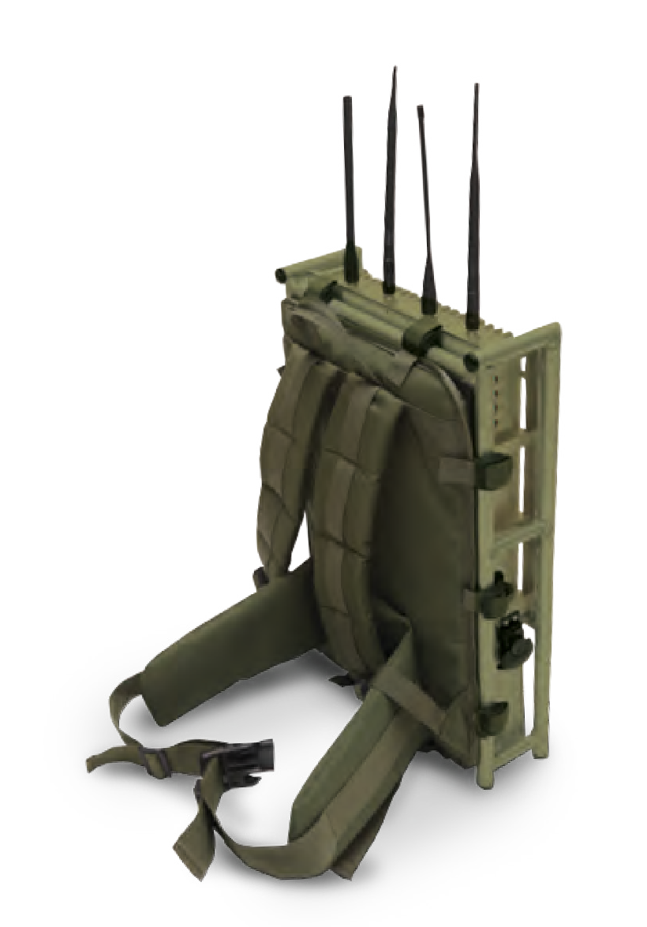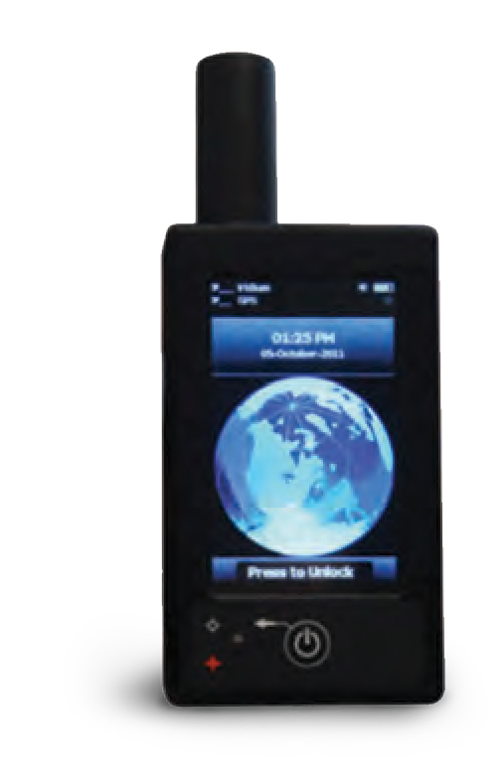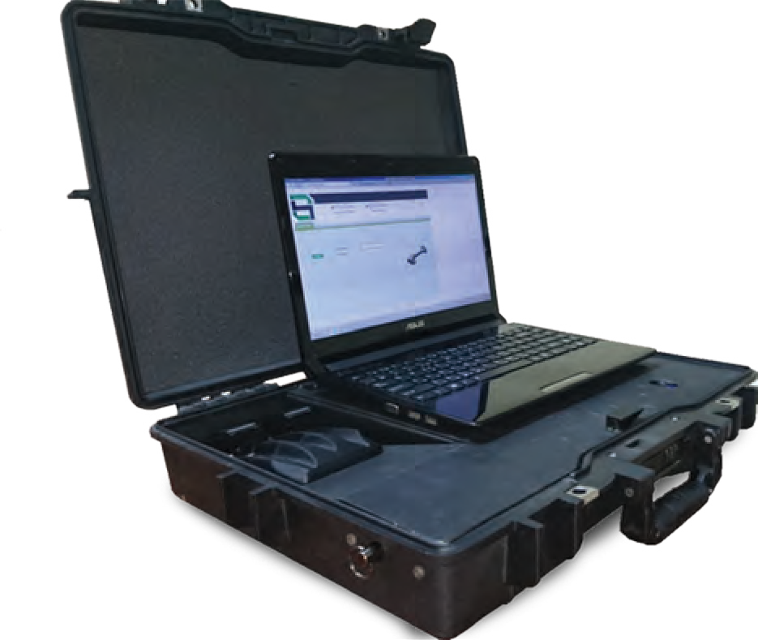
48
MILITARY AND POLICE EQUIPMENT
WWW.TARIDEAL.COM
49
System Highlights
Rapid interrogation process Fully automated
Multi lingual system Dynamic and Adjustable Easy to use

MILITARY EQUIPMENT SURPLUS

Scan The Code

We offer a variety of surplus military equipment and previously used products and systems that can be tailored to meet our clients needs.

Catalogues

All devices
Request for information

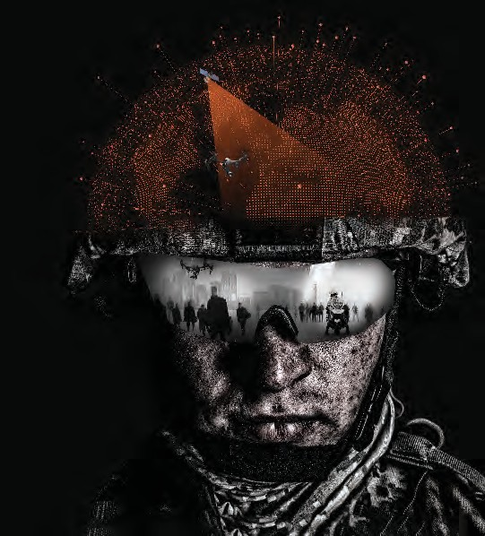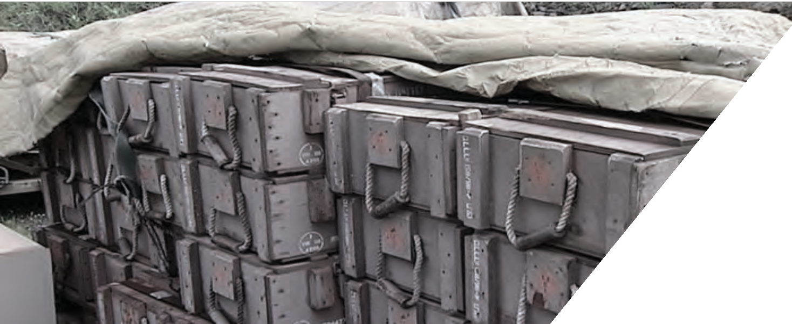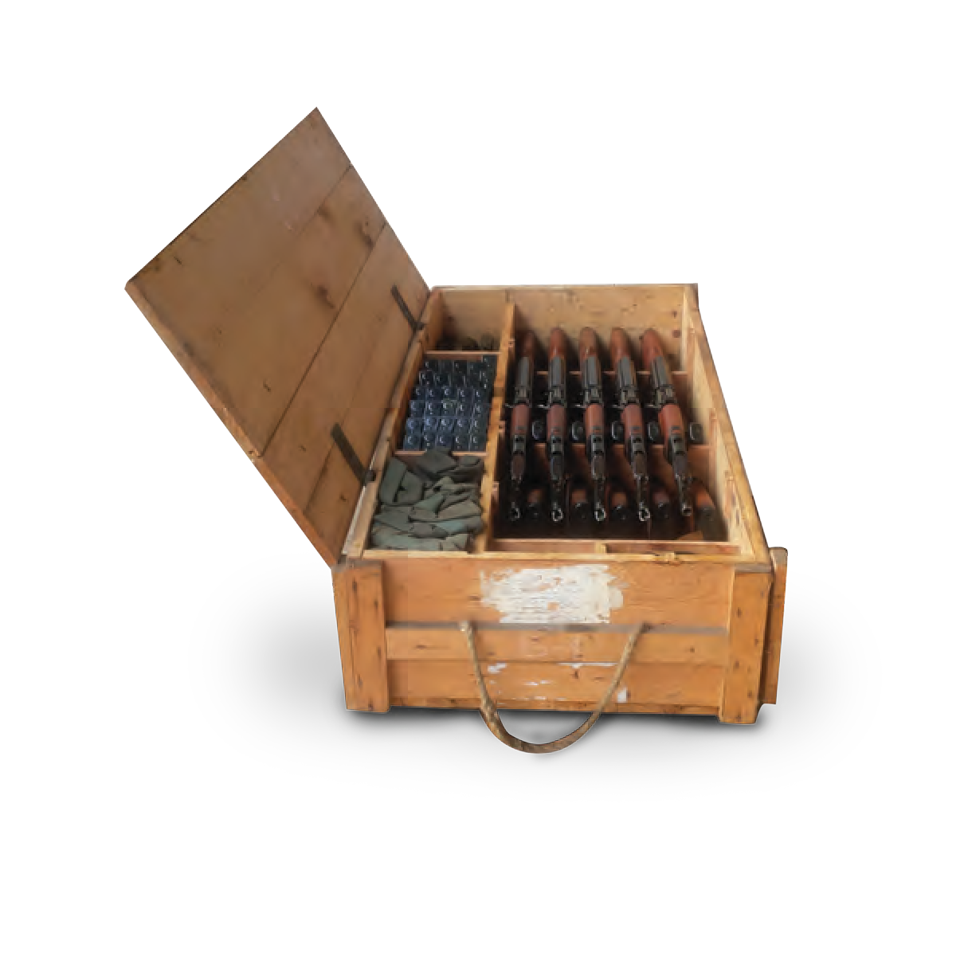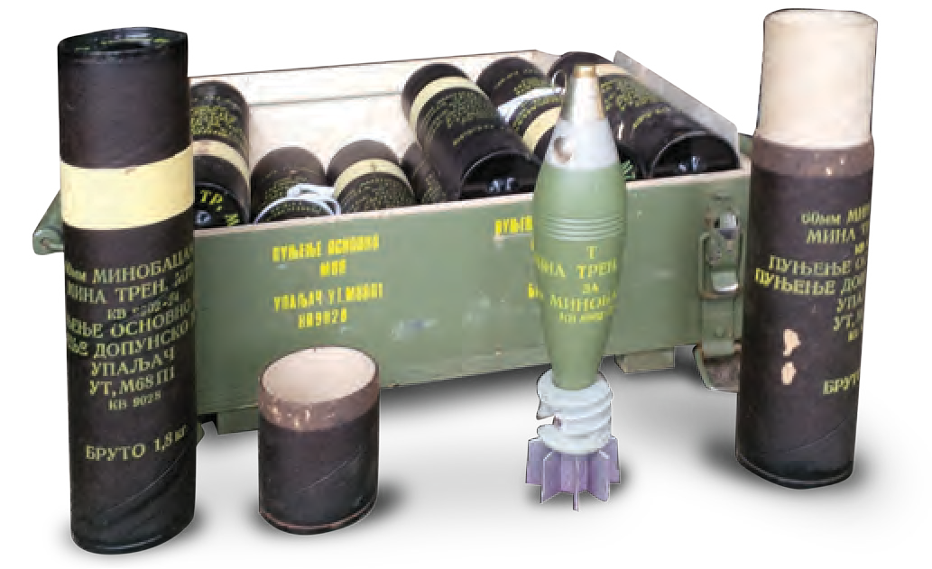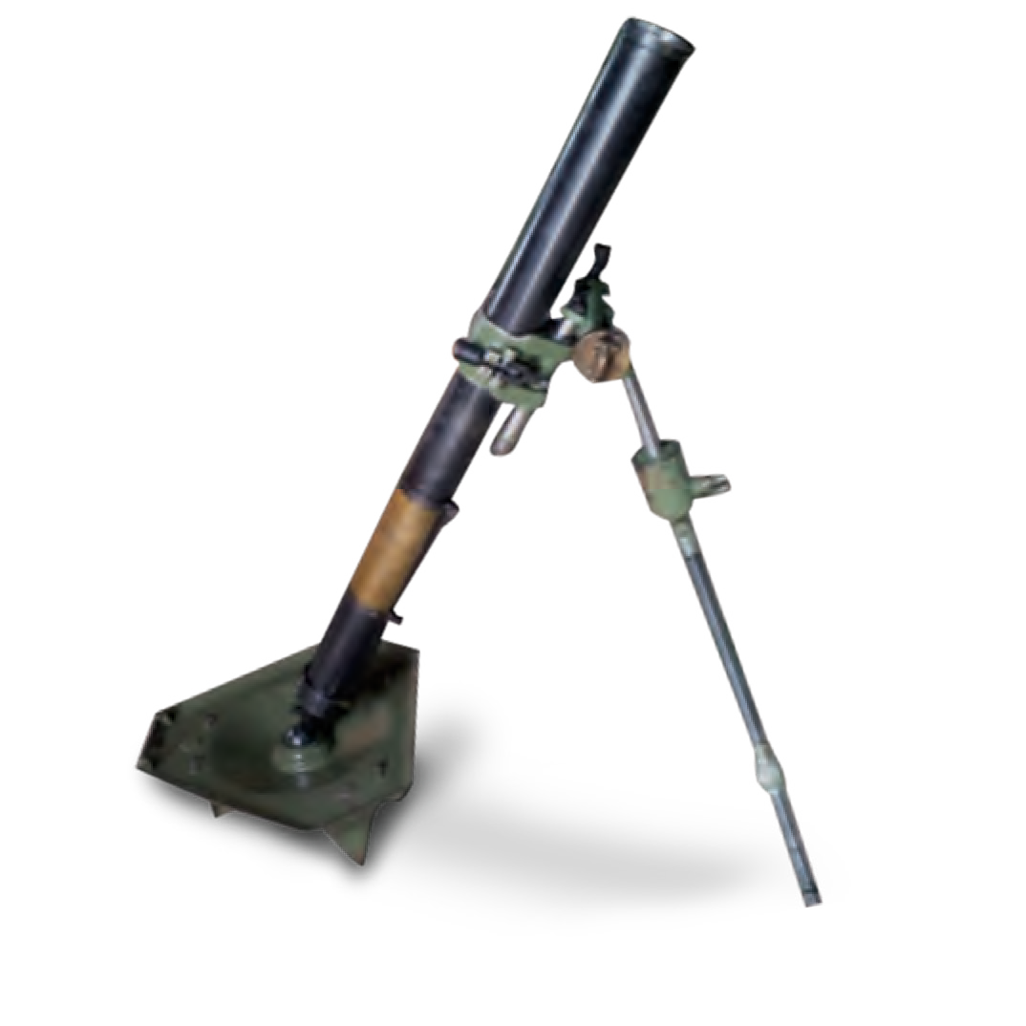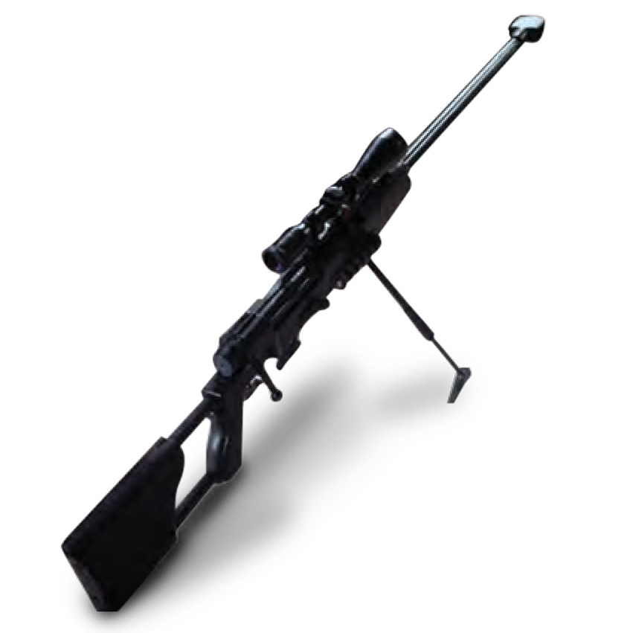

50 MILITARY AND POLICE EQUIPMENT WWW.TARIDEAL.COM 51

_{G} ONE STOP SHOP

TA04000-TA004999
S.W.A.T

World Leader in Supplying S.W.A.T Equipment And Training

EOD & IED

World Leader in Supplying EOD & IED Equipment And Training

RAPPELLING

World Leader in Tactical Rappelling Equipment And Training

K9

World Leader in Supplying Dogs, Equipment and Training

HOMELAND SECURITY

World leader in supplying Homeland Security Solutions, Equipment & Training
LAW ENFORCEMENT

World Leader in Supplying Law Enforcement Equipment And Training

VEHICLES

World Leader in Supplying Tailor Made Vehicles
C.B.R.N

World Leader in Supplying C.B.R.N Equipment And Training
GROUND FORCES

World Leader in Supplying Ground forces Equipment and Training

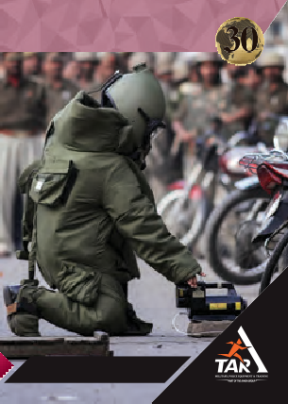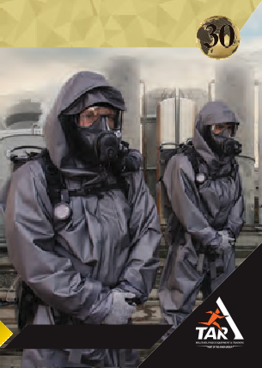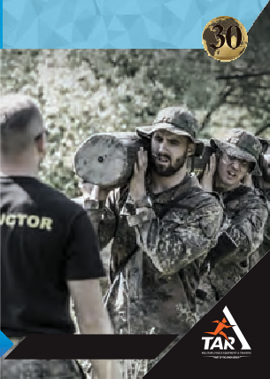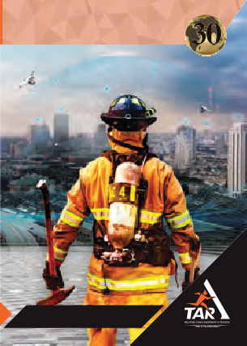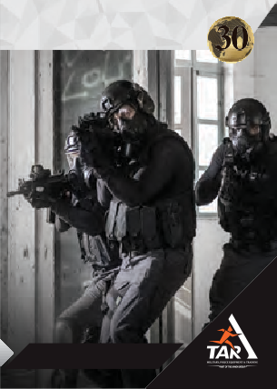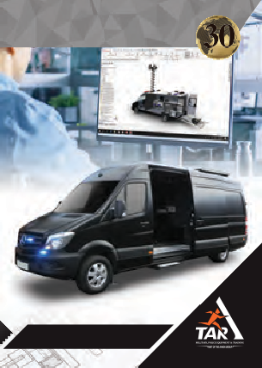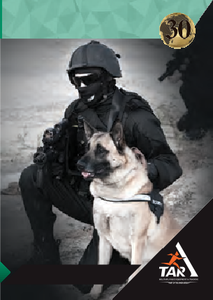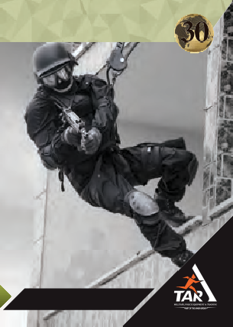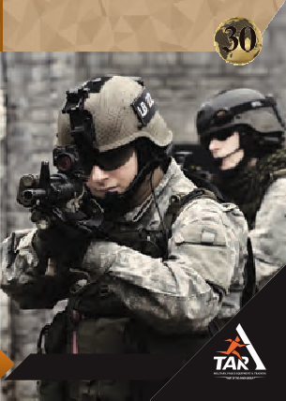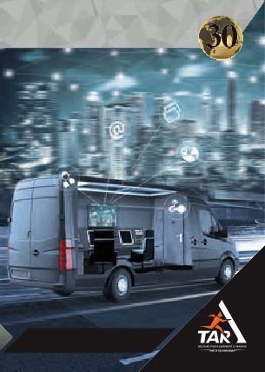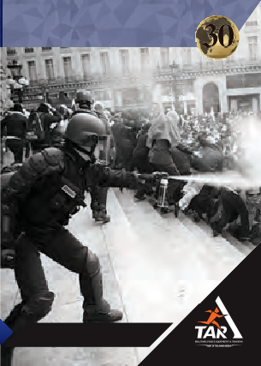

Tel: +972-3-6914564
Fax: +972-3-6914567
Email: tar@tarideal.com
w w w. tari de al. co m

SCAN HERE TO VISIT OUR WEBSITE
ACADEMY

World Leader in Supplying Military And Police Training
INTELLIGENCE

World Leader in Supplying INTELLIGENCE Equipment and Training

